

**GROUP ASSIGNMENT**

**TECHNOLOGY PARK MALAYSIA**

**CT118-3-3-ODL**

**Optimization and Deep Learning**

**APD3F2402CS(DA) / APU3F2402CS(DA)**

**HAND OUT DATE : 26TH JULY 2024**

**HAND IN DATE : 18TH OCTOBER 2024**

**WEIGHTAGE** **: 100%**

**INSTRUCTION TO CANDIDATES:**

1. **Submit your assignment via Moodle.**
2. **Students are advised to underpin their answers with the use of references**

**(cited using the 7th Edition of APA Referencing Style).**

1. **​Late submission will be awarded zero (0) unless Extenuating Circumstances (EC) are upheld.**
2. **​Cases of plagiarism will be penalized.**
3. **​You must obtain 50% overall to pass this module.**

|  |  |
| --- | --- |
| **Group 4** | |
| **Student ID** | **Student Name** |
| TP066841 | CHEN YONG JING |
| TP066981 | NG QI WERN |
| TP065116 | NEAW AIK KA |

Table of Content

1 Part 1 5

1.1 Dataset & Algorithm selection 5

1.1.1 Dataset Analysis 6

1.1.2 Deep Learning Models 8

1.2 Data Preparation 12

1.2.1 Data Preparation 12

1.2.2 EDA 16

1.2.3 Data Saving 37

2 Part 2 38

2.1 Model Building Preparation 38

2.2 Custom CNN Model (Neaw Aik Ka TP065116) 44

2.2.1 Model Building 44

2.2.2 Model Tuning 54

2.2.3 Model Explainability 71

2.2.4 Model Testing 77

2.3 MLP Model (Chen Yong Jing TP066841) 79

2.3.1 Model Building 79

2.3.2 Model Tuning 87

2.3.3 Model Explainability 100

2.3.4 Model Testing 103

2.4 RNN Model (Ng Qi Wern TP066981) 104

2.4.1 Model Building 104

2.4.2 Model Tuning 115

2.4.3 Model Explainability 135

2.4.4 Model Testing 143

2.5 Model Selection 145

2.6 Conclusion 147

3 References 149

1 Part 1 4

1.1 Dataset & Algorithm selection 4

1.1.1 Dataset Analysis 5

1.1.2 Deep Learning Models 7

1.2 Data Preparation 11

1.2.1 Data Preparation 11

1.2.2 EDA 15

1.2.3 Data Saving 36

2 Part 2 37

2.1 Model Building Preparation 37

2.2 Custom CNN Model (Neaw Aik Ka TP065116) 43

2.2.1 Model Building 43

2.2.2 Model Tuning 53

2.2.3 Model Explainability 70

2.2.4 Model Testing 76

2.3 MLP Model (Chen Yong Jing TP066841) 78

2.3.1 Model Building 78

2.3.2 Model Tuning 86

2.3.3 Model Explainability 99

2.3.4 Model Testing 102

2.4 RNN Model (Ng Qi Wern TP066981) 103

2.4.1 Model Building 103

2.4.2 Model Tuning 114

2.4.3 Model Explainability 134

2.4.4 Model Testing 142

2.5 Model Selection 144

2.6 Conclusion 146

3 References 148

4 Appendix 150

# Part 1

## Dataset & Algorithm selection

Image classification in the overall field of computer vision plays an important role in categorizing into different scenes. Image classification is central to allowing systems to learn the contents of an image by identifying different classes for them to continuously interpret their environment, which is essential for practical applications like autonomous vehicles, environmental monitoring, disaster management, and geographic information systems (Akhtar et al., 2023). In contrast to object detection, in which the aim is to recognize specific objects, natural scene identification has to consider other factors, such as lighting, textures, and landscape types. This complexity demands sophisticated models to interpret various signal patterns under different environmental contexts (Sorkhi et al., 2020). Since the demand for an efficient automated system increases, the prediction of natural scenes plays a decisive role in enhancing the performance and reliability of technology that can interact with their surroundings.

Nevertheless, several challenges can be noted concerning the classification of natural scene images. A significant problem is the inconsistency in the images’ features, such as illumination, resolution, and orientation, that can affect model performance. This occurs because scenes such as forests or streets can be observed under diverse conditions, such as different times of day or seasons (Sorkhi et al., 2020). This is because, in some cases, the classes are very similar, and there are inter-class similarities between them. For example, it is challenging to differentiate between mountains and glaciers or between streets and buildings since these two combinations share common appearances (J. Wang et al., 2023). Low resolution and quality of images in datasets are also an issue that greatly limits the model’s ability to capture details for classification.

The primary objective of natural scene image classification is to create deep learning models that provide good performance in the classification of different natural scenes. These models must be able to categorize images under specific categories, including forests, seas, glaciers, mountains, streets, and buildings. The second is to ensure these models are robust to changes in scenario conditions, including lighting, viewpoint, and image resolution. Lastly, the comparative analysis of the developed algorithms with different benchmarks and, therefore, select the best model for this project.

### Dataset Analysis

The Intel Image Classification dataset is a dataset from Kaggle that is commonly used for the classification of natural scenes. It consists of approximately 25,000 images, each sized at 150x150 pixels, classified into six distinct categories: buildings, forests, glaciers, mountains, seas, and streets. The dataset contains images that are divided into the training set, the test set, and the prediction set to help train deep learning models. Since the images are entirely captured for different natural scenes with different environmental conditions, this dataset is highly suitable for training image classification models (Soudy et al., 2022).

Dataset Link: https://www.kaggle.com/datasets/puneet6060/intel-image-classification/data

**Significance of Dataset Diversity**

The diversity within the Intel Image Classification dataset is vast in developing sophisticated deep-learning models. It includes images gathered from a diverse set of settings, from natural to urban environments across the globe, at various lighting conditions, weather situations, and geographical locations. This type of variety enables models trained on the dataset to be able to perform better on unseen data from real-world environments. The variation of scene categories, including natural scenes like forests, glaciers, and mountains, and urban scenes like streets and buildings ensure that the models acquire feature differentiation from complex cues that characterize unique scenes (Soudy et al., 2022).

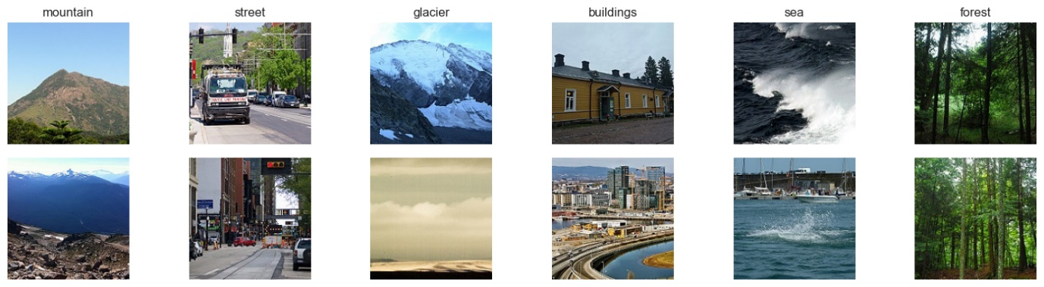

**Comparison with Other Datasets**

Unlike other datasets used in image classification, the Intel Image Classification dataset is unique in that it focuses more on natural and urban scenes under different conditions. For example, a dataset like MS COCO has a richer variety of object classes but is less concerned with scene classification than object detection (S. Wang et al., 2020). MS COCO is more focused on object detection as well as its relationships, therefore it is useful in tasks that include object detection while not so effective for scene classification. Likewise, datasets such as CIFAR-10 and MNIST are meant for simple tasks such as basic image classification with fewer classes and not as diverse or complex in terms of variations in the environment (Gupta & Khobragade, 2023). But while the Intel Image Classification dataset is smaller, it focuses more on natural scene classification, comprising realistic images that illustrate the specifics of the outdoors. This makes it more useful for occasions where environmental observations are relevant, rather than instances where there are only objects or simple conditions.

**Justification of Dataset Chosen**

As for the Intel Image Classification dataset which has been chosen as the target dataset, it is justified by its relevance to the task of natural scene classification. This is advantageous for quick prototyping and experimentation because the dataset is not very large (around 25,000 images) and thus does not require significant computation resources to train the deep learning models. This dataset is not very large, but it covers different scene types and environmental conditions which provides a good set of samples that can be used for model training and learning more in terms of real-world conditions. This diversity makes sure that models trained on this dataset have some ability to handle the different conditions that are useful in automated applications. In addition, its availability and usability make it suitable for fine-tuning and evaluating algorithms for image classification, which is a key aspect of the study of natural scenes.

### Deep Learning Models

#### Custom Convolutional Neural Network (CNN)

##### CNN Architecture

A typical CNN for the most part incorporates three main types of layers:

**Convolutional Layers** – These layers are the core of a CNN. Different filters or kernels are applied to the input image so that features like edges, corners, and textures can be detected. This is important in scene classification because some filters are better at capturing details than others. For example, they can detect sharp outlines of buildings or the softer textures of forests and glaciers.

**Pooling Layers** – Pooling layers are used after convolutional layers to downsample the spatial dimensions of the feature maps, thereby reducing the number of parameters and computational load. Pooling helps make the network more invariant to small shifts, rotations, and distortions in the image. This is especially useful for the Intel dataset, as images are captured in varied conditions, and certain scenes (like mountains or seas) may appear differently depending on perspective and lighting.

**Fully Connected (FC) Layers** – After several convolutional and pooling operations, the output is flattened into a one-dimensional vector, which is passed through fully connected layers. These layers classify the image based on the features extracted by the convolutional layers. In the Intel dataset, this layer will classify the image into one of six categories: buildings, forests, glaciers, mountains, seas, or streets.

##### Justification of Model Choice

Custom Convolutional Neural Network (CNN) is a very appropriate model for most image classification tasks, especially when using the Intel Image Classification dataset, which consists of around 25,000 images from six distinct categories: buildings, forests, glaciers, mountains, seas, and streets. CNNs are particularly efficient in learning spatial hierarchies of features from images, as convolutional layers can capture image patterns and then learn more complex ones found in natural scenes (Soudy et al., 2022).

Because the dataset consists of a variety of images from different natural and urban scenes under various environmental conditions, CNNs are well-suited to handle such complex image data with diverse patterns. CNNs, for example, have a good ability to pick out the characteristics of these categories, thereby identifying parts that make each type different from one another in this specific dataset. For example, the model may be able to discriminate between these scenes—like glaciers with smooth textural details, forests with dense patterns, or buildings and streets with intricate structures (Y. Zhang et al., 2020a).

CNNs are also the perfect fit for this dataset not only because it involves image data but also because they work fabulously well with small image sizes like the 150x150 pixel images of the Intel dataset. Since variations in lighting, weather, and perspective are present in the dataset, CNNs need to learn about this variability, and by using techniques like data augmentation (rotating images slightly, flipping horizontally, or cropping), they can generalize well even on unseen data.

Furthermore, CNNs can handle the large dataset that Intel offers without suffering from very high computational complexities, making them ideal for quick experimentation and model prototyping (C. Zhang et al., 2018a).

#### Recurrent Neural Network (RNN)

##### RNN Architecture

The only special point of RNN’s architecture is that it has what we call the recurrent layer, where a connection loops back to previous states. In an RNN, every unit passes its current state at a time step to the following one, and this helps capture dependencies in data because it is similar to maintaining a memory of past states. For more challenging problems, the most widely used RNN variant is the Long Short-Term Memory (LSTM) network, a model that has special units called gates which allow it to control what information flows through them, hence avoiding issues such as vanishing gradients.

##### Justification of Model Choice

Although Recurrent Neural Networks (RNNs) are more popular in handling sequential data, e.g., text or time series, they can also be applied to image classification problems where the temporal order of features is significant as well as some contextual information among them. For instance, an RNN may be applicable with respect to the Intel Image Classification dataset if classification depends on sequences of features found within or across images (Ma & Filippi, 2020a).

For instance, employing a variant such as Long Short-Term Memory (LSTM) networks can allow an RNN to detect relations between features in images or even across multiple patches of one image sequentially (e.g., categorizing a sequence of patches from one picture, or processing spatial correlations among sky, sea, and land regions in a scene). This may be extremely useful where it is needed to model time- or structure-related sequences of features, like in natural scenes (forests and glaciers), as patterns can vary spatially or sequentially across an image (Soudy et al., 2022).

#### Multi-Layer Perceptron (MLP)

##### MLP Architecture

**Input Layer** - As an example, in a simple MLP the pixels of an image are flattened into a 1D vector and served as the input layer. An image of 150x150 pixels (as in the Intel Image Classification dataset) would have 22,500 input nodes, for instance. This method treats individual pixels separately without considering relationships between neighbouring pixels.

**Hidden Layers -** These are the layers of an MLP that take input and weights, applying activation functions (such as ReLU) to those values, and transforming them into learned representations. MLPs can have one or more hidden layers depending on the task's complexity. In an image classification task, the hidden layers learn to identify patterns that distinguish types of scenes from one another (even though they don't know about spatial relationships).

**Output Layer** - The output layer maps the learned features from the input to a set of output classes. In this case, the MLP would have six output nodes, corresponding to all the categories in the Intel dataset (buildings, forests, glaciers, mountains, seas, and streets). Each class is assigned a probability using the softmax activation function in the output layer, with the highest probability determining the final classification.

##### Justification of Model Choice

Although MLPs can identify patterns in data, they are not suitable for image classification problems where spatial hierarchies and local features are important. An MLP treats each pixel as an independent input and does not capture the relationships between neighboring pixels, which are crucial for detecting edges, shapes, textures, or other higher-order patterns. This limitation becomes significant when analyzing more complex images, like those in the Intel Image Classification dataset, where classification relies on the spatial relationships between features (e.g., distinguishing environments like forests or streets based on geometric patterns and textures) (Meng et al., 2021).

Furthermore, the large number of input nodes (essentially equal to the pixel count in an image) results in a massive amount of parameters, especially when adding hidden layers. This can lead to overfitting, where the model performs well on training data but fails to generalize to unseen images. Additionally, using a basic MLP model would be inefficient and computationally expensive for high-dimensional input data, compared to specialized models like CNNs, which reduce the number of parameters by sharing weights across the input image (He & Chen, 2021).

Despite these drawbacks, MLPs can still perform well in very basic image classification tasks or when working with fewer classes and smaller, simpler images. For example, MLPs can handle simpler datasets like MNIST (28x28 grayscale images of handwritten digits) reasonably well because the task does not require learning complex spatial features. However, for more complex datasets like the Intel Image Classification dataset, which includes both natural and urban scenes under varied conditions, MLPs' limitations become clear, and they are less effective than CNNs, which are designed specifically for handling such tasks (Zheng & Sun, 2021a).

When classifying images into six categories in the Intel dataset (e.g., forests vs. streets or mountains vs. glaciers), an MLP would likely struggle due to its inability to capture spatial patterns that distinguish one category from another. Without the ability to detect local features and how they are spatially arranged, an MLP would treat the image as a collection of pixels, leading to inaccurate predictions. For this reason, basic MLPs are not often used alone for image classification tasks and are typically combined with specialized models like CNNs, which excel at feature extraction (Lv et al., 2022).

## Data Preparation

Perform an Exploratory Data Analysis (EDA) on your dataset using the suitable tools and techniques. All the data preparation activities are expected to take place in detail and clearly reported.

### Data Preparation

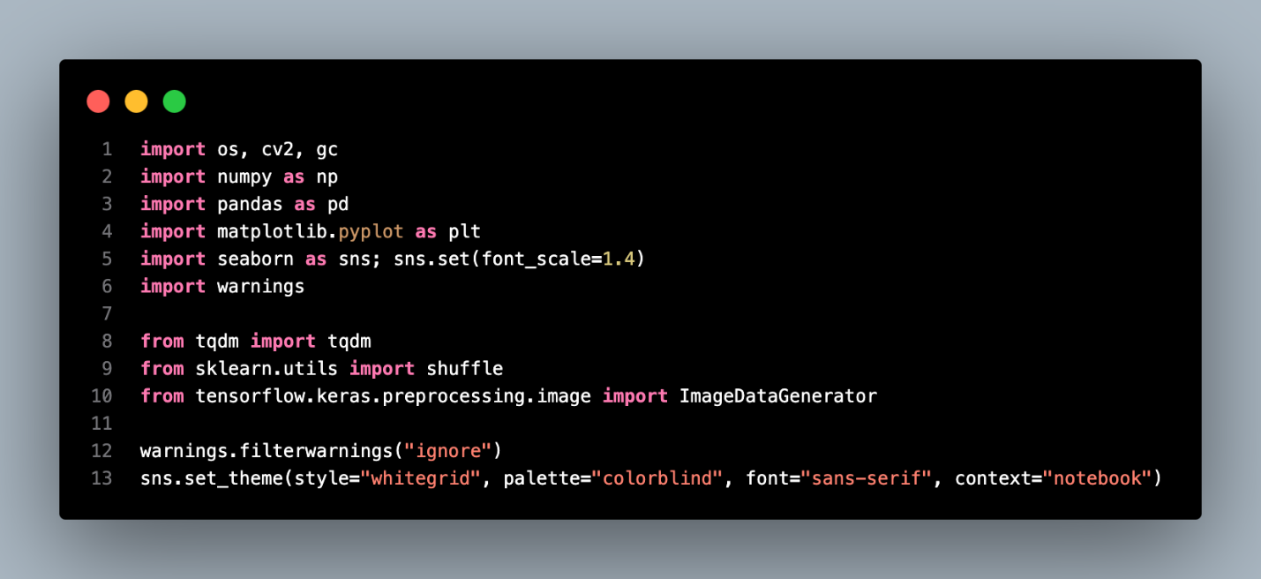

Before starting the task, we need to import the libraries including os, cv2, gc, numpy, pandas, matplotlib, seaborn, tqdm, shuffle from scikit-learn, and Image Data Generator from TensorFlow. Then, we ignore the warnings and set a base theme for all the seaborn graphs.

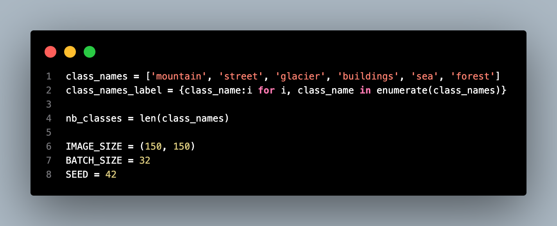

In the dataset, we have 6 classes in the target variable, hence we make a dictionary of the target variable for label encoding and decoding. The 6 classes include mountain (0), street (1), glacier (2), buildings (3), sea (4), and forest (5). The image size in the dataset is 150 px X 150 px. For the dataset we use for the training, we will set the batch size to 32, and the seed number is 42.

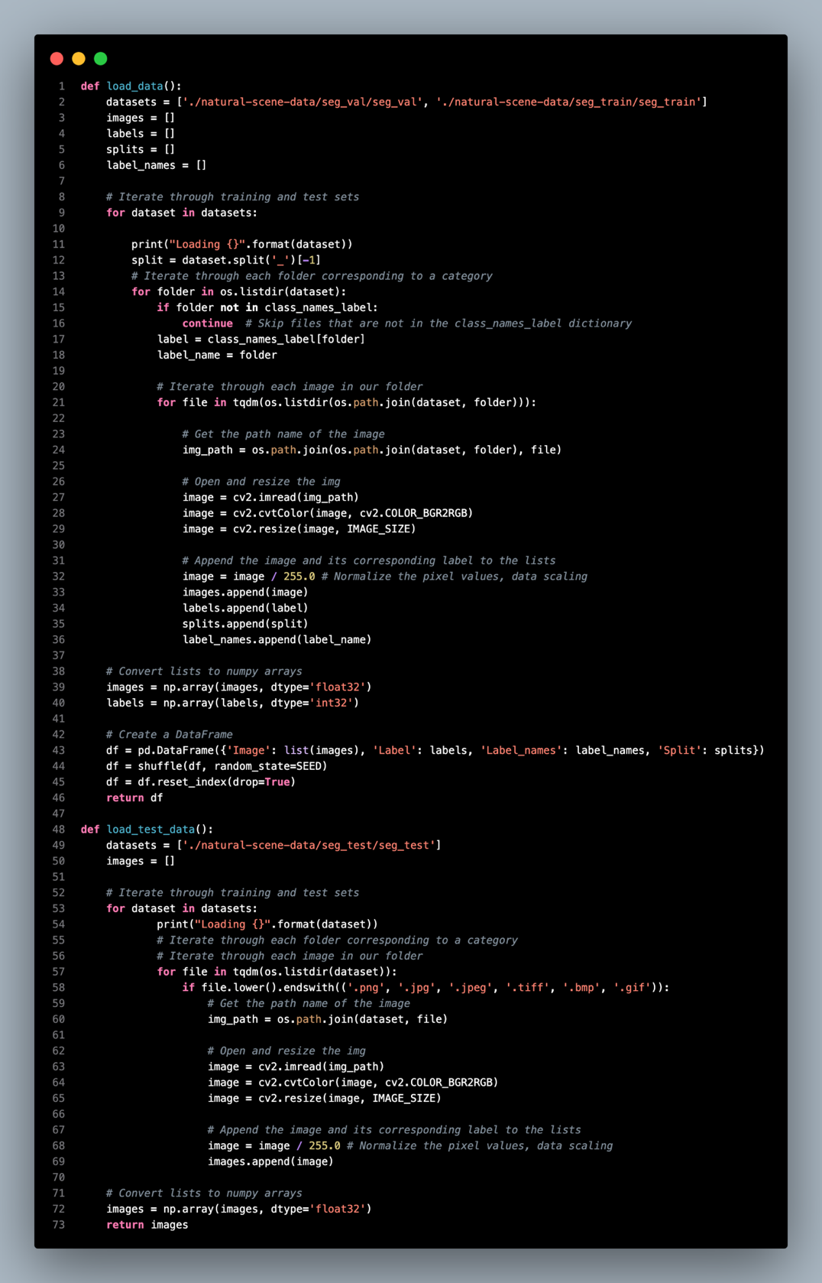

In the following section, we need to declare a few functions for data loading and turning image data into numerical data in table format for further work. The `load_data()` function is used to load and prepare the training and validation data from particular directories. It loops through folders in the given path of the dataset (training and validation directories) where each folder represents a class label. The function post-processes each image by converting the BGR format to RGB, scaling it to a predefined variable `IMAGE_SIZE`, and scaling the pixel values by dividing by 255. For each image, the label is also recorded in the list which is then converted into NumPy arrays for better image and label management. The data is shuffled for randomness and is returned as a DataFrame containing the image, label, and class name.

The `load_test_data()` function is similar in structure, but it is intended to load images coming from a test dataset. It goes around all the images in the test directory, and also resizes and normalizes each one of the images like the training set but without containing labels since we assume the test set is without labels. The function returns the processed images in a NumPy array format as preparation for the model calculations.

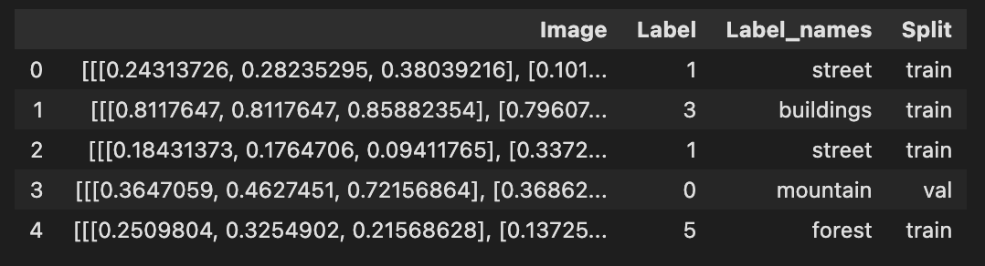

The figure above shows the data.head() for the data frame we get from load_data() function. The Image column consists of the array for image pixel values while the ‘Label’ column is the encoded label. ‘Label_names’ and Split are the labels for the class and the dataset split it belongs to respectively.

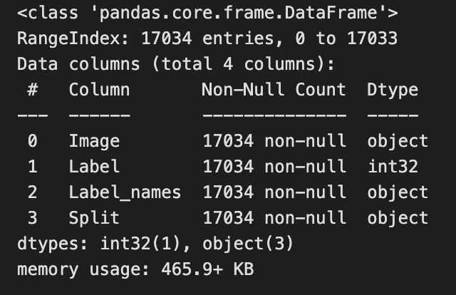

For the whole data frame, we have 17,034 rows of images, only the label column data is in integer format while the Image column data is in a list format and the other in string format.

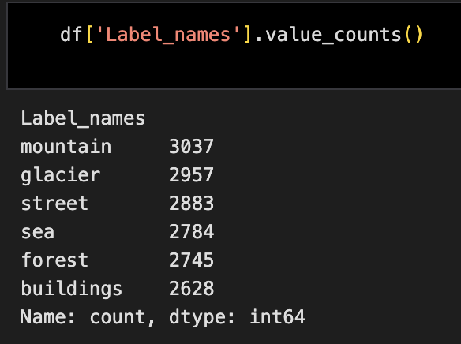

Next, we use value_counts() function to check on the number of labels for each class. ‘Mountain’, ‘glacier’, ‘street’, ‘sea’, ‘forest’, and ‘buildings’ classes have 3037, 2957, 2883, 2784, 2745, and 2628 samples respectively.

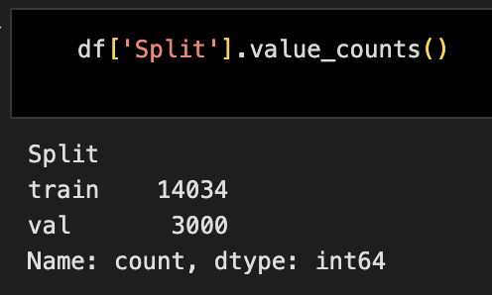

Furthermore, we check the split number for the dataset to make sure that the training and validation have an adequate number of samples. In this dataset, we have 14,034 training samples and 3,000 samples of validation images.

### EDA

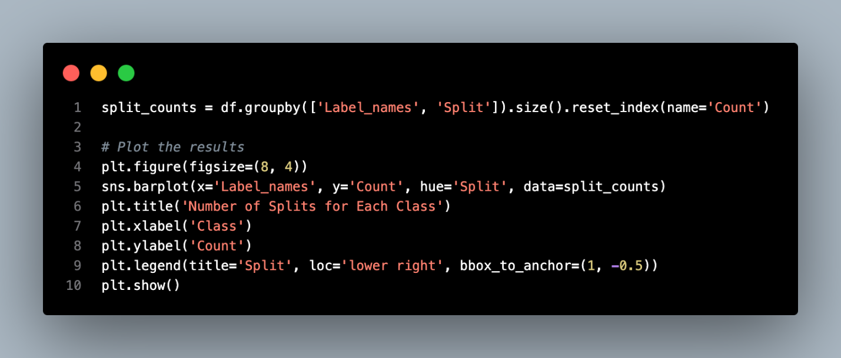

In the next step we will plot out the distribution of data for the class labels and the split up of data into training and validation sets. In the first part, we aggregate the `Label_names` and `Split` to determine the count of samples for each class and split. Using this count, we create a barplot to show the distribution of the dataset across the classes involved.

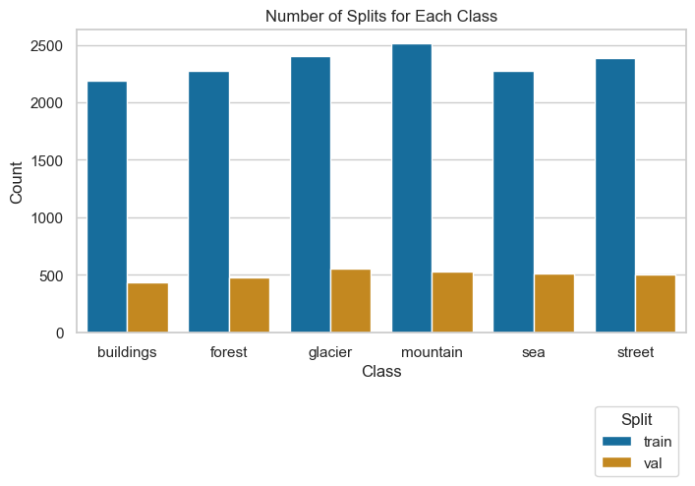

The train set can be considered balanced having approximately 2200 to 2500 samples per class and approximately 500 samples for each class in the validation set as well. This equal distribution of the data across classes will ensure the quality of training and evaluation later.

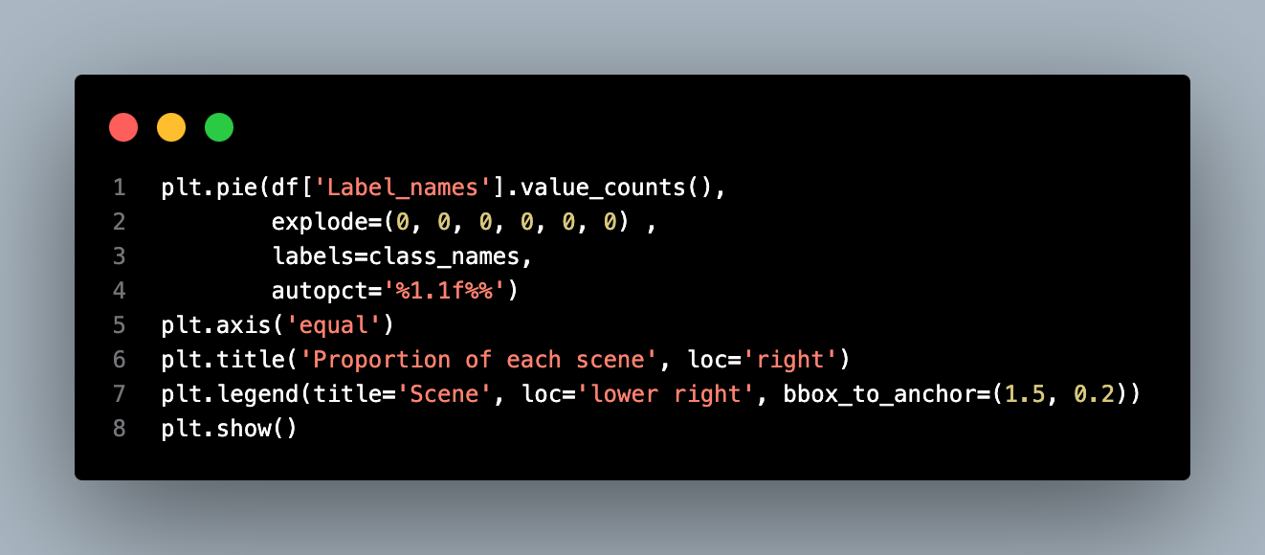

In the second part, a pie chart is created, and it shows the percentage of images that belong to each scene class. The `df['Label_names']. The `value_counts()` function gives the count of how often labels occur, and these are used to plot this pie chart. Every piece of the pie is a class and its name with the percentage of the entire dataset is indicated on the pictogram. From the chart, there is a clear view that can display the tendency of the distribution of different scenes present in the set.

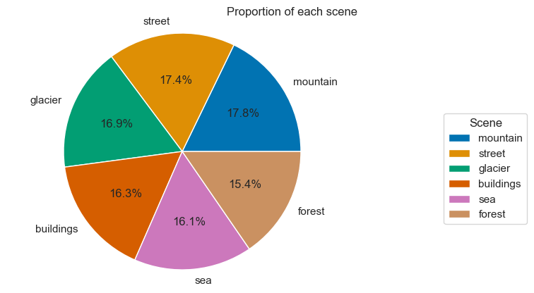

The largest category in our dataset is “Mountain” which comprises 17.8% of the dataset, the second is “Street” which took 17.4% of the dataset, and "Glacier" at 16.9%. While “Buildings” at 16.3%. The “Sea” category constitutes 16.1% while “Forest” is the lowest at 15.4%.

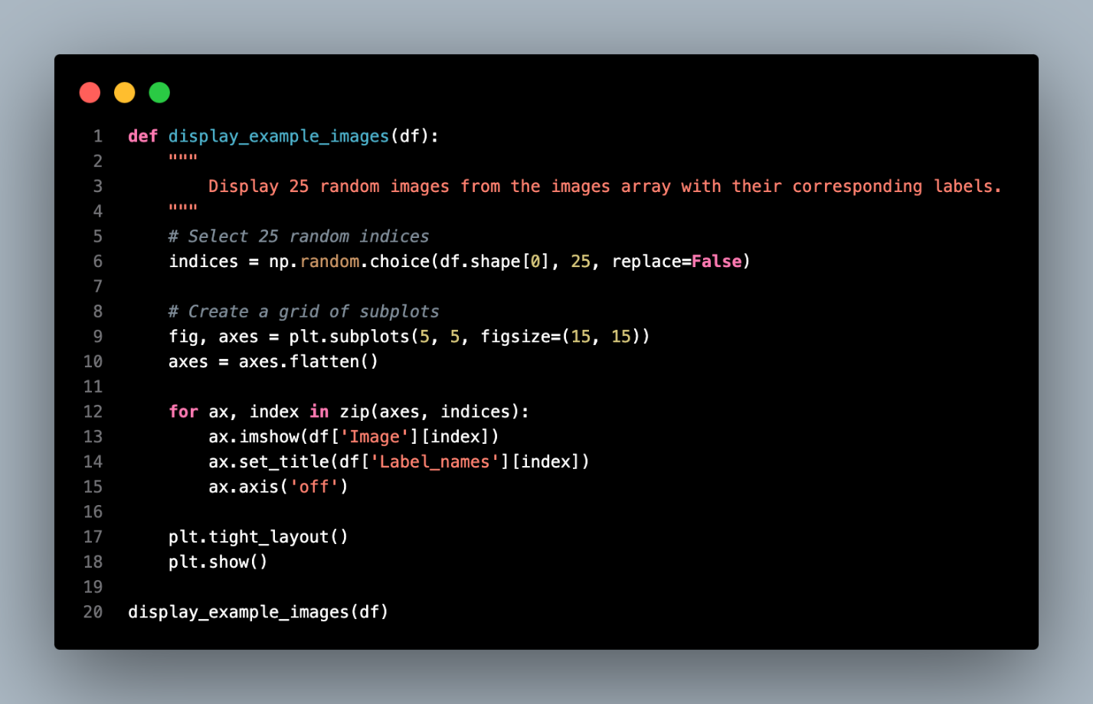

The `display_example_images` function is expected to display 25 randomly chosen images from the dataset with its labels. Firstly, we draw 25 random numbers from the index of the dataset. Then create a 5 x 5 grid of subplots, each showing one image and its label. Plotting the example images is to evaluate the quality of data, ensuring that the entropy, complexity, and diversity of the images in the dataset are enough for model building.

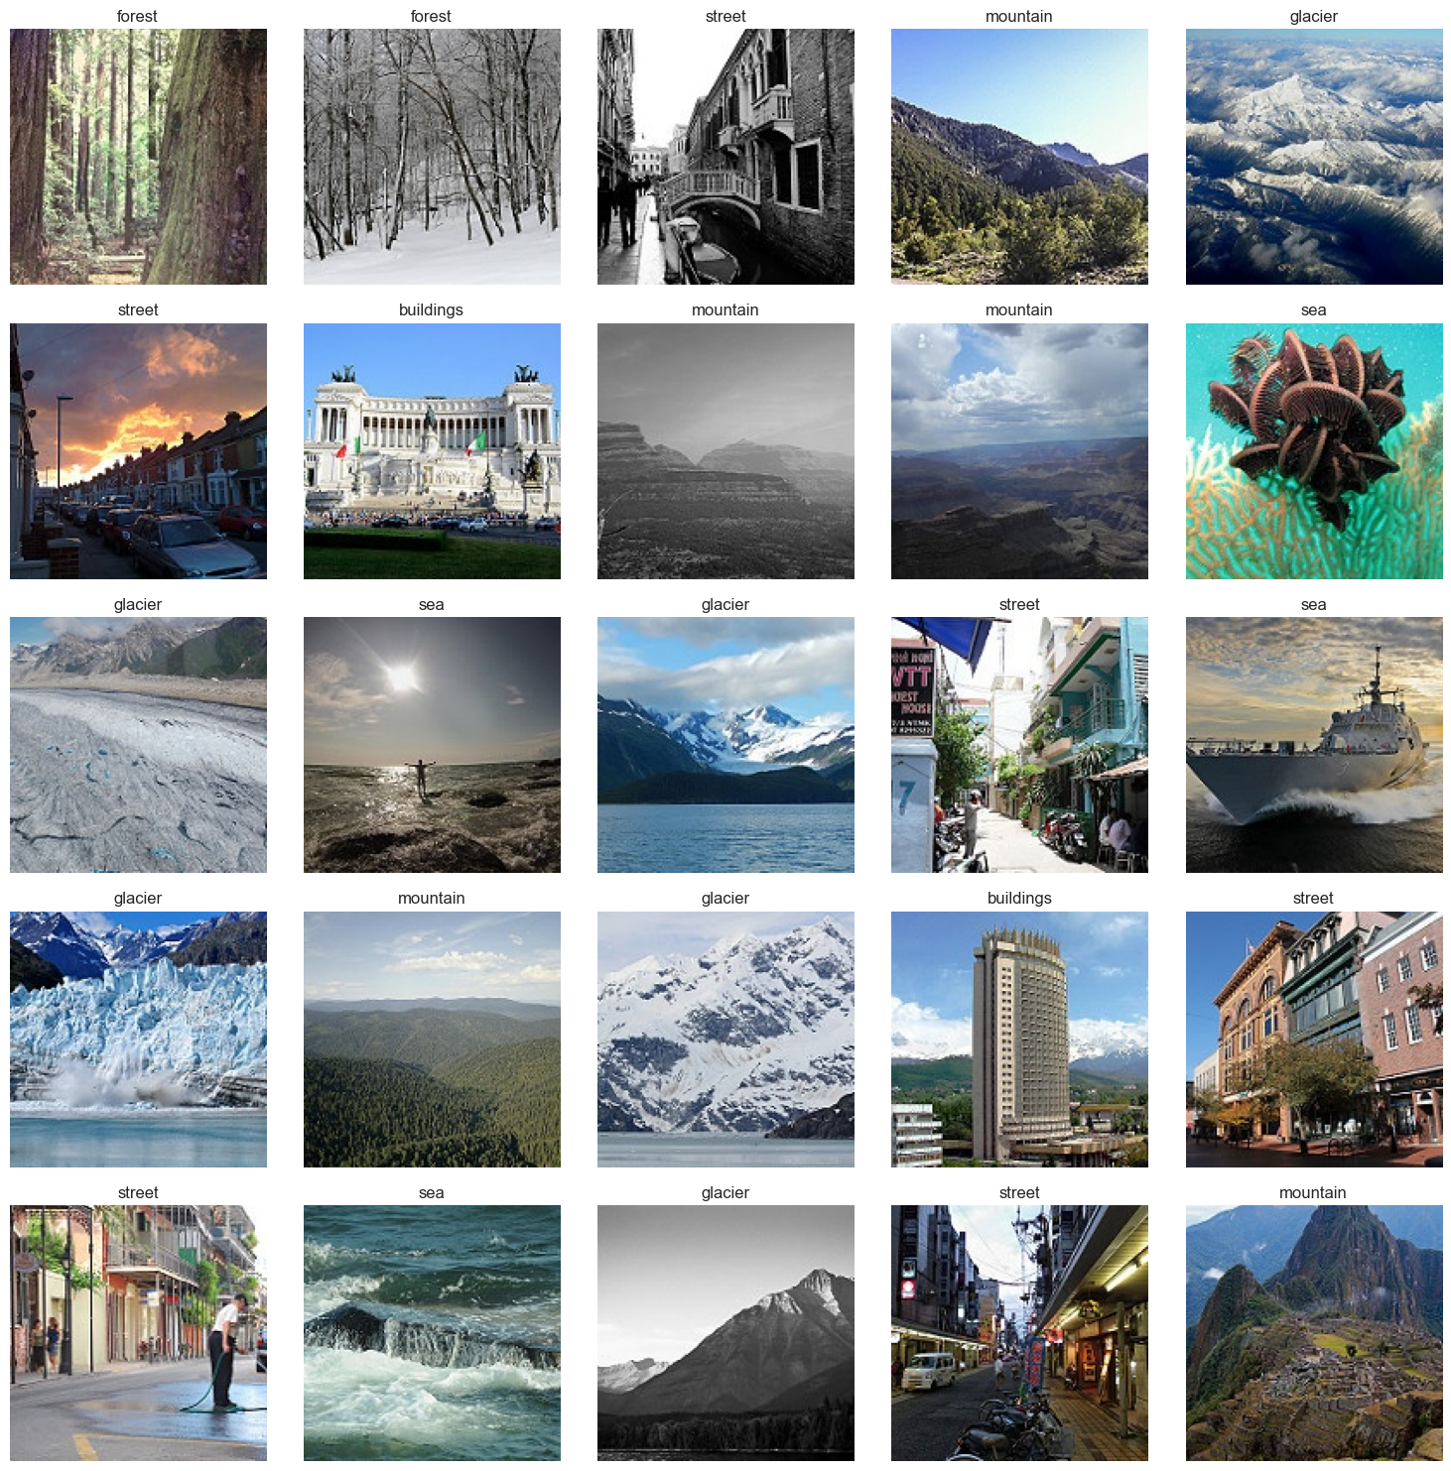

According to the example images plotted, the ‘street’ class involves old photos in black and white, underexposed photos under the sunset and streets with buildings and people. For the ‘forest’ class, there are forests with snow during the winter season. In the ‘sea’ class, there are photos in the sea, by the beach, sea with boats and animals. The ‘glacier’ photos, it has glacier photos from far distances and short distances. For the ‘mountain’ and ‘buildings’ classes, there are different types of photos including mountain views from the top and far distances, skyscrapers, and monuments, showing sufficient diversity and complexity in the dataset.

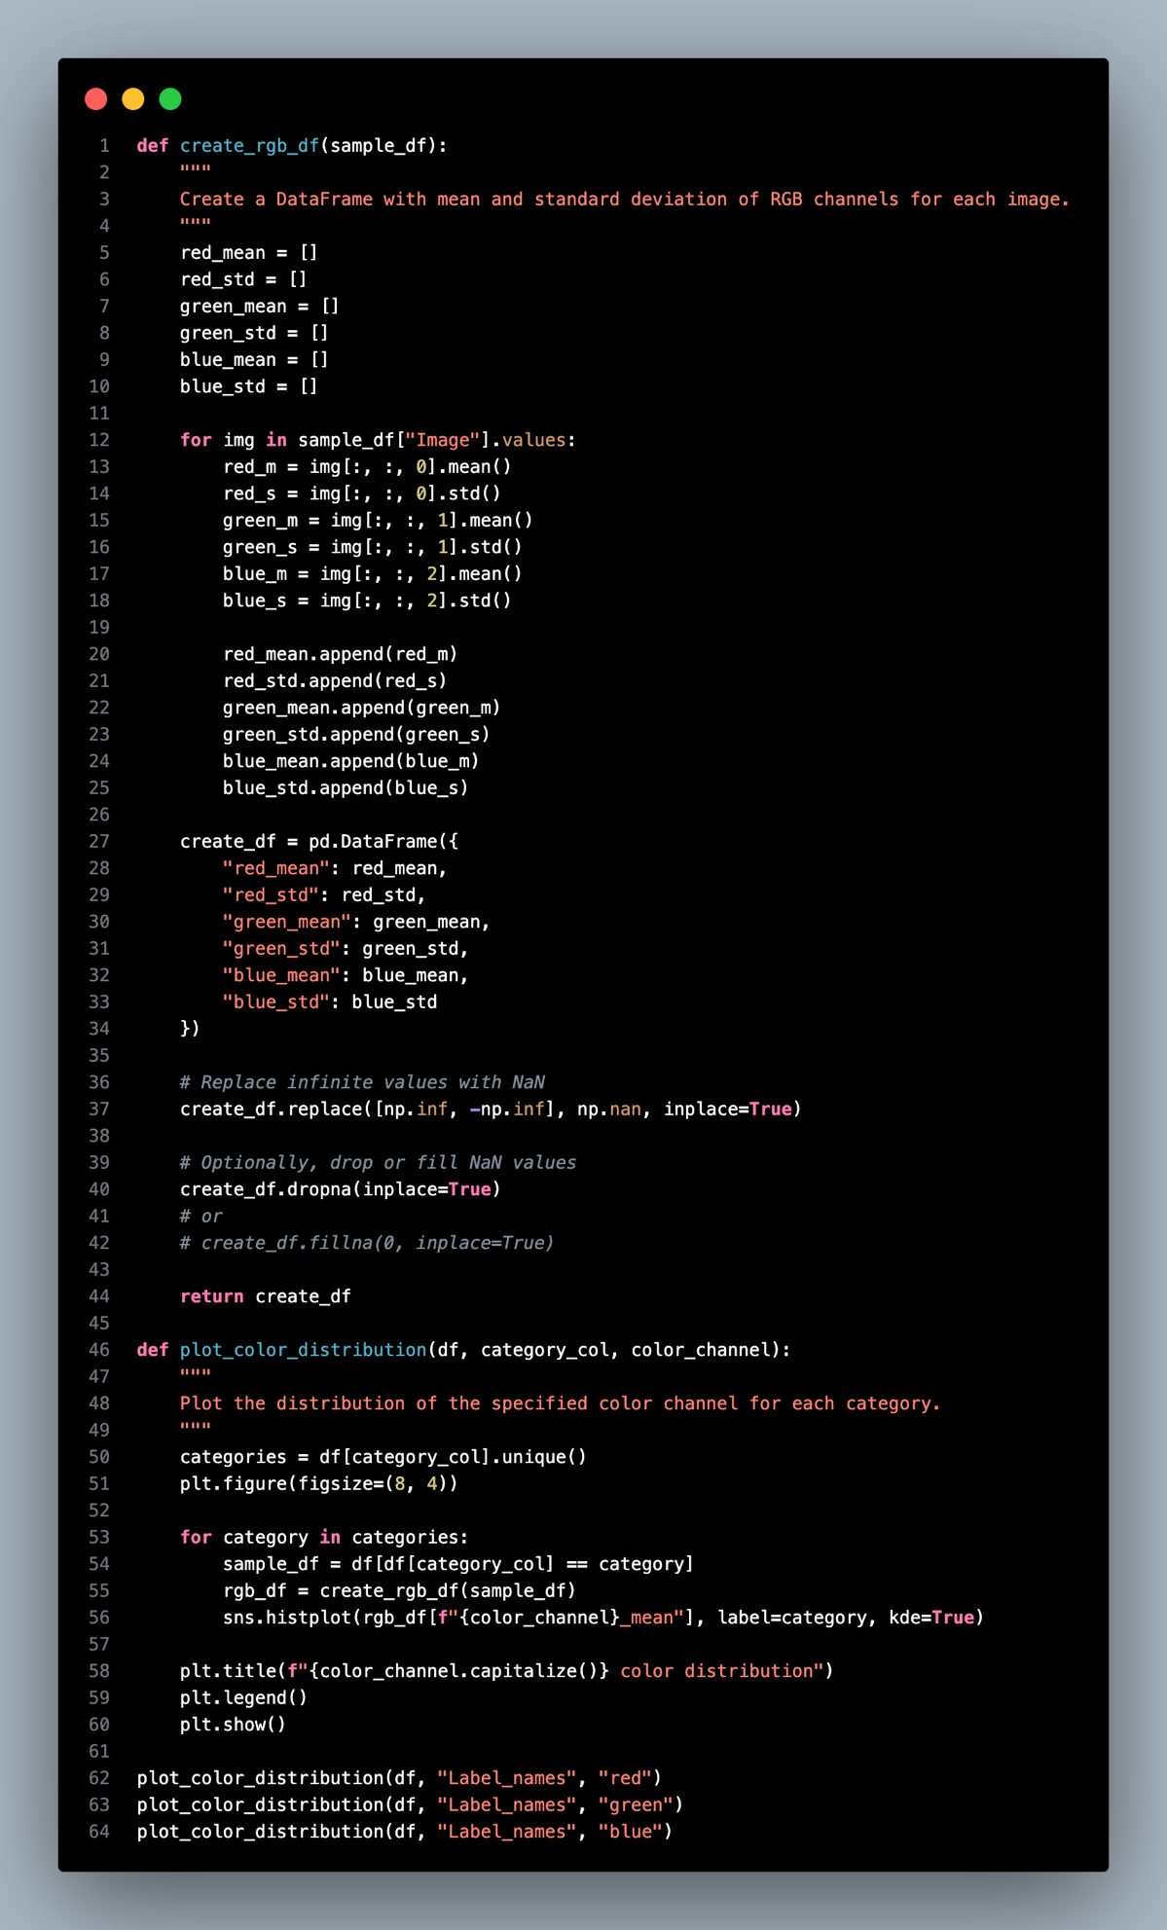

The create_rgb_df function calculates the average and standard deviation for the RGB channels for all images in the dataset. Due to their nature, the function takes each image and, after processing it to calculate the color statistics, it creates a data frame that contains the average and dispersion of the color characteristics to evaluate the color distribution in the variability in the images’ color channel.

The plot_color_distribution function is to plot the mean of red, green, and blue color channels for different categories. The histogram uses the mean value of each color channel with Kernel Density Estimation (KDE) to show the distribution. Plotting these color distributions can detect imbalance and variability in each category, which guarantees sufficient color variance in the dataset.

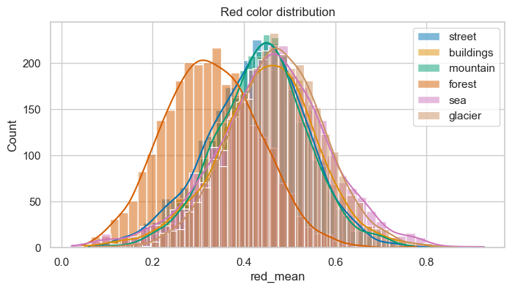

In the red color distribution, the ‘forest’ class has the darkest red color element in images, while the ‘street’ class has the greatest number of red color pixels counted in the images.

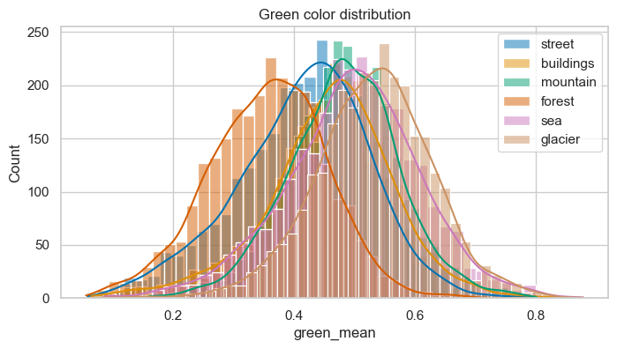

In the green color distribution, the ‘forest’ class has the darkest green color in the images while ‘street’ and ‘building’ have the most green color pixels in the image.

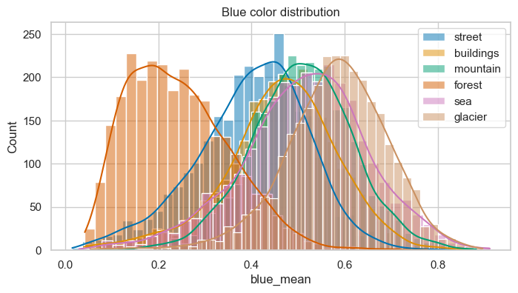

For the blue color in the images, ‘forest’ class images has lighter blue color while ‘glacier’ images has darker blue color in its images. ‘Street’ class images has the most number of blue pixels counted in the images.

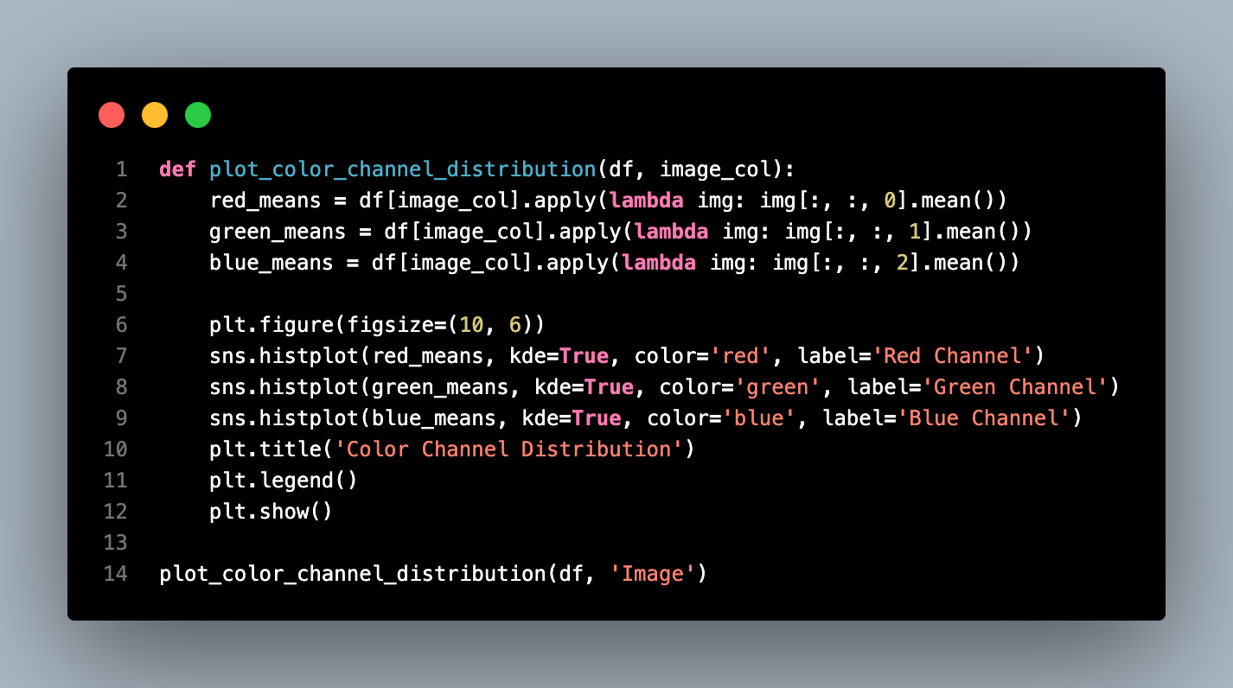

For color channel distribution function, it takes a set of images as input and computes and displays a histogram of the red, green, and blue color intensities. It compute the mean intensity in each of the color channels namely red, green and blue. These values are then stored in lists. Then, we plot three histograms with density plots. The graph displays the general distribution of intensity of RGB colors in the images.

This visualization can be used to determine the distribution of colors in the dataset in analyzing image quality, samples’ variability and data biases if any. For instance, if one color is too bright, then it might mean that the dataset is too monotonous.

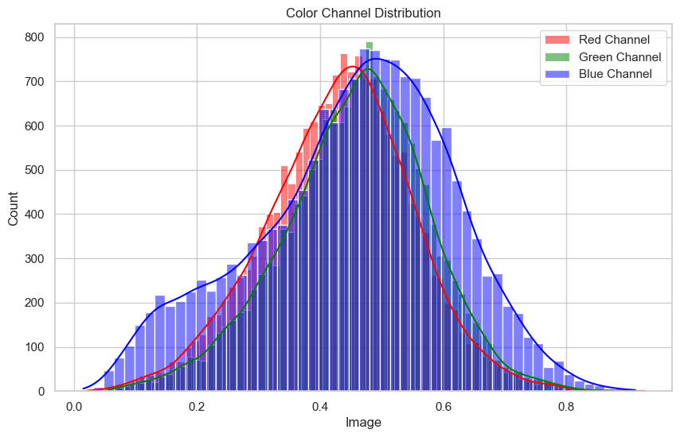

This graph represents the RGB color channels distribution in the dataset images. X-axis with 0 to 0. 8 indicates the intensity of the color, and on the Y-axis to clearly show the number of pixels occurrences in each color channels. The peak of all three-color channels, red, green and blue channels focus on range between 0.4 to 0.5. The blue channel was the broadest spread channel. From the graph, we can conclude that the distribution of color in the dataset images is quite average.

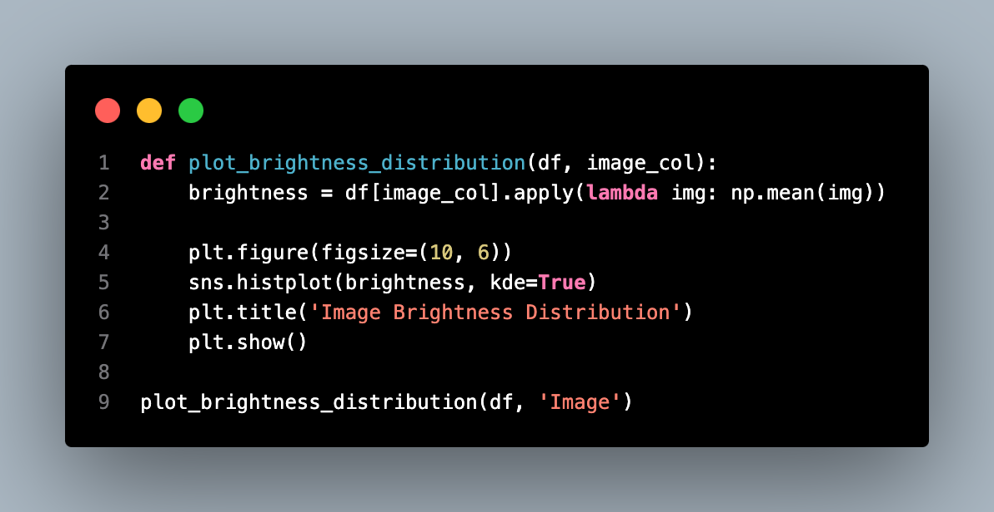

The `plot_brightness_distribution` function responsible to compute and plot the histogram of image brightness levels for the data. It calculates the mean pixel intensity of the given images on the required image column. We present the brightness values in the histogram. The graph will help in understanding the distribution the data in its brightness intensity.

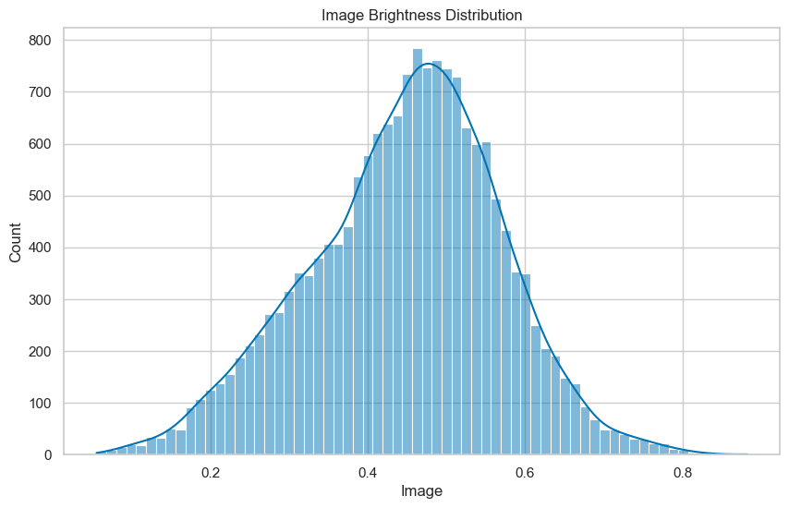

The X axis shows the image brightness values, ranged from 0 to 1 while the Y-axis denotes the frequency of each value obtained in the frequency table. The brightness are distributed around the mean value, which is equal to 0.4. Most of the brightness values are within the range of 0.4 to 0.6.

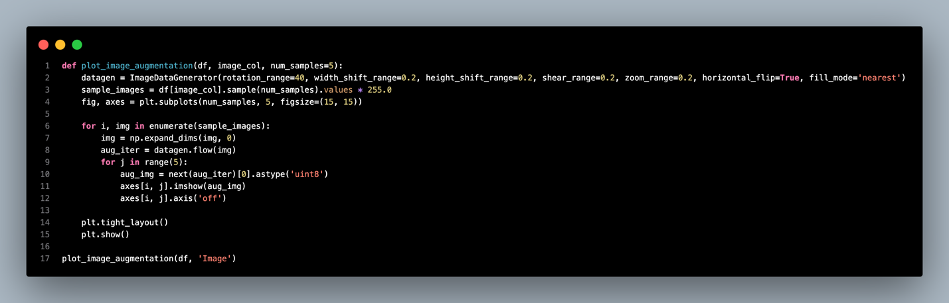

The function above is to visualize image augmentation techniques that we will be using during training model ranging from rotation, flipping as well as zooming. The function first creates an image augmentation generator using parameters that apply the random. Then chooses a few sample images and resizes them for presentation purposes. For each image, five different augmented versions are plotted. The plot visualizes the variety brought by these augmentations, and their impact on image quality, and the need for the augmentations to increase the variability of the training data to improve the model’s robustness.

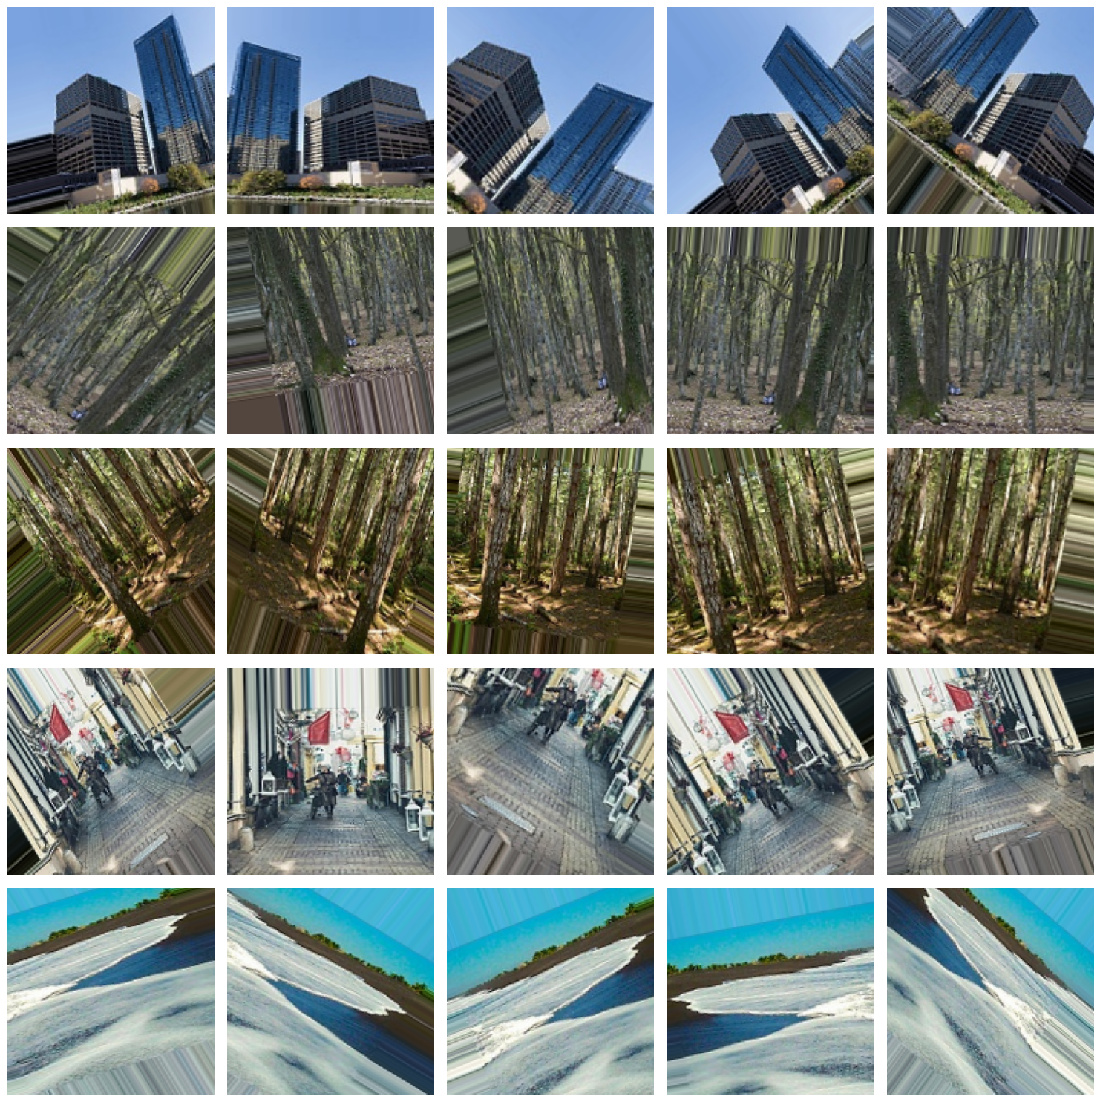

The result above indicates the augmentation techniques applied on the 5 random chosen images that each of them will be randomly rotate, flipping, and zoom to ensure that variable of images is fed into the model for better performance.

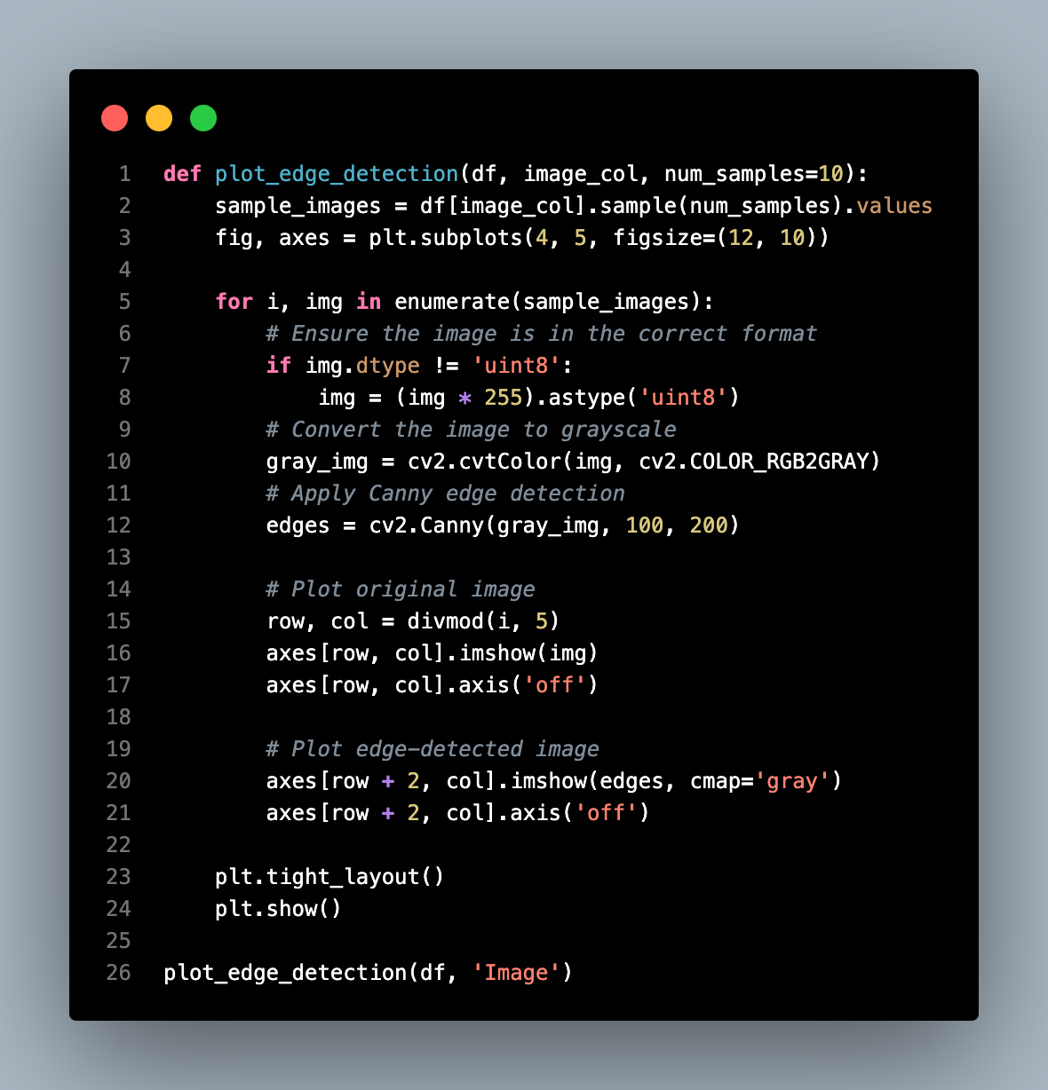

The function plot_edge_detection() draws the edge detection to highlight the important part of the images. First, we choose a few image samples from the dataset randomly, then for each of them, the program changes its color palette to grayscale and uses the Canny edge detector to draw emphasis on the edges inside the picture. The function then converts the image into a grey scale for edge detection. In the upper row, the function will show the original images, and in the lower row, the corresponding edge detected images. This detection is important to understand the structure of an image, which can help in improved feature extraction to boost the performance of models.

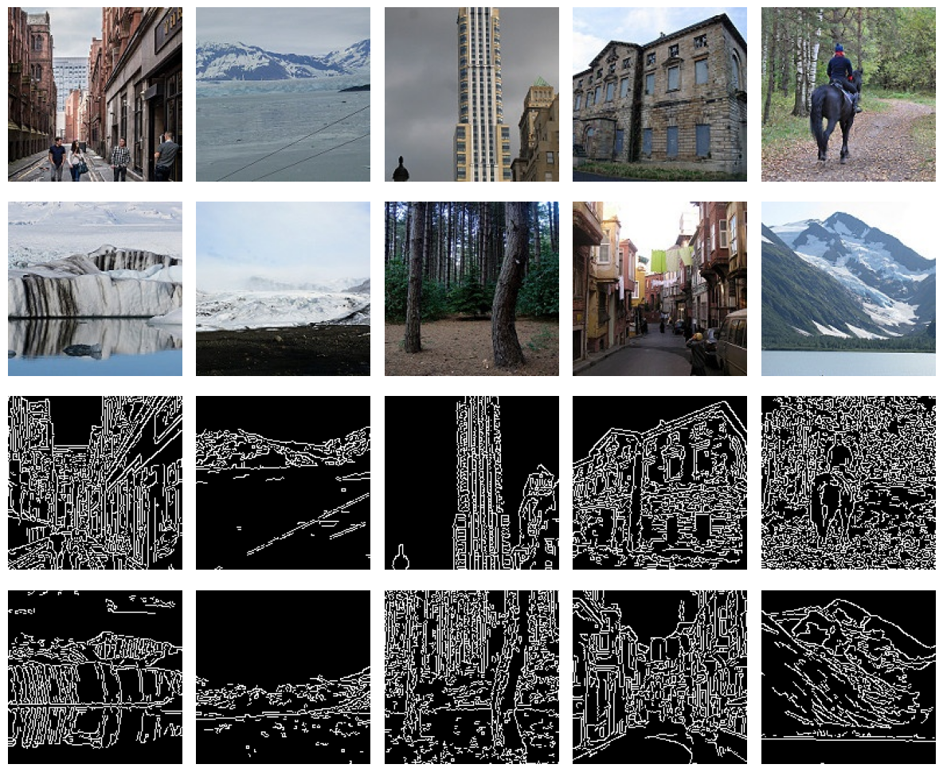

This picture illustrates the edge detection result of a set of pictures. The often black and white contrasted edges help to draw out outlines of objects and hence make different boundaries easily recognizable. This is useful for identifying certain structural features in the image, for instance, buildings or natural formations.

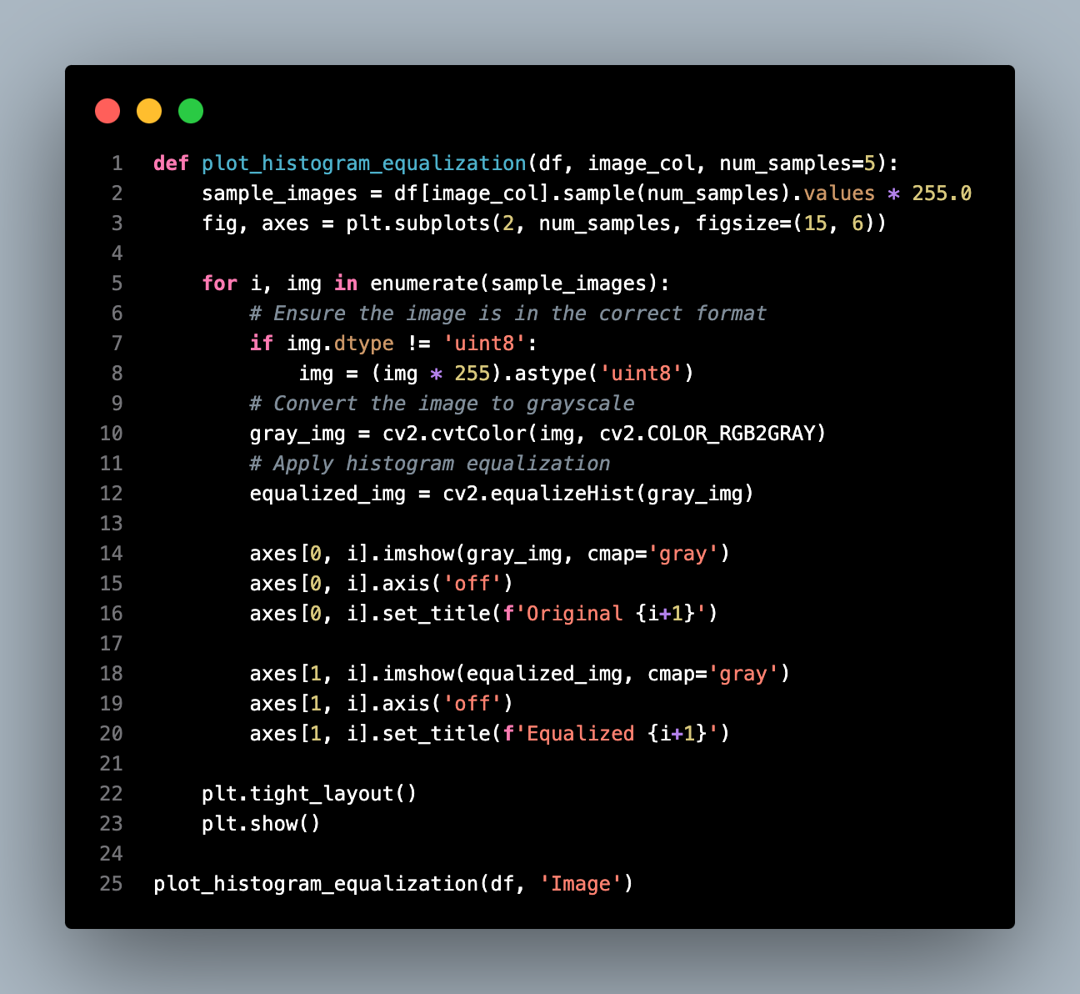

This function plots the histogram equalization of images by taking input from the images and visualizing their results. The parameters needed are the data frame with pictures on the column and the number of samples to be displayed.

The function first selects sample images from the DataFrame and then scales them by 255. For the subplots, the first column will be the original grayscale images, and the second column will be the equalized image. The dimensions of each image are changed to grayscale; then histogram equalization is done with OpenCV’s `equalizeHist()`. Equalization here is to help us increase visibility when working with low-contrast images.

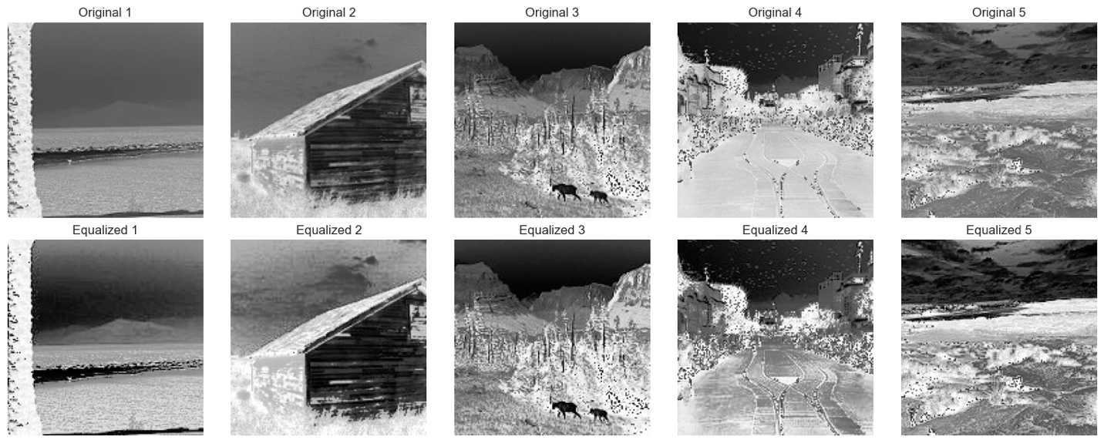

The first row of the original images demonstrates a low contrast and loss of the finest details, which is usually in the original images. The regions that are either extremely dark or extremely bright where may cause the important features to not be well seen.

The contrast of the images is improved in the bottom row after using the Histogram Equalization process. This process reallocates pixel intensity to spread over a larger dynamic range, improving the visibility of the important features. For example, in image 4, the most obvious change we can see is that the road is more visible in the image after equalization.

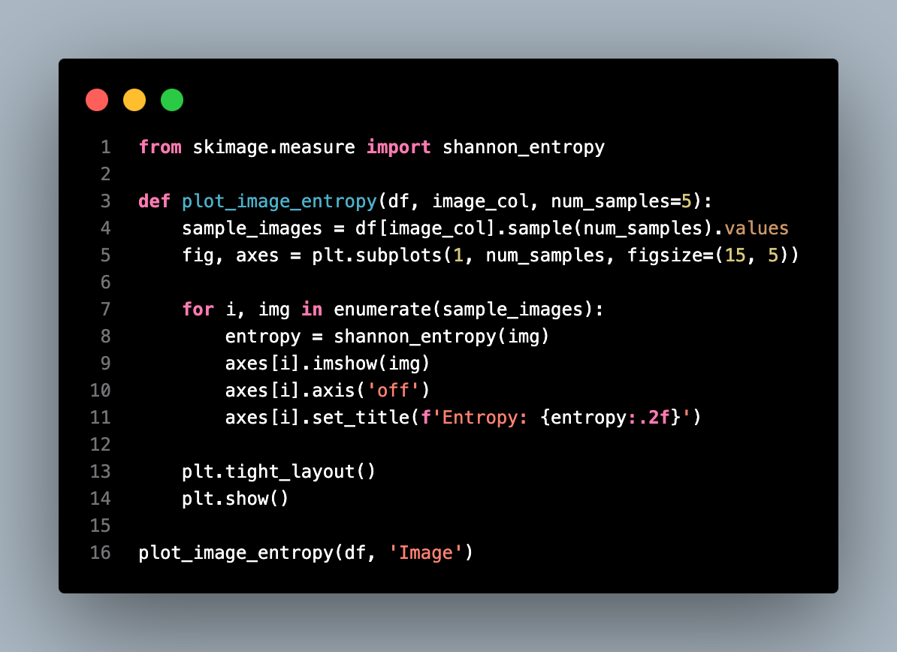

The `plot_image_entropy()` function computes entropy to measure the complexity of an image using the Shannon entropy. This function takes three inputs: the data frame, the image column, and the number of images.

First, we select the sample images from the data frame. For each image, we compute the Shannon entropy by utilizing the Shannon entropy computing function `skimage.measure.get Shannonentropy()`. This entropy value is to show the complexity of the image. The higher the values, the more complex or detailed the image is.

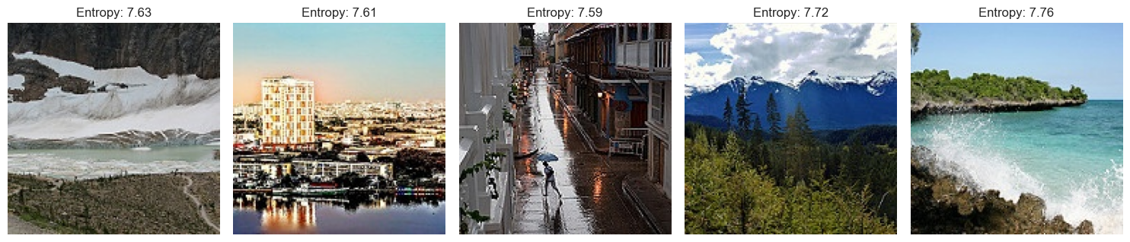

The sample images above show the entropy of the images. An entropy value around six is considered an optimal entropy value. All the image entropy shown is around 7.6, meaning that the images are not highly repeated and the dataset has high variability, which is good for model training.

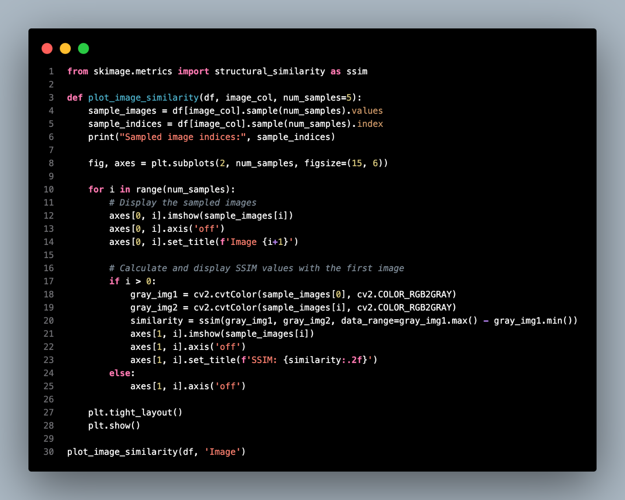

The plot_image_similarity() function calculates the image similarity of a set of sample images based on the Structural Similarity Index. The purpose is to quantize the similarity level between the second image and the first image in SSIM, where the SSIM ranges from -1 to 1, where 1 is the highest similarity.

The function samples several images from the data frame. Then, display the sampled images in 2xN dim. The sampled images are put in the first row. The second row consists of the SSIM index between the first picture and the others, indicating how structurally similar the other pictures are to the first picture.

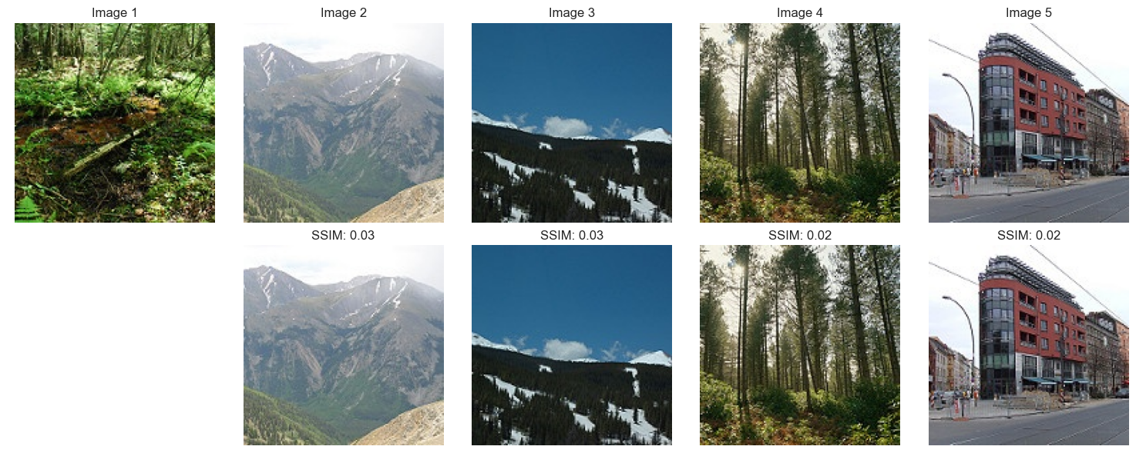

The sample images above show the SSIM similarity of the images, all the SSIM values are around 0.02 to 0.03, indicating that the images have no high similarity. This means that the variability of the dataset is enough for the model training.

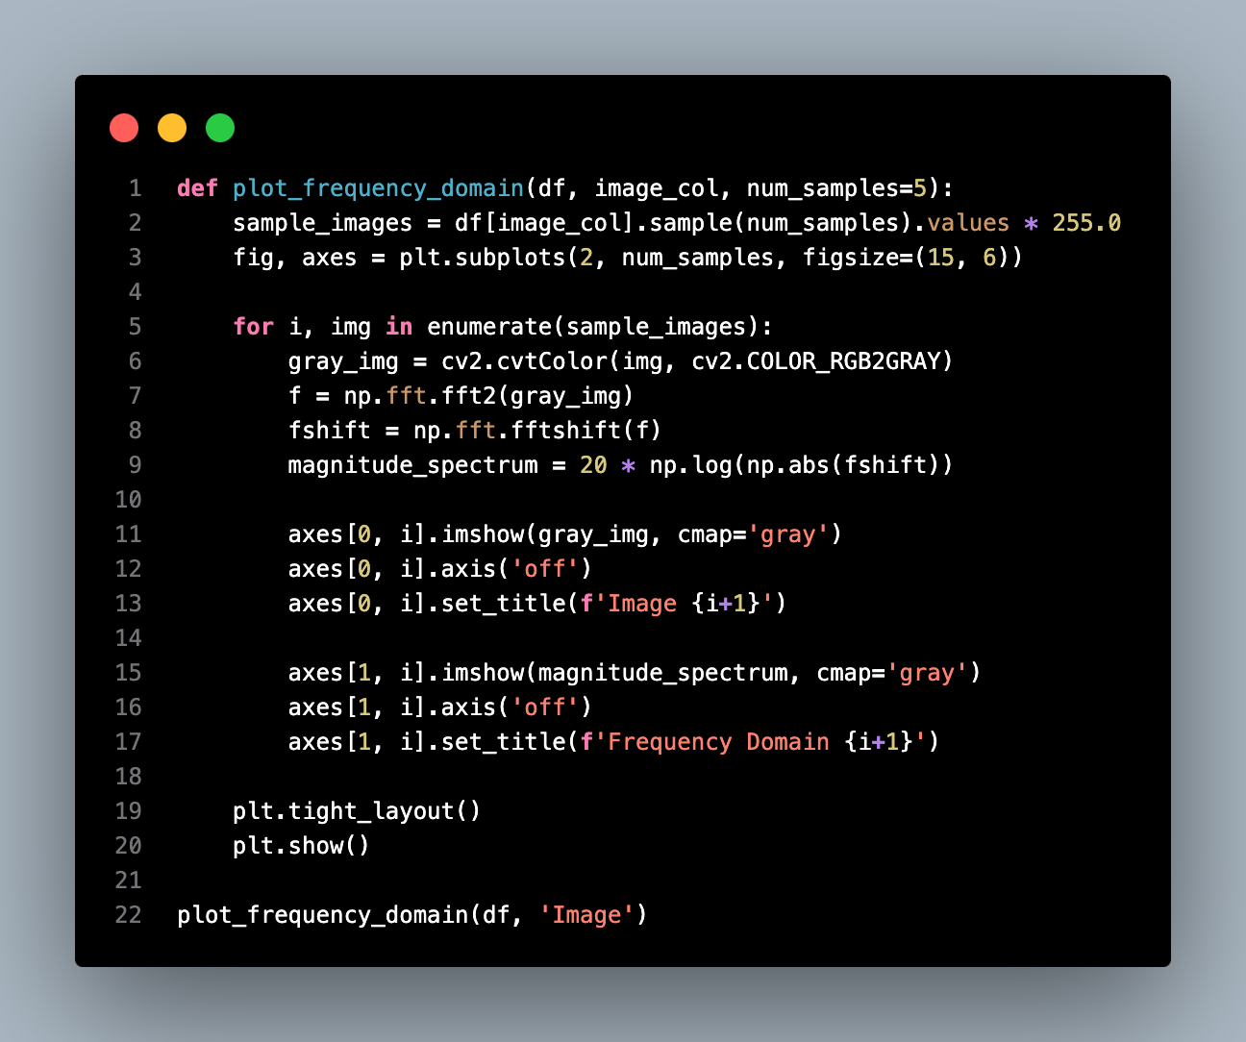

The ‘plot_frequency_domain()’ function uses the Fourier Transform mathematical method to determine the frequency components of an image.

This function first randomly chooses the sample images. Each image will be covered in grayscale, which makes the analysis simpler. Next, it uses the 2D Discrete Fourier Transform to transfer the grayscale image into the frequency space, which demonstrates the frequencies of the image. The Fourier Transform shift translates the low-frequency coefficients to be located at the center of the image for visualization purposes. The magnitude spectrum is then computed and shown in the format of a logarithmic scale for increased visibility.

The function first displays the first row of subplots containing the original grayscale image and, in the second row, the corresponding frequency domain or the magnitude spectrum. This analysis assists in uncovering patterns, textures, or recurring structures that would not be clearly discerned through spatial domain analysis.

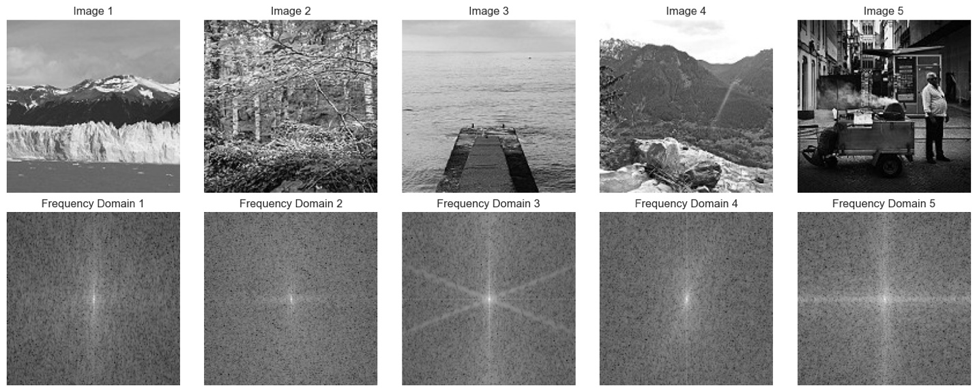

The top row is the original images, while the bottom row is the frequency domain representations that are received with the use of the Fourier Transform. This transformation divvies out the spatial information into the frequency components. The center bright spot in these images indicates the low-frequency features. These correspond to the overall shape and smooth regions of the image.

Meanwhile, the high-frequency features are the edges of the frequency spectrum. It represents rapid changes, edges, and fine details in the image. Furthermore, the symmetry is seen in the images in the frequency domain. The symmetry can plot out the mirrored areas in the images to check for redundant patterns in images.

### Data Saving

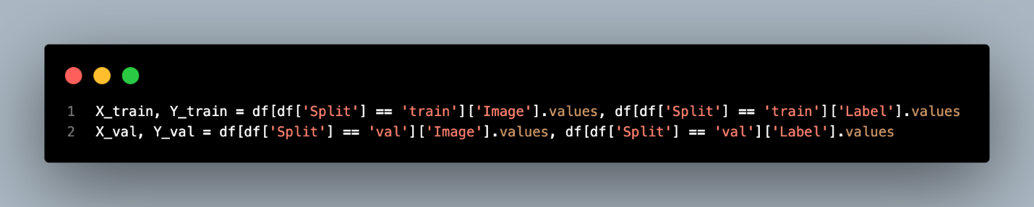

At the end of the preprocessing and EDA, we will need to save the data for further use. The code above splits the data according to the split label given.

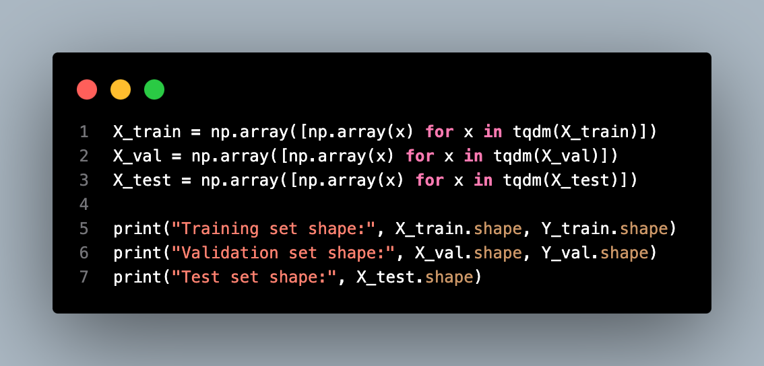

After that, we load the NumPy array of the images and check the shape of each dataset.

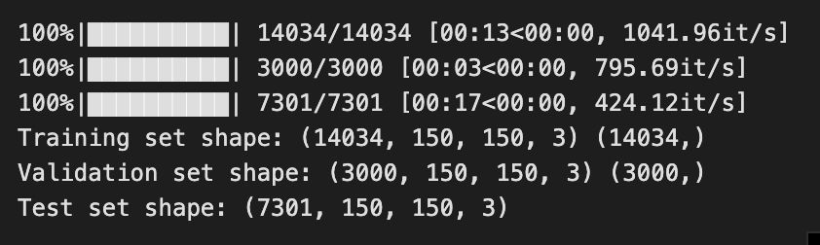

For training, validation, and testing datasets, we have 14034, 3000, and 7301 samples, respectively.

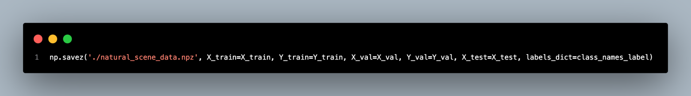

The last step is to save the train, validation, and test dataset into an npz file with the responding encoded label.

# Part 2

## Model Building Preparation

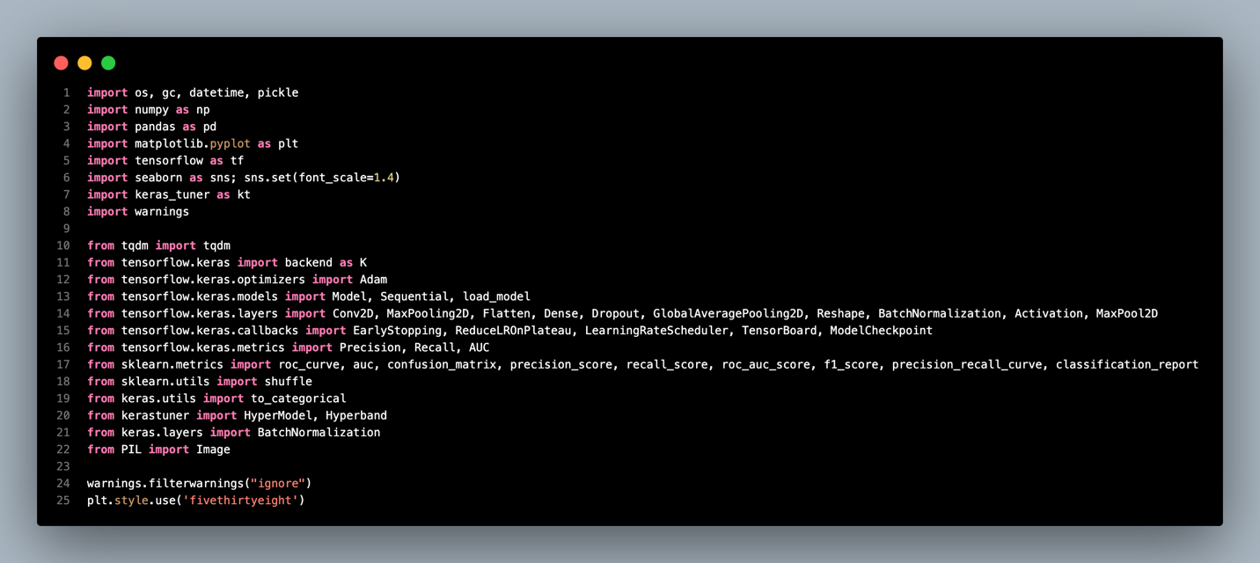

For the preparation of the model-building phase, we have imported multiple libraries, including NumPy, pandas, Matpotlib, TensorFlow, seaborn, Keras, sci-kit learn, tqdm, and PIL.

Most of the essential functions for model building like Conv2D, Dense, Dropout, etc. are from TensorFlow. On the other hand, we also need Seaborn and Matplotlib for graph plotting while NumPy and pandas are used for the data loading.

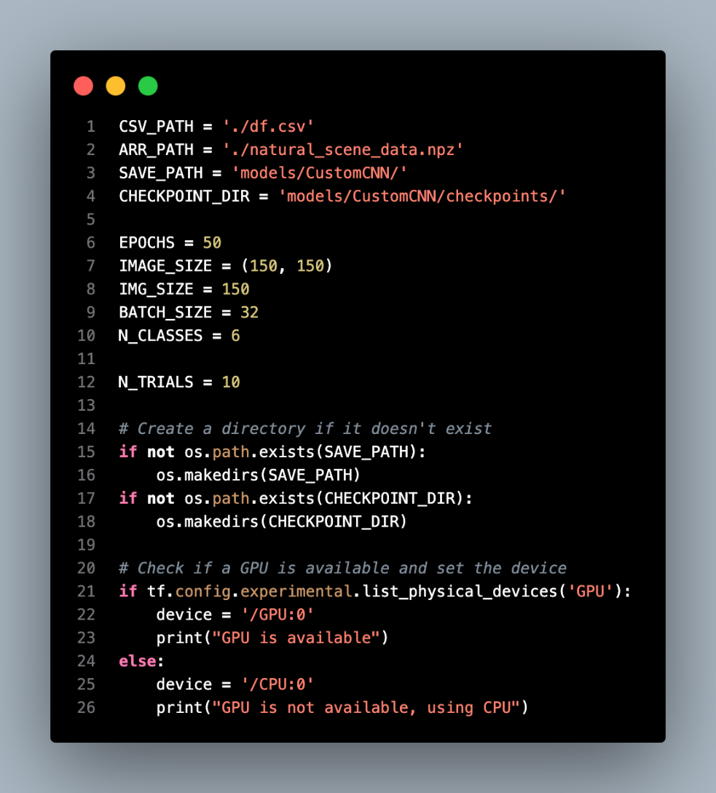

After importing libraries, we declare some variables for the model-building settings, namely data path, saving path, epochs, batch size, image size, number of classes, and hyperparameter tuning trials. Following, we ensure the model saving path is available and determine the device that will be used for the model training, either GPU or CPU.

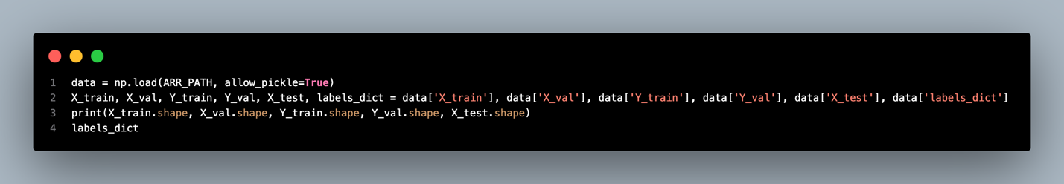

The next step is to load the data according to the data split. After loading, we will check the size of the data to see if it is correct.

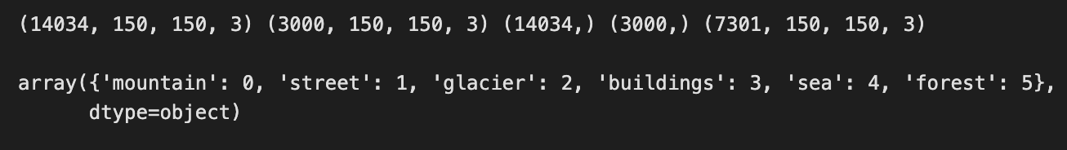

The number of samples for training, validation, and testing is the same as the time we save it. Meanwhile, according to the labels dictionary, we have six classes in the dataset.

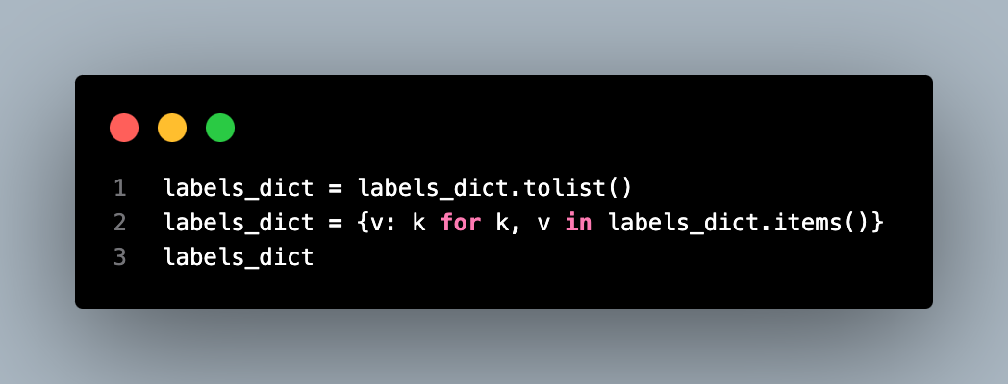

In order to decode the predicted labels, we invert the labels and their encoded numbers from the labels dictionary. Below is the result of the inverted labels dictionary.

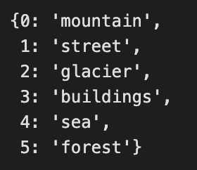 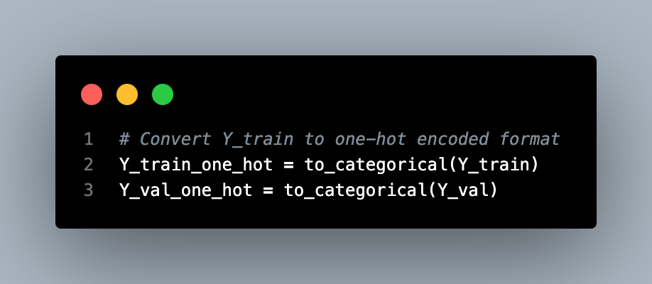

As our model training will be using categorical cross-entropy loss as an indicator later, here we will need to one-hot encode the Y_train and Y_val (e.g., from 2 to [0,0,1,0,0,0]).

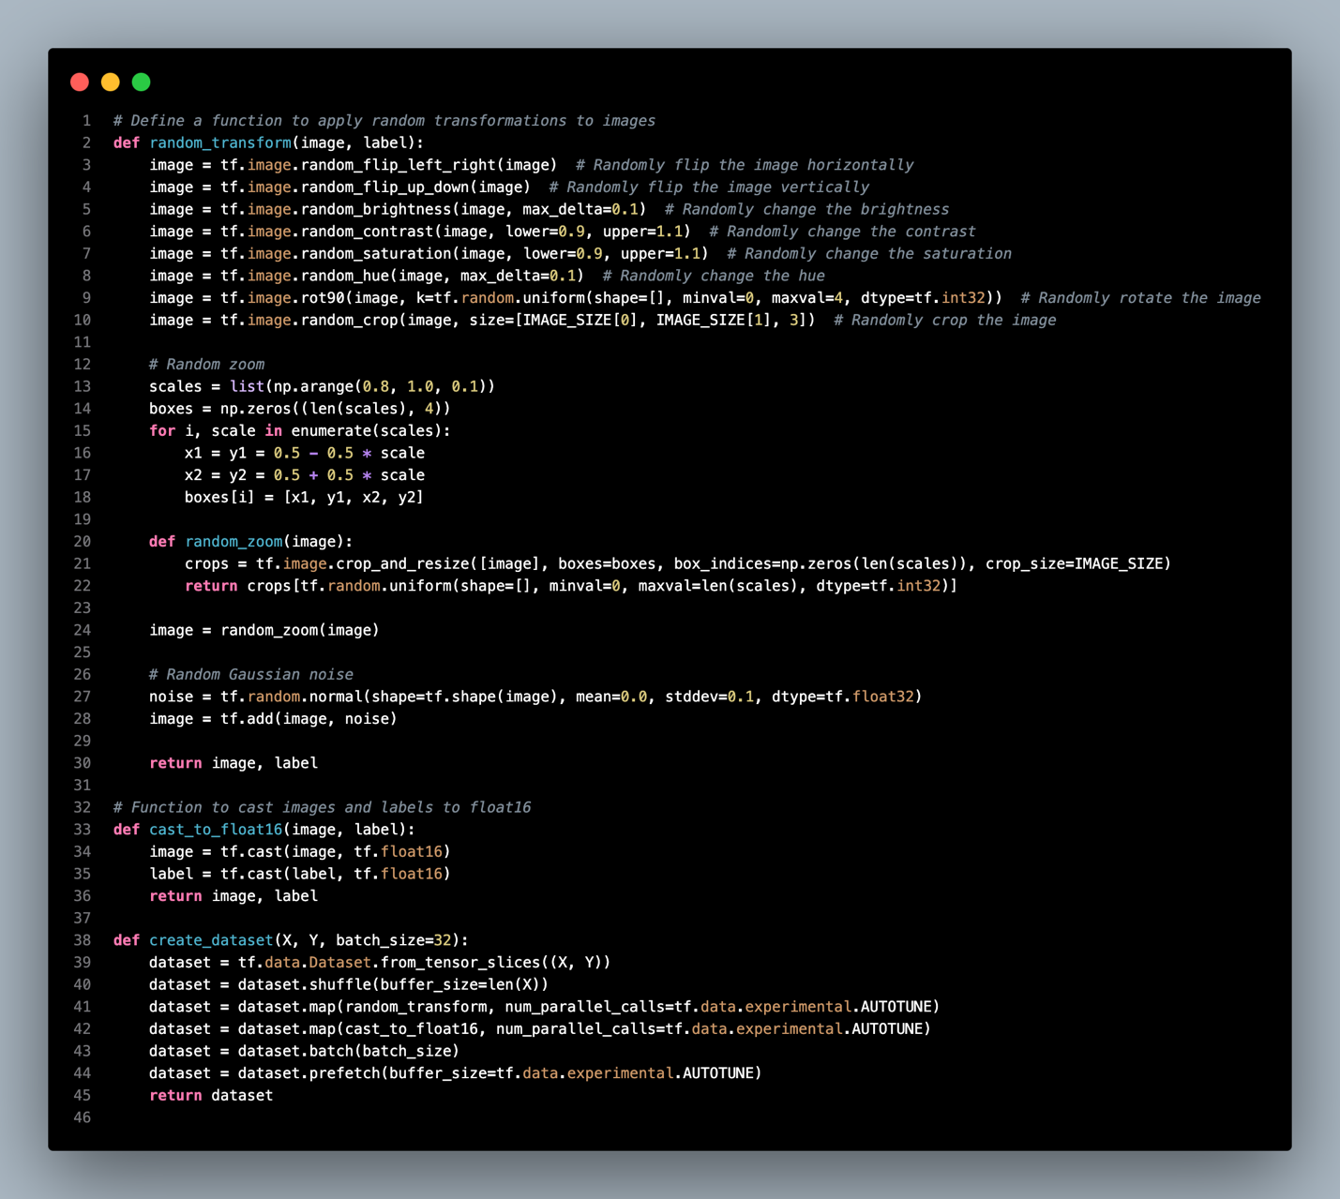

Then, we need to define the code for data augmentation and prepare image data for the model building. The main function random_transform() is to perform several random on-fly augmentations to the input pictures. This is to better increase the generalization of the model with a variety of transformations to the training data, including horizontal and vertical flips, changes in brightness, contrast, saturation and hue, rotation, cropping, etc. These augmentations are randomized.

`Cast_to_float16()` is to cast both our image and labels to the `float16` data type. This is for conserving memory and improving the calculation speed, especially for large datasets where the image data’s quantitative accuracy might be lower than the actual value.

The `create_dataset(X, Y, batch_size=32)` function wraps all together by using the image and label arrays and converting them into a TensorFlow’ tf. data.Dataset’. This function also randomly permutates the data so that in a given batch, many categories of images are included, appends random transformations and data type conversion, and then forms batches for training purposes. It also prefetched input data while the current batch is being processed so that data can be availed fast while training the models.

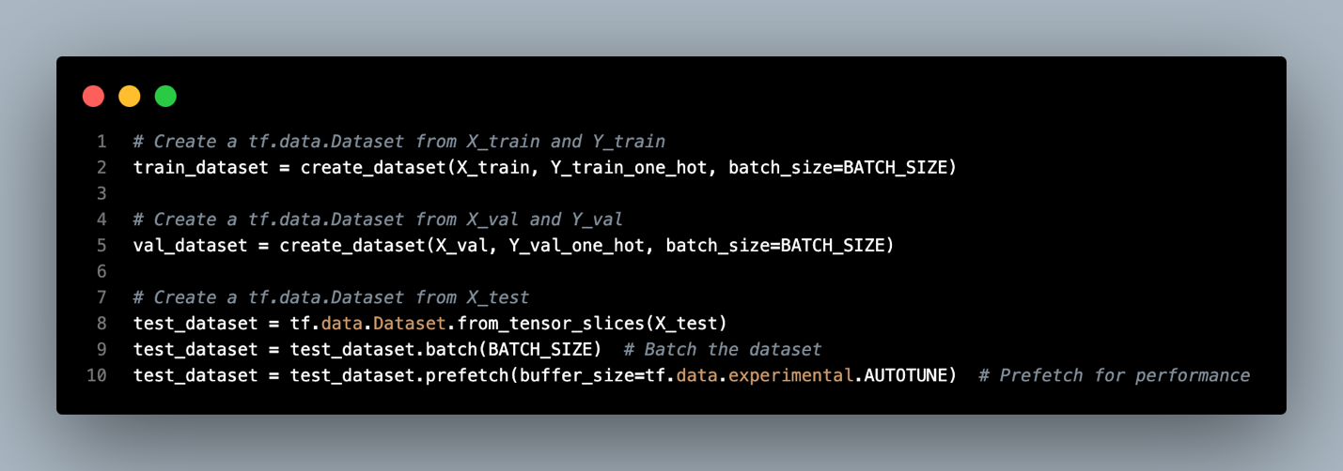

The code above uses the functions we mentioned above to load the three datasets for the training, validation, and testing phase later.

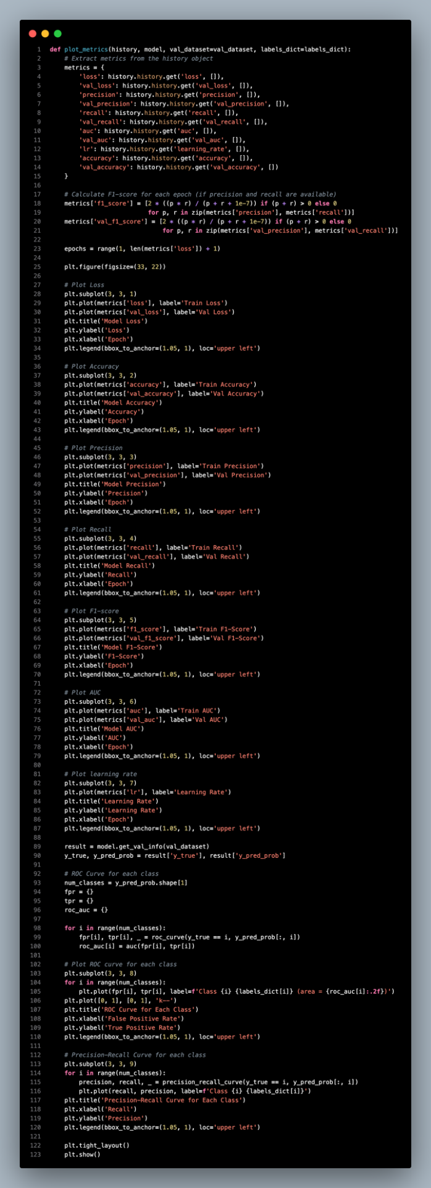 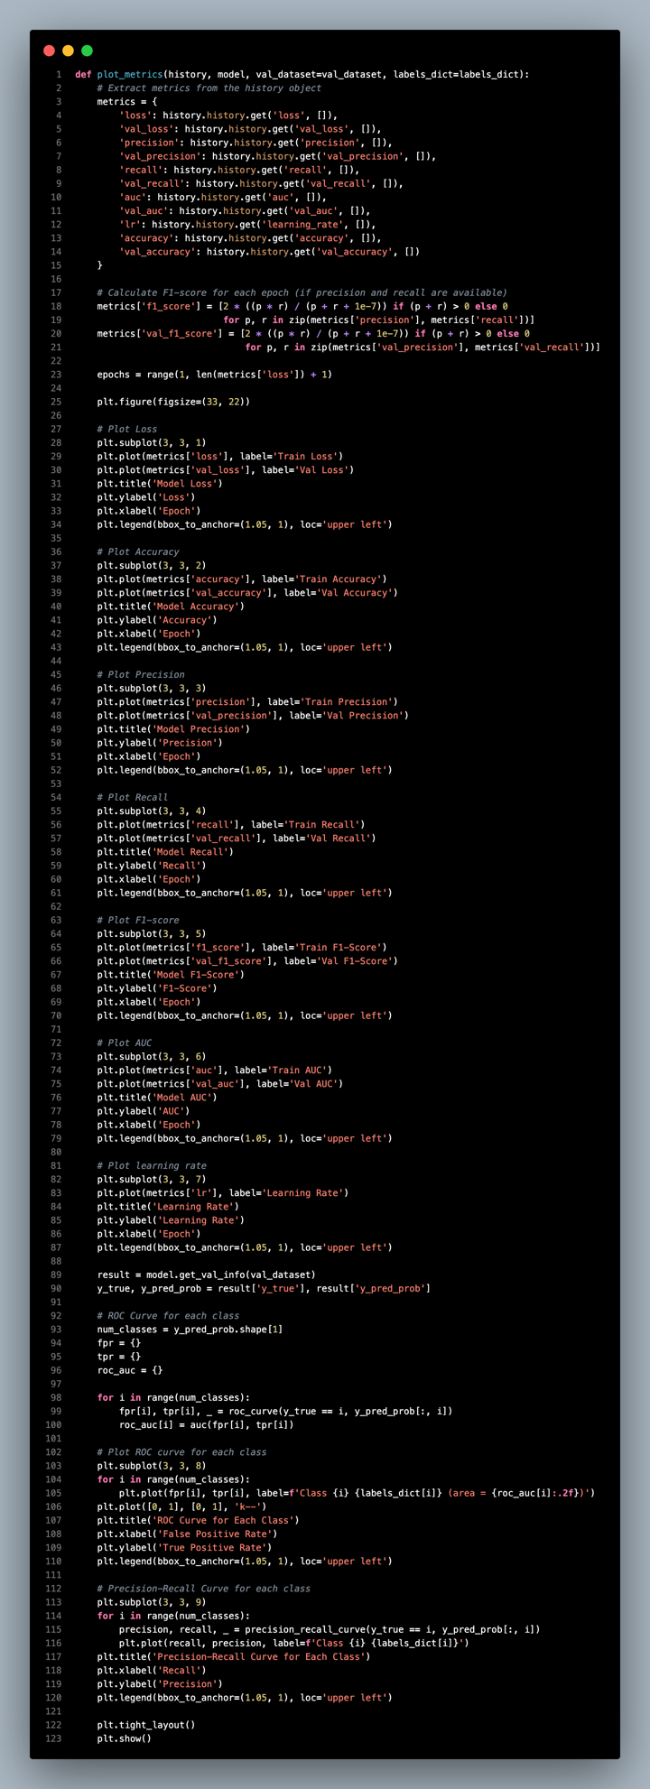

Next, we also define a function to help us visualize the training metrics after model building. The `plot_metrics()` function will take the history of the model building and extract the metrics for visualization. Meanwhile, we will also use the model and validation dataset to calculate the ROC curve and Precision-Recall curve of every class.

## Custom CNN Model (Neaw Aik Ka TP065116)

### Model Building

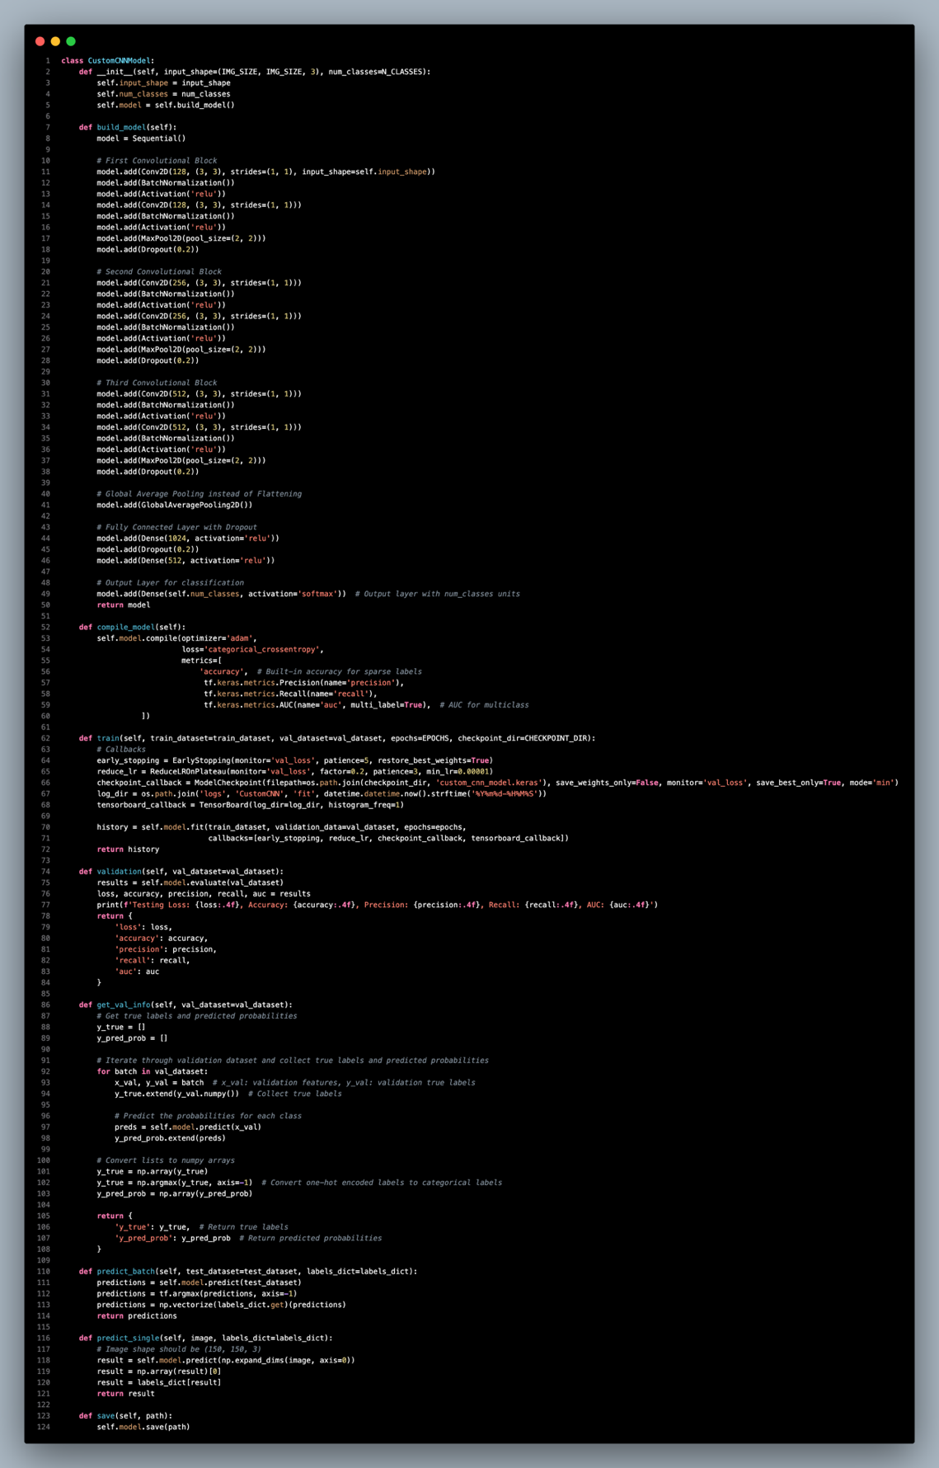

Here we will work on a CNN for image classification and build our own architecture from scratch. The model first starts a structure by making a class of `CustomCNNModel` where we mention the input shape and the number of output classes. These parameters enable us to tune the connectionist network depending on the size of images and the number of categories of images in our specific dataset.

We construct the architectures of the model in the `build_model` method and the network consists of multiple convolutional blocks. Within each block, two convolutional layers are followed by batch normalization and ReLU activation. Max pooling is also used to reduce the image sizes. In addition, dropout is also used to minimize the over-fitting. This process is repeated over three blocks with the number of filters for each 128, 256, and 512.

Subsequently, we employ a Global Average Pooling layer to downsample the features while retaining significant spatial characteristics, followed by a dense layer of 1024 neurons and another dense layer of 512 neurons. Last, we include a dense layer with `num_classes` neurons and use the softmax nonlinearity to get the class probabilities.

To compile the model, we define the `compile_model` function which utilizes the Adam optimizer and the categorical cross-entropy loss that is suitable for multi-class classification. The model will record accuracy, precision, recall, and the AUC (Area Under Curve) to assess the model during the training and validation.

For training, the `train` method comprises early stopping, learning rate reduction, and checkpoint. We also employ TensorBoard as the visualization tool that helps track the training process too.

Upon building the training model, we may use the `validation` function to compare loss, accuracy, precision, recall, and AUC on the validation data set. This assists in helping us determine how well the model fits general data that are not in the training dataset.

To look into the predictions further, there is a method `get_val_info` through which one can obtain true labels and probabilities of data from the validation set. This function may be used if a detailed evaluation report has to be shown or for a special type of visualization such as the confusion matrix.

For predictions, we provide two methods: One is for processing entire batches of test data and another one for class prediction of a single image, namely `predict_batch` and `predict_single`.

Last but not least, we have the function to save the model which will enable us to later use the trained model during other phases such as deploying the model for prediction.

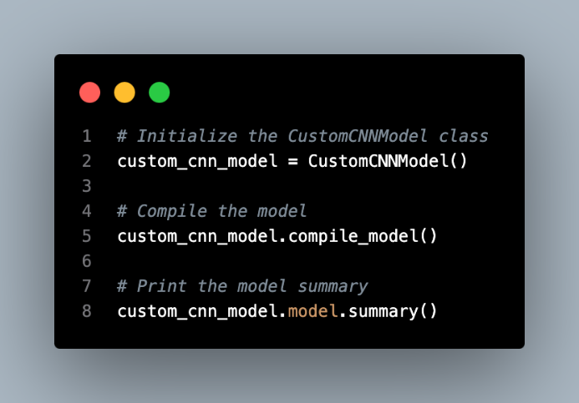

Once we define the model architecture class, we proceed to call the model and compile it. The figure below shows the summary of our custom CNN model architecture.

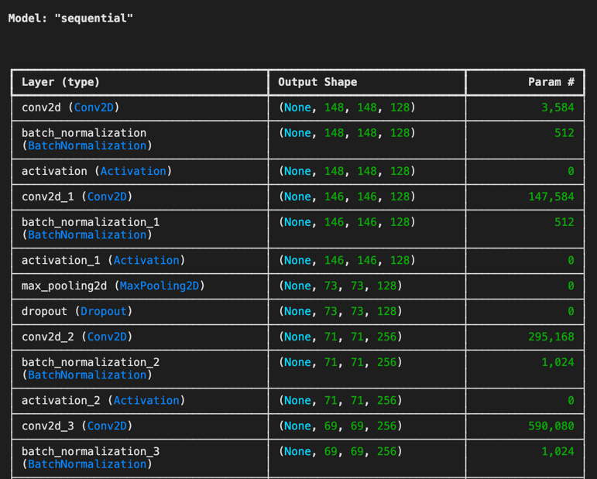

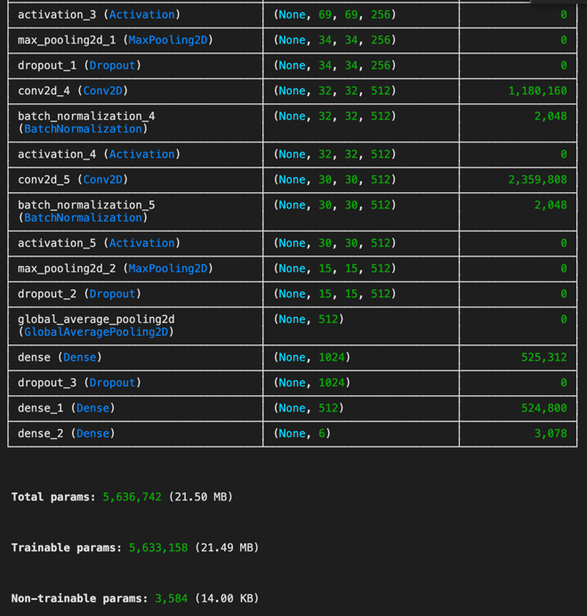

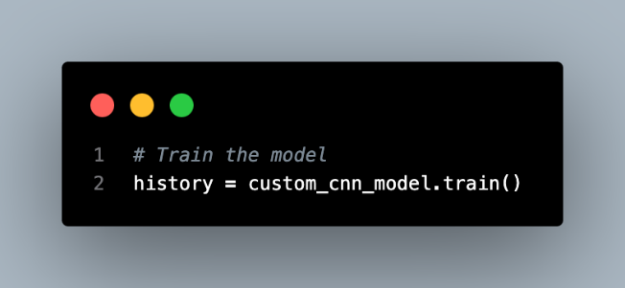

After this, we can start to train the custom CNN model. Here, we train the model with a maximum of 50 epochs, five early stopping rounds, and a minimum learning rate of 1x10-6.

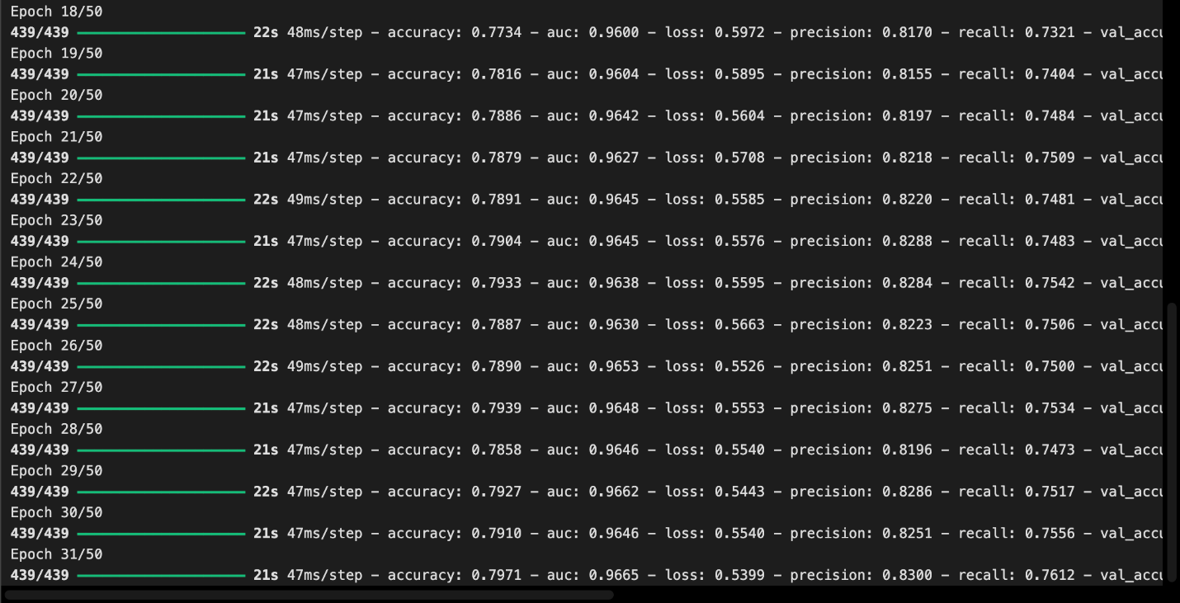

The training stops at the 31st epoch with the best result of:

**Training:** accuracy: 0.7971 - auc: 0.9665 - loss: 0.5399 - precision: 0.8300 - recall: 0.7612

**Validation:** accuracy: 0.7987 - auc: 0.9673 - loss: 0.5366 - precision: 0.8312 - recall: 0.7663

learning_rate: 1.0000e-05

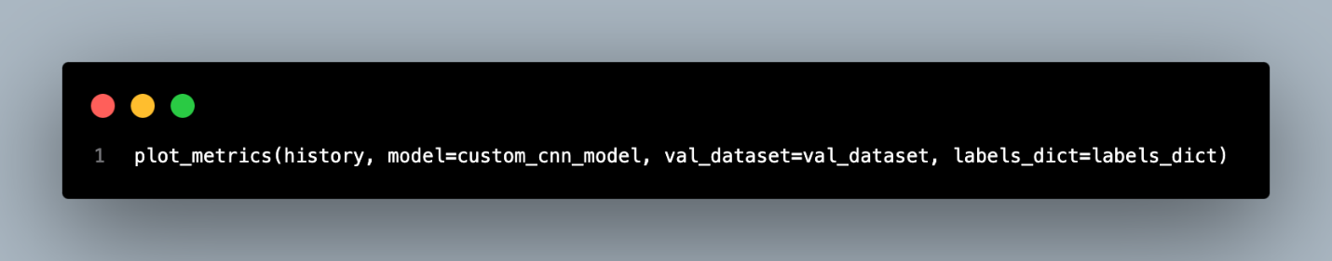

The next step is to plot out the training metrics for visualization using the `plot_metrics()` function specified above.

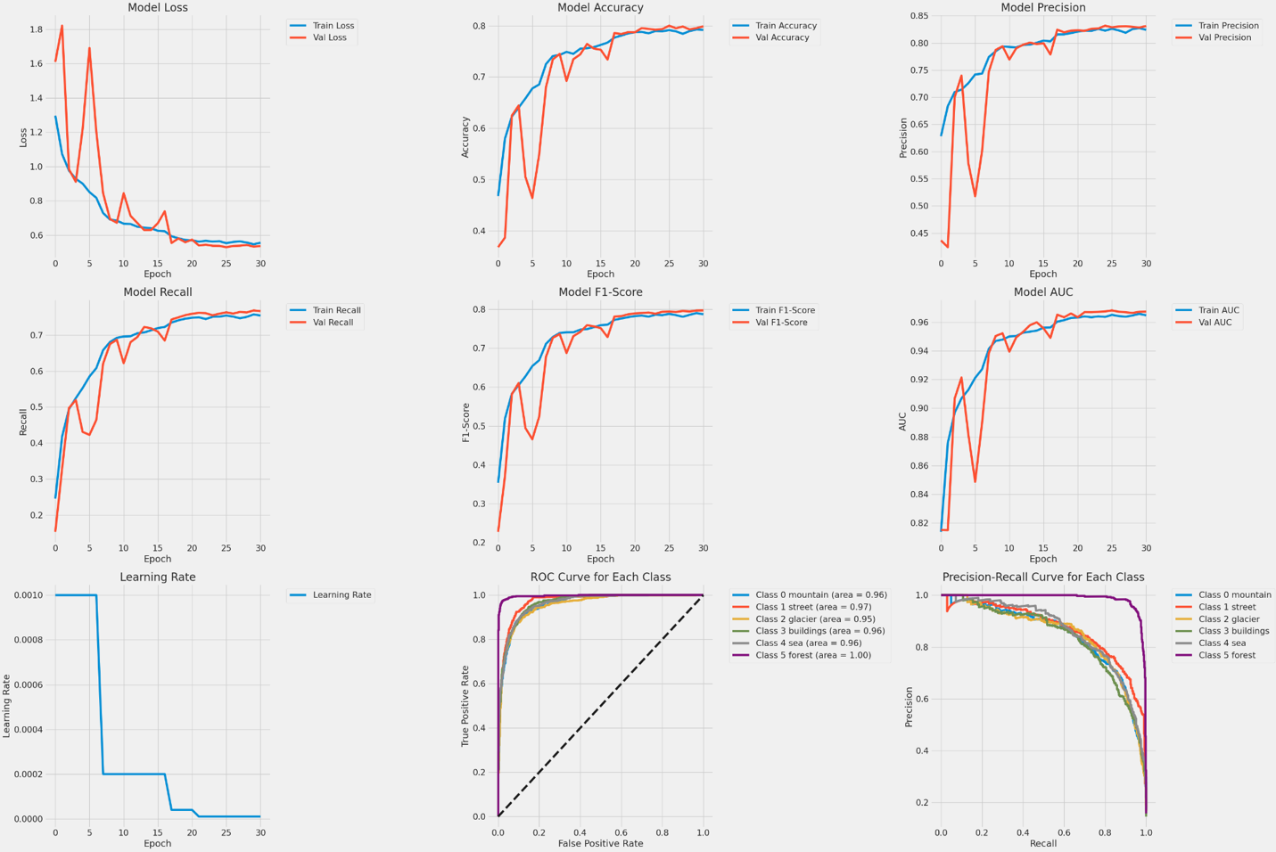

Our designed CNN model seems to perform well across various metrics sets, meaning it can be reliable and efficient.

During the training, the training and the validation loss reduced gradually with each step. This shows that the model is training step by step from the training data. As a result, losses approach zero and there is no huge divergence between the training and validation loss, hence overfitting is minimized. This also means that the model has a good generalization to unseen data that were not part of the training data.

When training was carried out, we observed improvement in both training as well as validation accuracy. These metrics fluctuated at the earlier epochs but started to stabilize at the later epochs, which proves that our model has successfully developed the capability to learn the patterns existing in the training data as well as validate the patterns in the validation data. The continuous increment in the accuracy score shows the reliability of the model for our image classification task.

Our custom CNN model also obtained higher precision, recall as well as F1 scores both in training and validation. These metrics are crucial because it means its classification performance is at the right balance of false positives and false negatives. The model was fairly good on these parameters and exhibited a stable classification performance.

The AUC values above 0.96 in both datasets prove that the model is able to properly define distinct features for various classes. This is particularly important in multiclass classification problems, our model is able to make the correct distinctions. The AUC values themselves being consistently high for epochs also indicate that the classification ability of the model does not deteriorate in consecutive epochs of training.

We also implemented a learning rate scheduler that progressively decreased the learning rate during the training process. This technique was a great way to improve the learning of the model whereby the training was made more stable as it progressed and went on to converge. The idea of decreasing the learning rate gradually avoids overfitting over optimal points within the loss funnel hence providing better convergence. The learning rate scheduler of our custom CNN model gradually drops to zero at the 21st epoch.

The actual ROC curves for each class of the dataset indicated that the model had a good ability to classify between the two classes. Precision-recall curves of our model again demonstrated reasonable and balanced accuracy and are extremely useful in addressing the issue of Class Imbalance.

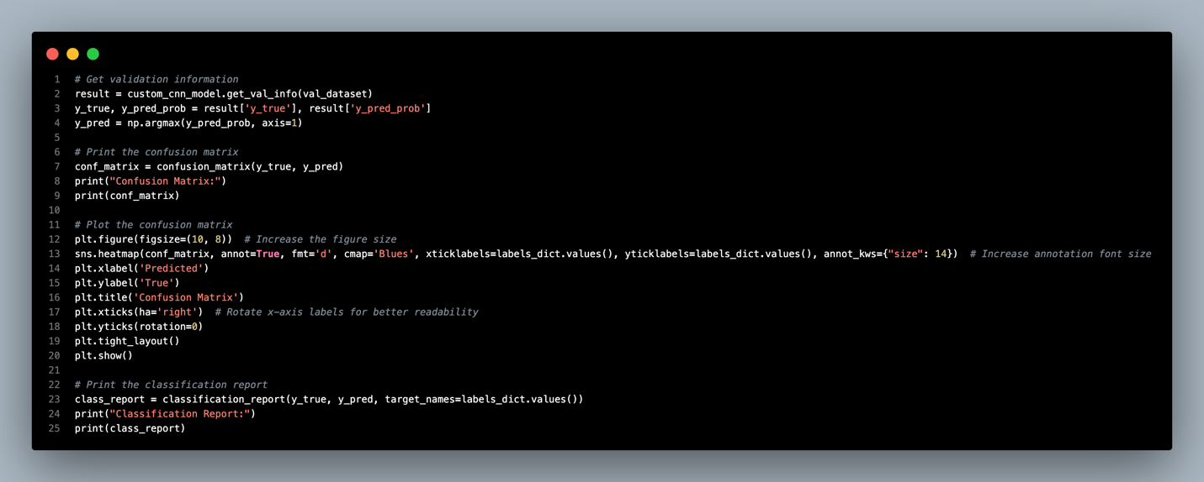

Next, we get the predicted labels (y_pred) and actual labels (y_true) of the model using `get_val_info()` function to plot the confusion matrix and the classification report of the model on validation data.

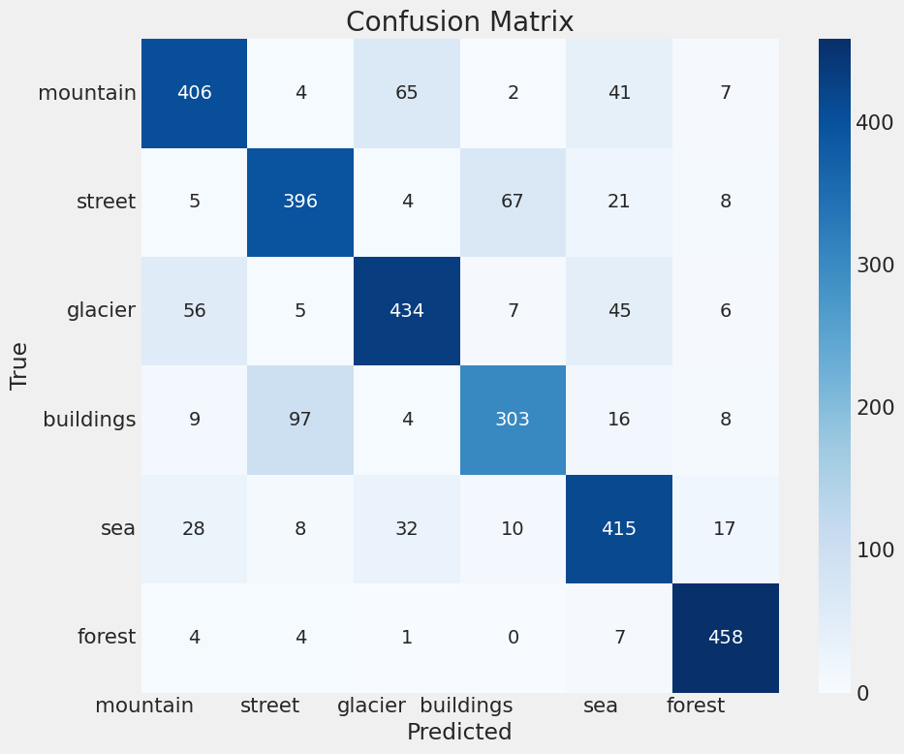

The confusion matrix result shows that our custom CNN model presents fairly accurate results. For the mountain class, the model is accurate giving out a true positive of 406 on 525 images but seems to have confusion with glaciers and sea, which are visually similar classes in the dataset.

In the street class, we have obtained 396 correct results in 501 and the model frequently misclassifies streets with buildings. This is understandable as often the streets depicted contain elements of urban construction, which complicates the differentiation.

For glaciers, we identified the correct class for 434 out of the 553 images. However, several spots are classified as mountains, meaning that the model has some issues in differentiating the two classes. The same is observed with buildings; the recognizer is successful with 303 out of 437 images, but there is significant misclassification with the street images.

The sea category is fairly well projected with 415 of 510 images classified correctly, but glaciers and mountains can sometimes confuse the model. Finally, for forests, 458 of 474 images are classified as forests, showing that our model is good at identifying the forests.

In conclusion, our model gives satisfactory results; however, more work can be done on fine-tuning the model to help it to get finer distinctions between closely related types of objects like mountains and glaciers or between streets and buildings.

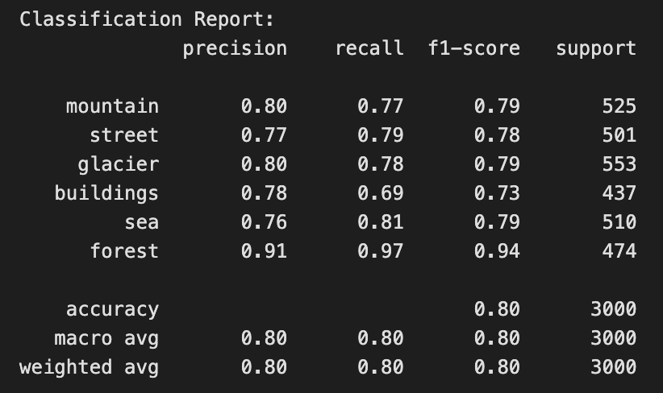

The classification report shows the value of precision, recall, and f1-score for each class. The CNN model gets an 80% accuracy with the same value on the macro average and weighted average of precision, recall, and f1-score.

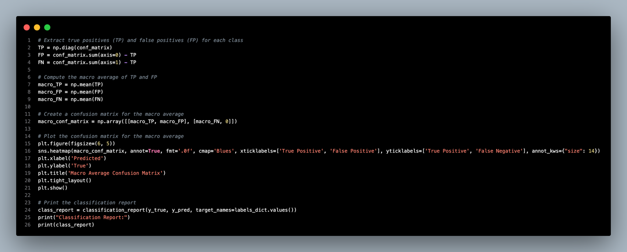

Additionally, we are going to plot out the macro confusion matrix of the model validation result.

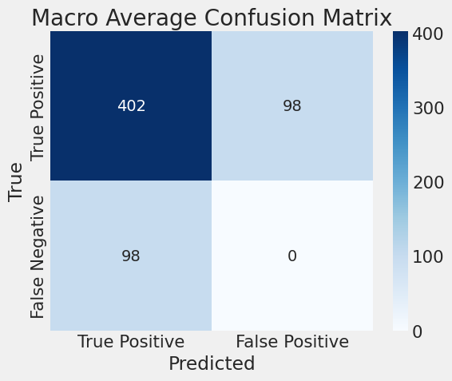

According to the macro confusion matrix, as this is a multiclassification model, hence there are no false positive classes. The 402 samples classified in the true positive class further show that our custom CNN model is successfully trained to solve our image classification problem.

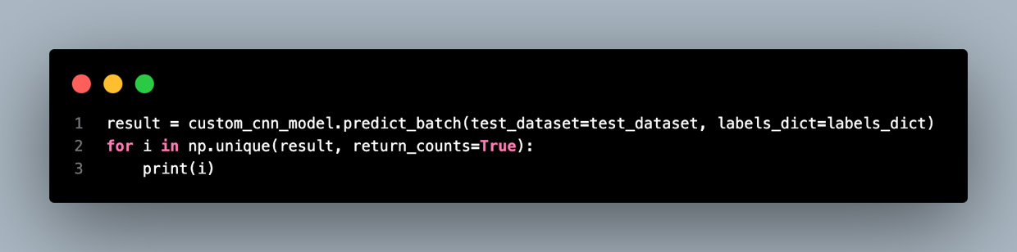

Then, we proceed to use our CNN model in testing on the testing dataset and print out the predicted samples on each class.

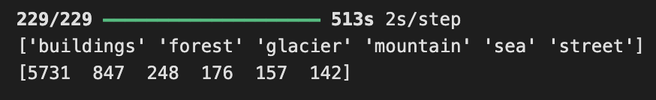

The result shows that the model works well in the testing phase for predicting the whole batch of the testing dataset using the `predict_batch()` function.

### Model Tuning

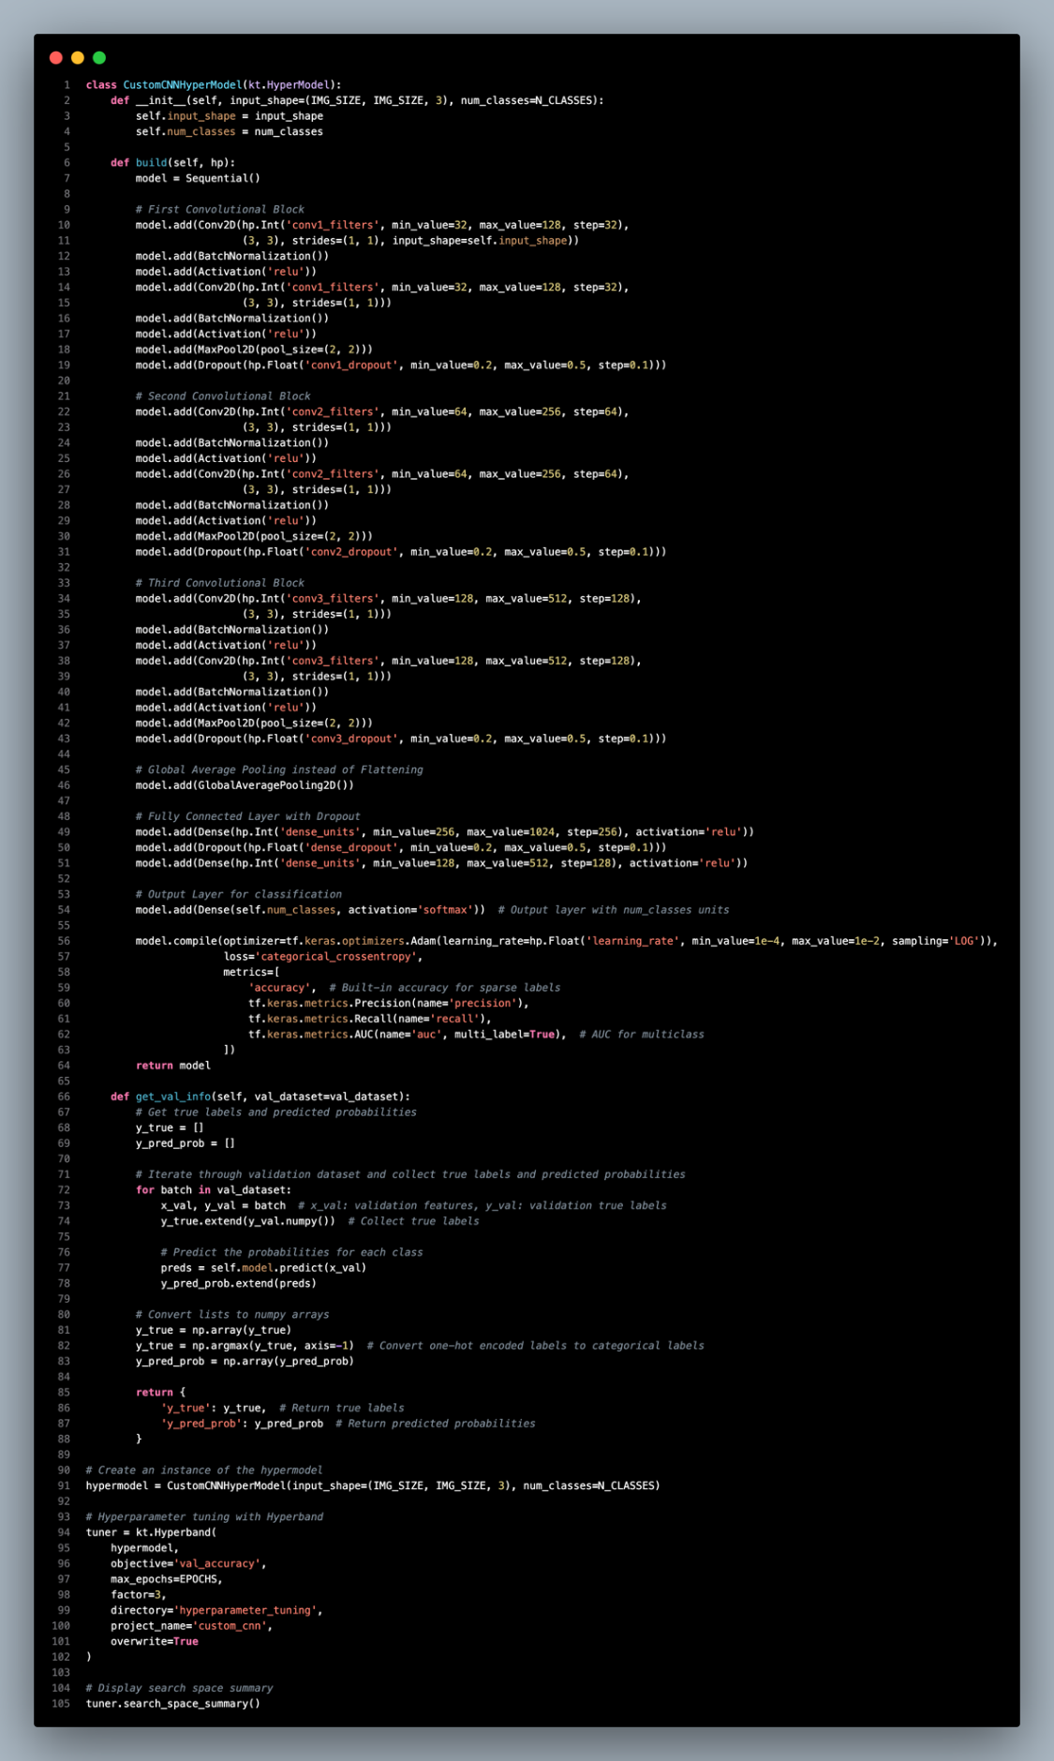

In hyperparameter tuning, we employ the same structure as the custom CNN model above but with several critical changes that allow hyperparameter optimization. The primary structure of the CNN remains the same with three spatial convolution blocks. However, instead of setting these parameters, we injected flexibility into several aspects of the architecture for optimal tuning.

For instance, the number of the filter in each convolutional layer. For the first convolutional block, the number of filters can be between 32 and 128, in the second and third blocks, the range of filters is set to run between 64 and 512. This helps the model to learn the right filter size at run time, therefore making it possible for the model to extract the best features for the model. Moreover, dropout rates within each block are also adjustable, which range between 0.2 to 0.5 dropout rates. Amending dropout allows to achieve better performance.

The output layer is still the softmax activation function suitable for the number of target classes. Furthermore, we do not manually set a learning rate but let it float within a range of 1e-4 to 1e-2, which makes it possible for the optimizer to adapt to the current model complexity and data distribution.

After defining the hypermodel architecture we use the Hyperband to efficiently search within the hyperparameter space. Hyperband controls the distribution of resources so that a weak model configuration is discovered and thrown out early while significantly more resources are dedicated to better models. This approach enables us to improve the speed of the best hyperparameter search.

Finally, to tune the hyperparameters, we call upon the ‘tuner.search_space_summary()’ function to show the summary of the search space we have set for the tuner. This summary makes sure that we can fully examine the whole range of options under consideration.

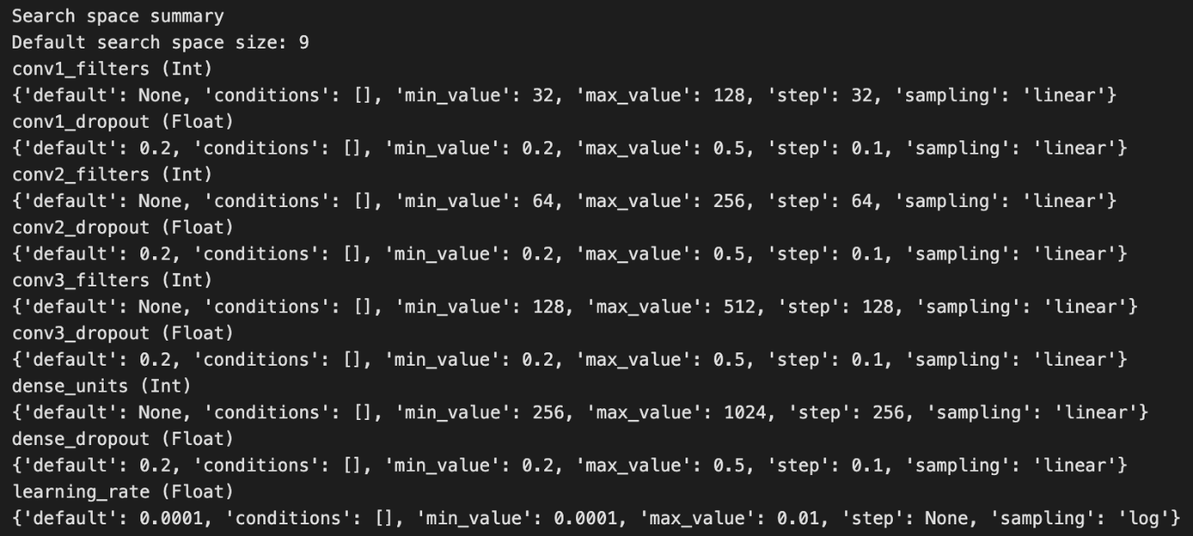

The search space summary above is provided by the hyperband according to the grid parameters we defined above.

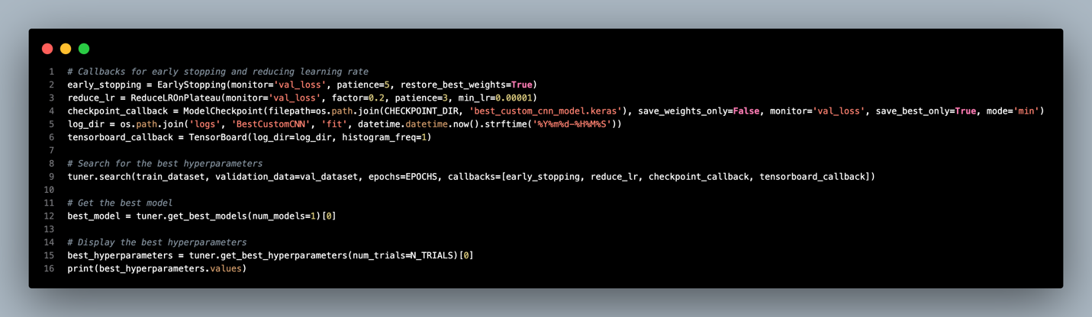

Then, we will start the hyperparameter tuning phase using the Keras tuner.

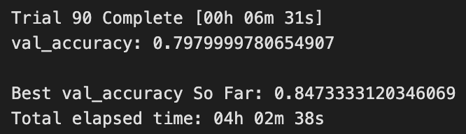

After 4 hours of hyperparameter tuning, we obtained the best model with a validation accuracy of 84.7%. The best hyperparameters calculated are:

|  |  |
| --- | --- |
| Hyperparameters | Value |
| conv1_filters | 96 |
| conv1_dropout | 0.2 |
| conv2_filters | 192 |
| conv2_dropout | 0.2 |
| conv3_filters | 256 |
| conv3_dropout | 0.4 |
| dense_units | 256 |
| dense_dropout | 0.30000000000000004 |
| learning_rate | 0.00030032086079758493 |
| tuner/epochs | 50 |
| tuner/initial_epoch | 17 |
| tuner/bracket | 3 |
| tuner/round | 3 |
| tuner/trial_id | ‘0047’ |

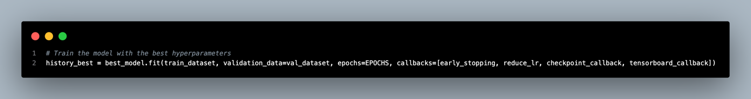

As we get the best hyperparameter values, we will retrain the custom CNN model with the best hyperparameter values.

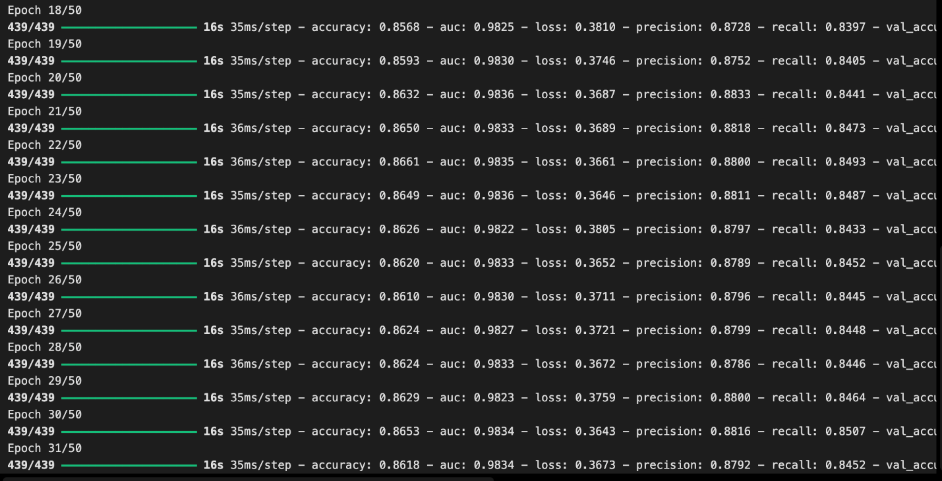

The model training then stops at the 31st epoch with the best result of:

**Training:** accuracy: 0.8618 - auc: 0.9834 - loss: 0.3673 - precision: 0.8792 - recall: 0.8452

**Validation:** accuracy: 0.8553 - auc: 0.9813 - loss: 0.3904 - precision: 0.8711 - recall: 0.8403

learning_rate: 1.0000e-05

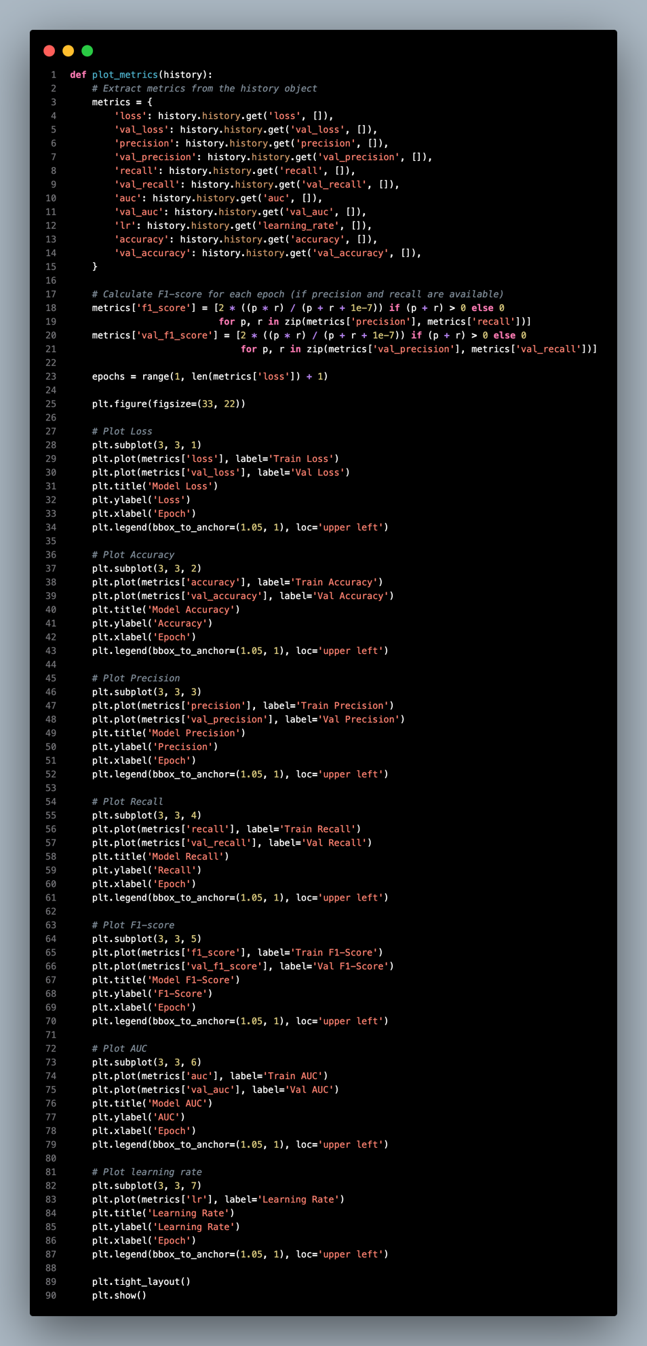

After that, we will need to define the new `plot_metrics()` function to plot the training and validation metrics.

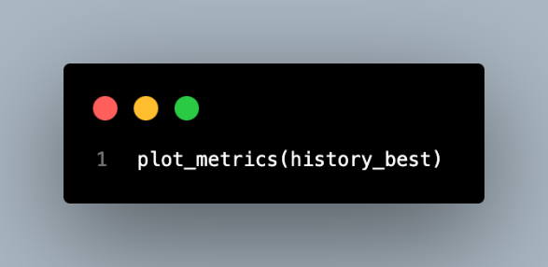

Following, we will plot out the metrics using the function defined with the best model trained.

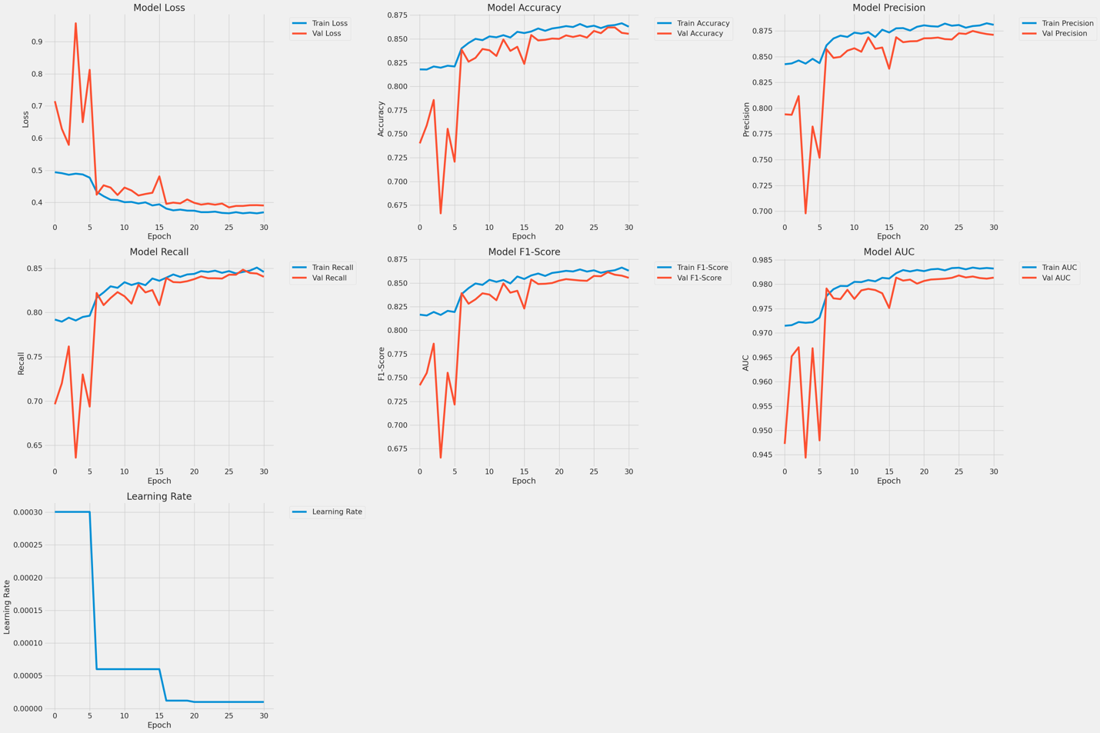

For hypermodel training, the model loss reduces gradually for both the training and validation datasets, though the validation has a slightly higher value than the training set at the 15th epoch but still has convergence, which does not show a sign of overfitting.

Accuracy increases progressively for both training and validation datasets; the difference between the two is very small, indicating that the learning algorithm is working well in training and validation. Precision and recall trends also show insignificant fluctuations after the first few epochs and still get a result above 0.85 at the end of training.

The F1 metric increases from 0.67 to 0.85; training and validation results are effectively similar, thus the balance of the model is obvious. The AUC is very high from the beginning, this implies that the model differentiates the classes well.

Last but not least, the learning rate is reduced effectively so that the convergence is fast in earlier epochs. Altogether, it is seen that the model has a good learning rate, is stable, and has good generalization ability in all metrics.

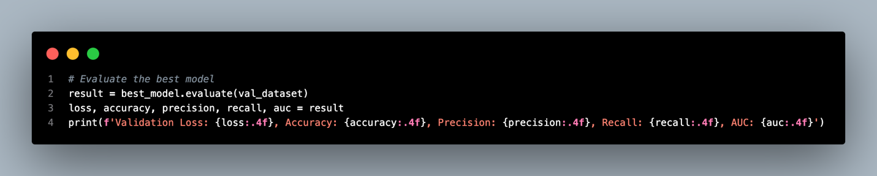

After the training of the best model, we evaluate it on the validation dataset again to get the value of loss, accuracy, precision, recall, and AUC.



The figure above is the result of the evaluation of the best model.

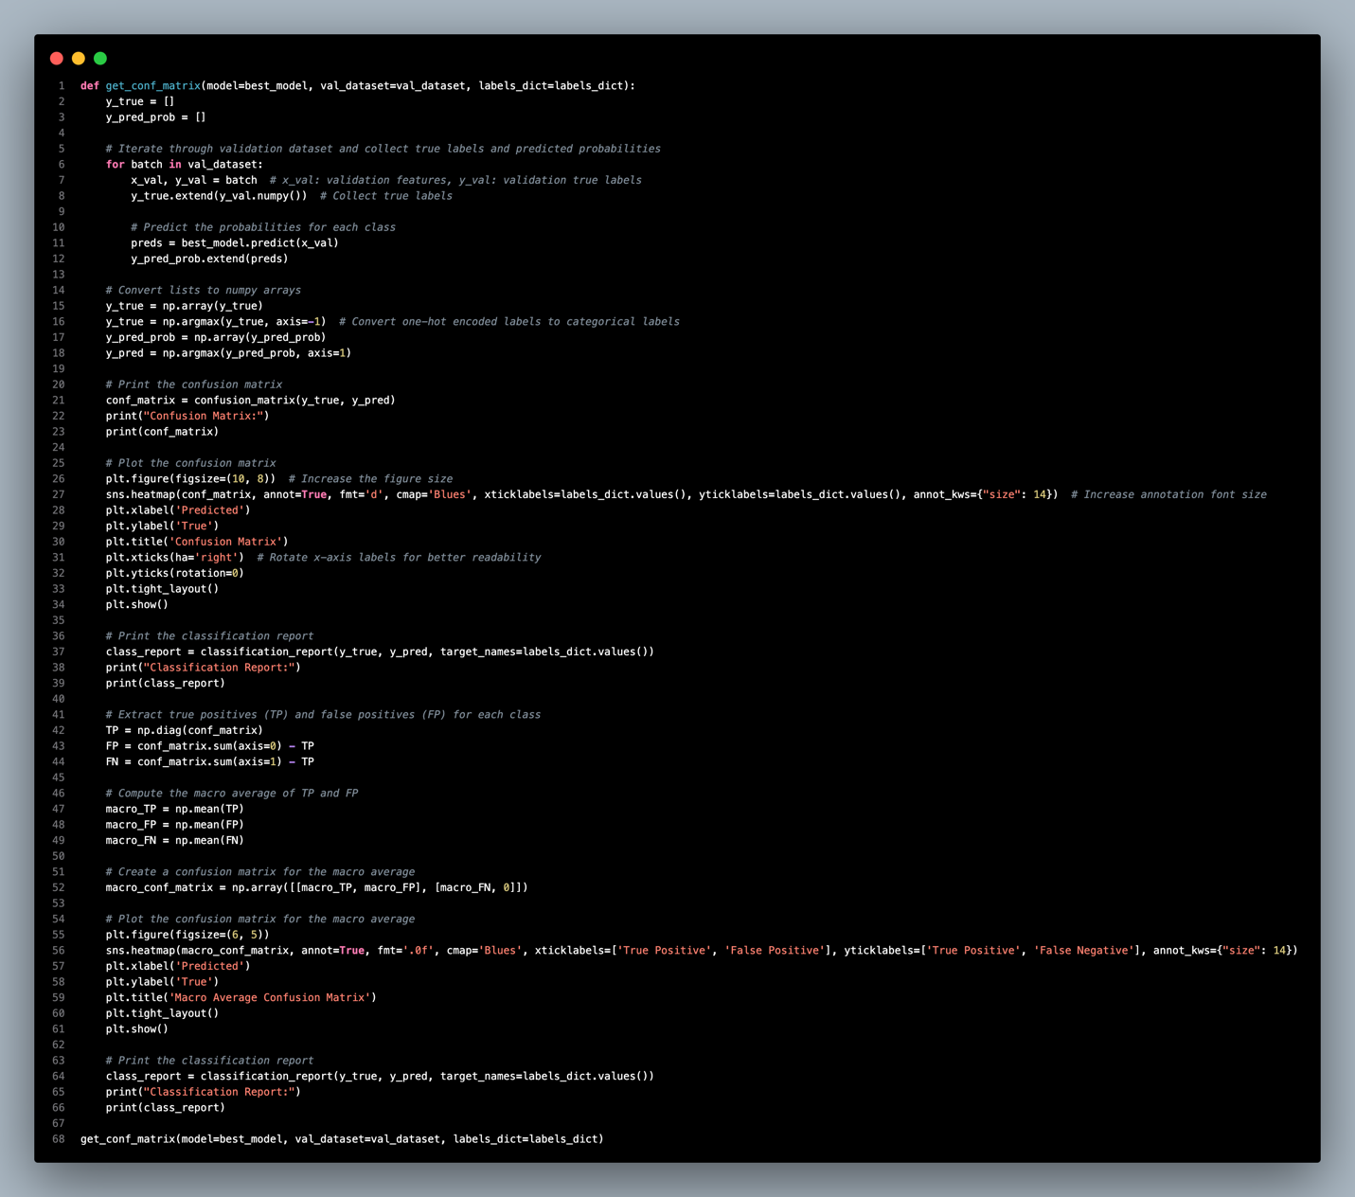

After that, we will have defined a function to plot the confusion matrix of the evaluation result. This `get_conf_matrix()` function will get the predicted labels and actual labels of the validation dataset, then decode it using the labels dictionary, visualize the result in the confusion matrix, and print out the classification report.

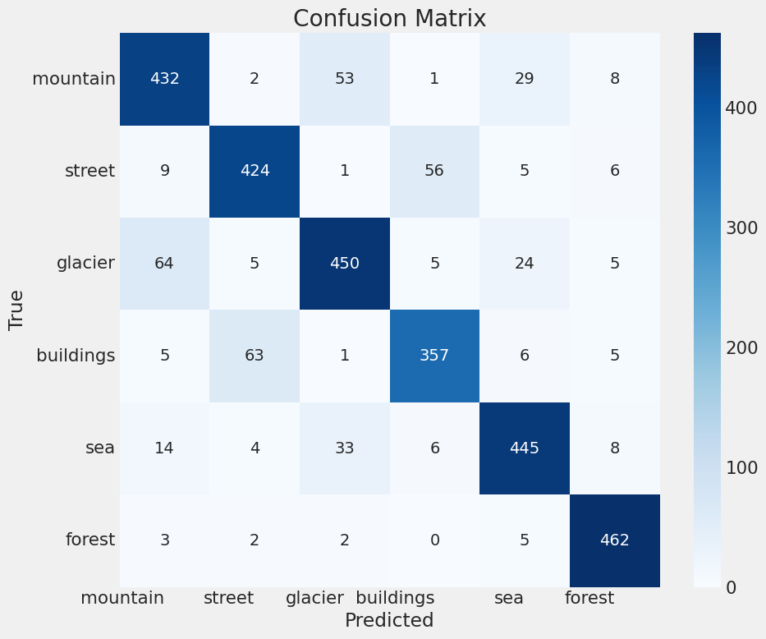

Our confusion matrix of the hyperparameter-tuned model shows the training improvement over the confusion matrix of our model. The most obvious change is the improvement in the diagonal cells, which is a sign of enhanced accuracy in the classification of classes. For example, the **mountain** class obtained 432 correct classifications, which is higher than the 406 in the training phase.

The **street** class also has increased performance, becoming 424 correct predictions compared to the previous. This improvement is accompanied by an increase in accuracy especially for the **buildings** and **sea** classes suggesting that the model is extremely refined to distinguish between these two categories.

For the **glacier** class, the number of correct predictions is 450. The **buildings** class also gets a notable improvement, it now contains 357 correct samples as opposed to 303 before, this shows that the accuracy has increased and the rate that errors made when predicting both **street** and **sea** instances has been minimized.

The **sea** class sustains a high performance with a more correct prediction of 445 and relatively fewer errors in determining **glaciers** and **buildings**. Last but not least, the **forest** class gets 462 correct predictions with minimal levels of misclassification.

In summary, the result reveals that our hypertuned model has better generalization capabilities and generates fewer errors in more classes while increasing correct classification for the majority of classes.

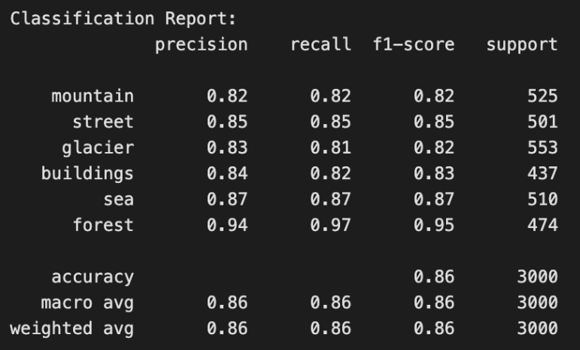

The figure above shows the classification report of the best model evaluation. Overall, the model has the best prediction ability on **forest** and **sea** classes, while other classes have a high precision, recall, and f1-score as well. The accuracy of the prediction is 86%, which is 6% higher than the base model.

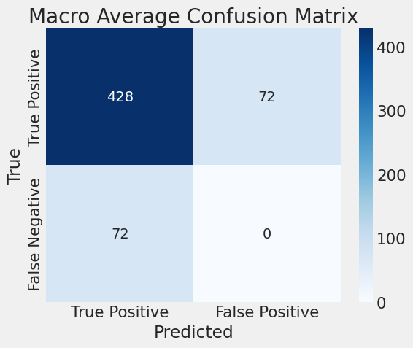

Then we also plot out the macro average confusion matrix, the true positive class has been increased from 402 to 428 here while false positive and false negative decreased.

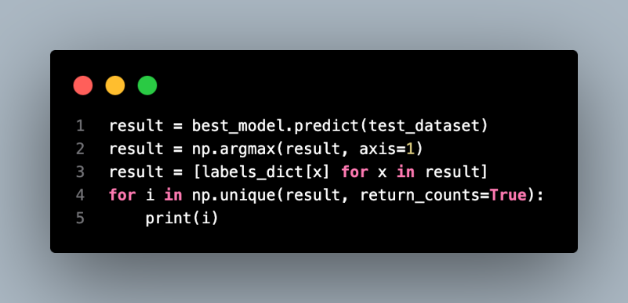

Following that, we still test the model using the testing dataset and print out the prediction result of the model.

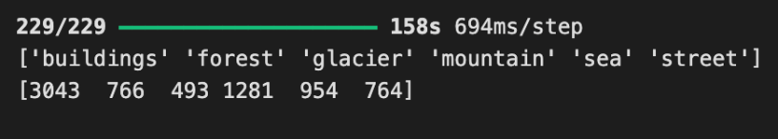

The figure above shows the prediction result distribution of the model on the testing dataset.

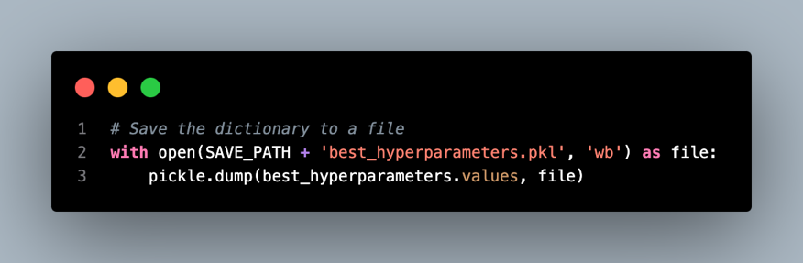

As a record, we save the best hyperparameter values of the model using pickle here.

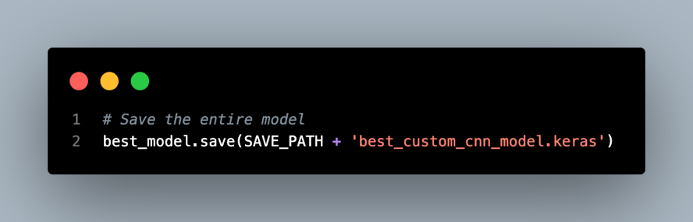

Then, we also save the best custom CNN model in the Keras format.

#### Model Error Analysis

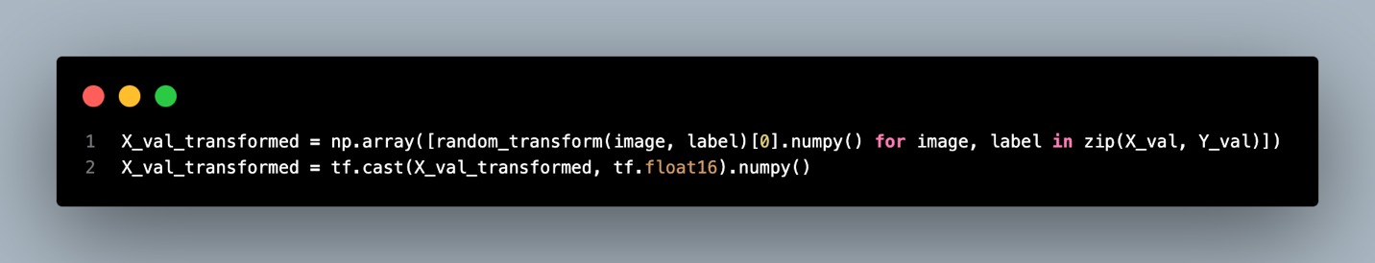

After saving the model, we are going to do an error analysis on the model’s prediction result. First of all, we will have to get the sample images from the validation dataset and do preprocessing on the data by doing random augmentation and converting the data format to `float16` like the preprocessing we have done above.

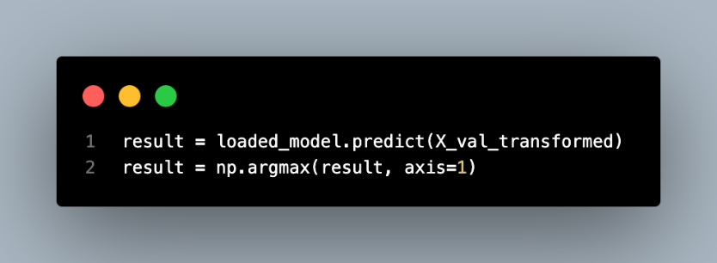

After that, we feed the validation data into the model to get the prediction result.

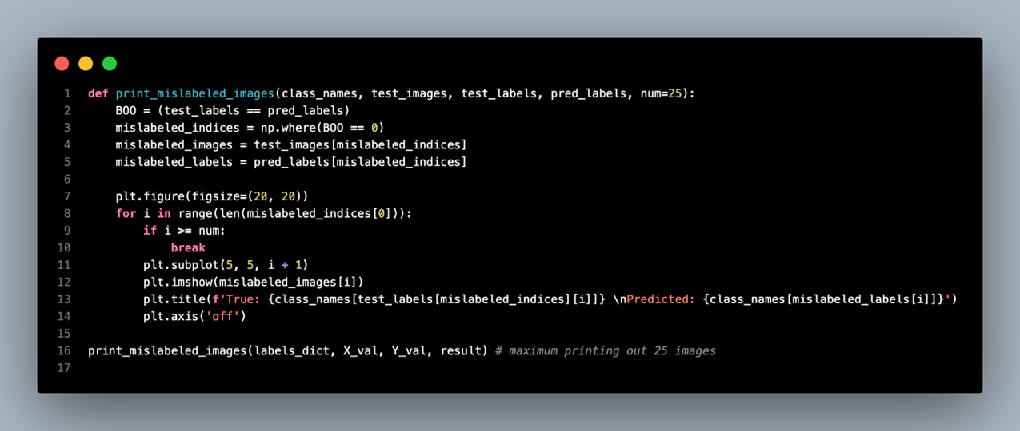

Then, we defined the `print_mislabeled_images()` function to plot out the misclassified images in the validation dataset with its predicted and actual labels to check the possible reason of the misclassification.

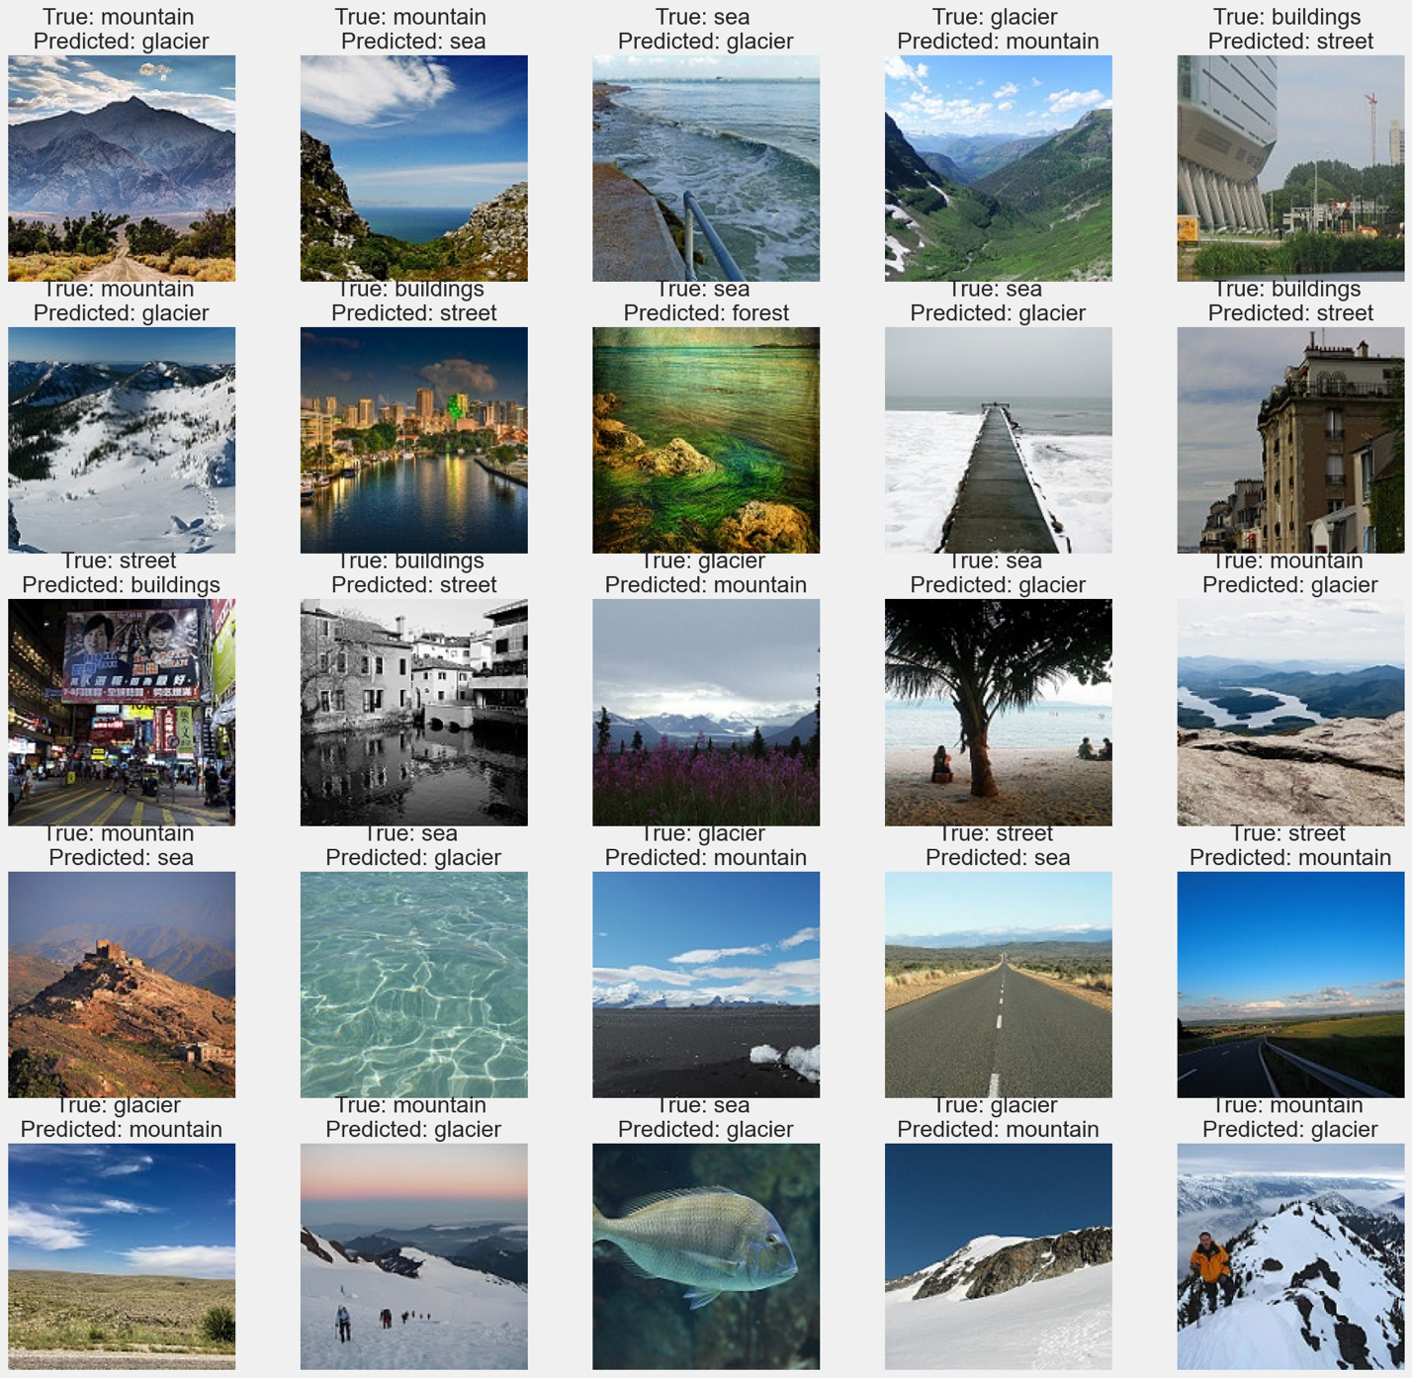

The misclassifications above could be due to the similarities of the classes and the limitations of our custom CNN model. For example, there are **mountain** images may be classified as **glacier** or **sea** due to similar textures and color. Since mountains consist of rocks most of the time, images with glaciers may increase the confusion between the two classes. For instance, images of coastal **mountains** might confuse the **sea** because the backgrounds are somewhat similar.

Likewise, cases of buildings being misclassified as **streets** may be because buildings are usually located on streets, and hence the model is again having a problem with context. This also holds the issue where street images misclassified as buildings may occur due to the tall structures that dominate the main part of the images.

In the case of **sea** class, some misclassifications with the **glacier** or **forest** class signify that our model responds to wide areas of space or large areas of water which in certain lighting or other conditions could be confused for a **glacier** or **forest**. It becomes difficult for the model to distinguish the difference between water and snow-covered **glaciers** on the texture and color patterns of the real scene due to low resolution or a distant shot.

Furthermore, confusion between the **glacier** class and the **mountain** demonstrates how similar and confusing the **mountain** and the **glacier** class could be. For example, snow-covered **mountains** or rocks could be **mountains** but the model could classify them as **glaciers** due to the similar color pattern of the images with the glaciers.

Consequently, the misclassifications mainly result from confusion between some natural landscapes, urban scenes, and surrounding contextual features that our model does not perceive as accurately as possible, which indicates that more refinement, for example, adding other context features or improving image resolution, could be useful for enhancing it.

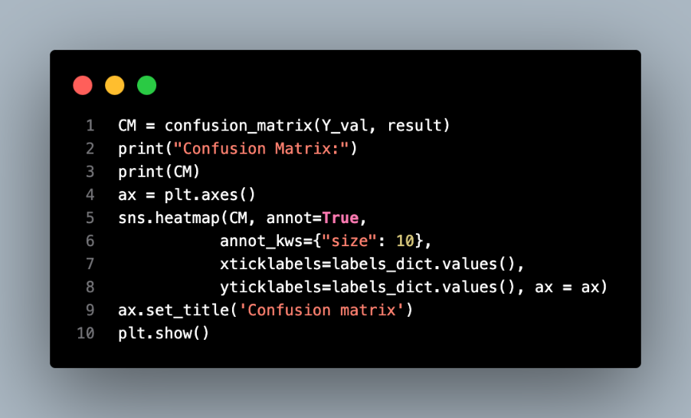

On other hand, we also plot out the confusion matrix for the prediction result here.

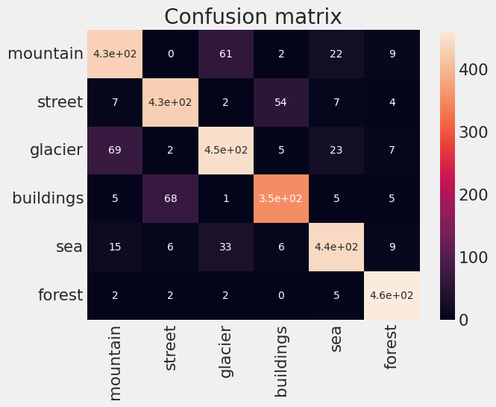

In the case of the **mountain** class, misclassification occurs most frequently with **glaciers** (61) and **sea** (22). This might mean that features of mountains may blend with glaciers, possibly because of snow features, and with seas because of the horizon or open space. The largest number of confusions with buildings is observed in the **street** class (54 misclassifications) since the **buildings** and **streets** are usually closely associated in the urban area. The **glaciers** class is often mixed up with **mountains** (69 misclassifications) and **glaciers** (23 misclassifications). With regard to **buildings**, there are 68 misclassifications with **streets**. On the other hand, the **sea** class made 33 misclassifications. Moreover, 15 errors are observed with mountains.

The prediction class distributions and error here are the same as our best model prediction above with some problems in the classification of **mountains** **with** **glaciers** and **sea** due to texture and color patterns, buildings and streets due to the image in urban areas.

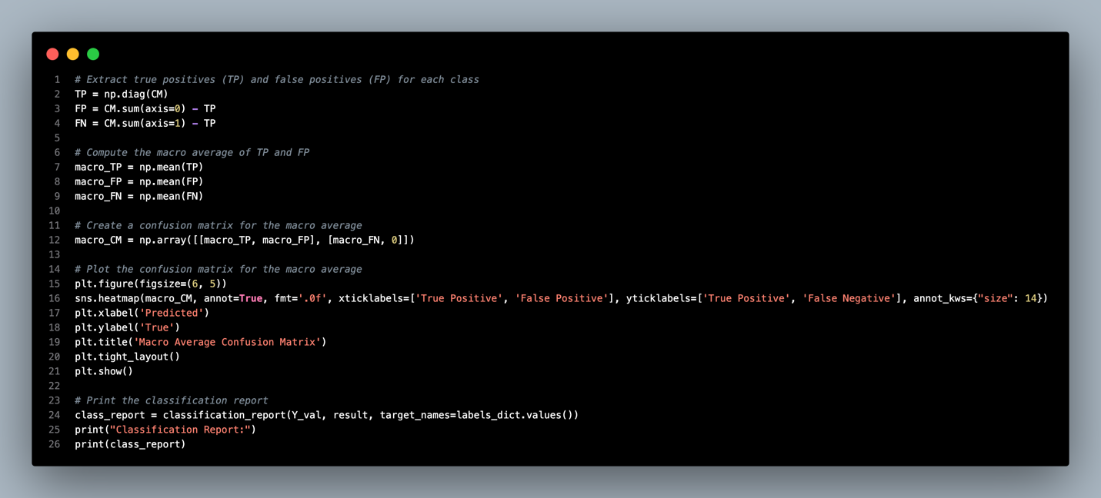

Then, we continue to use the same method to plot the macro confusion matrix for the prediction distribution.

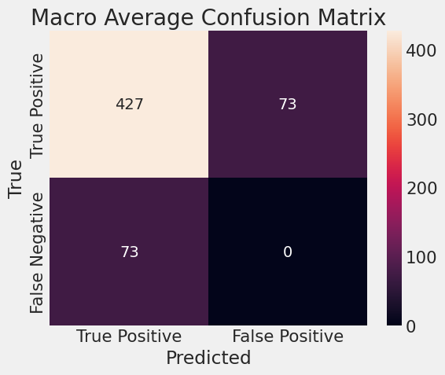

Here in the macro confusion matrix, our CNN model has 427 correct classifications with 73 for misclassifications in false positive and false negative.

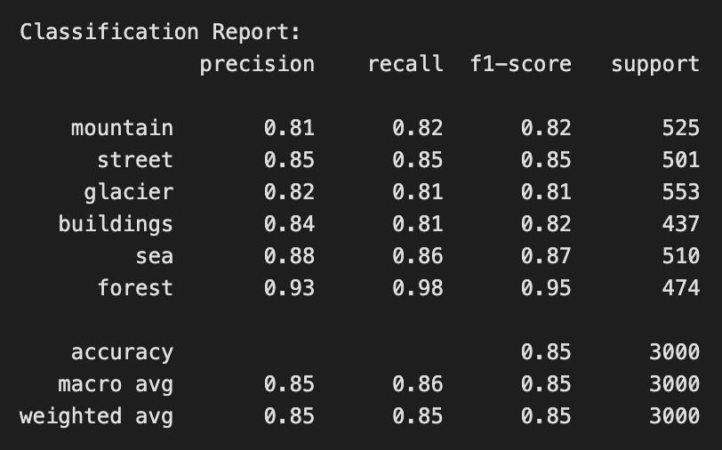

The precision, recall, and f1-score in the prediction range from 81% to 95% across all the classes with an overall accuracy of 85%.

### Model Explainability

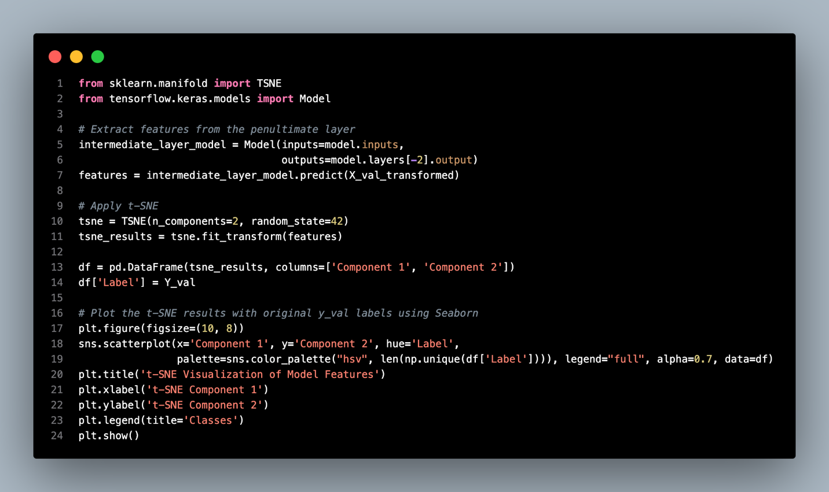

In addition, we will discuss the model explainability here to visualize the decision-making of the model. The first visualization would be t-SNE (t-distributed Stochastic Neighbor Embedding). The t-SNE plot can visualize how well the custom CNN model differentiates between the different classes in accordance with the learned representations. Every class is assigned to a particular color and from the picture it is easy to identify that similar features have been clustered together.

The code above shows the step of plotting t-SNE features by extracting features from the dense layer of our custom CNN model, then using dimensional reduction and producing embeddings to plot the t-SNE scatter plot with seaborn and matplotlib.

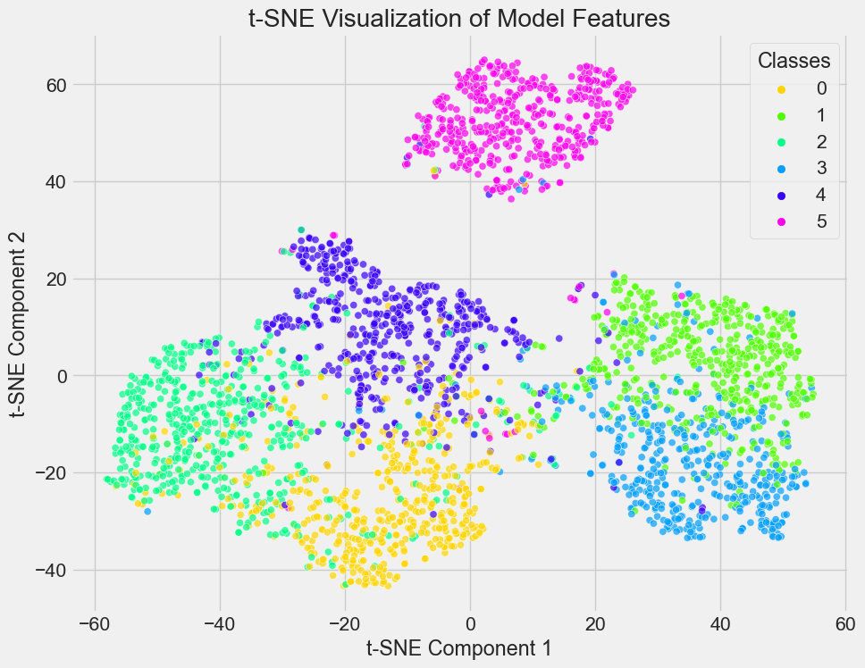

The labels corresponding to each class are as follows: 0 stands for ‘**mountain**,’ 1 is ‘**street**,’ 2 ‘**glacier**,’ 3 ‘**buildings**,’ 4 ‘**sea**,’ and 5 ‘**forest**.’

Class 1(‘**street’**) and Class 5(‘**forest’**) are two separate clusters in the feature space. These clusters are fully isolated which strongly suggests that the model has learned discriminative features for these two classes.

However, there is a high rate of overlap between classes 0 and 2, 0 and 3, 0 and 4, and 2 and 3. For example, Class 0(‘**mountain’**) and Class 2 (‘**glacier**) often have overlapping features such as snow and rocks. Likewise, there are some overlapping points of Class 3(‘**buildings’**) and Class 4(‘**sea’**). This might be because our model was confused with the waterfront city scene where both these classes have **buildings** **and** **sea** in one image.

Moreover, our model has a good differentiation on the image with greenery and natural scenery, thereby it performs best in identifying Class 5(`**forests**`).

It can be concluded that the custom CNN model works well with some classes such as ‘**street’** and ‘**forest**,’ where the learned features are different. But it is not very effective with others especially **‘mountain,’ ‘glacier,’ ‘buildings,’ and ‘sea’** because visually similar concepts map to the same feature space. Perhaps, improving feature extraction and increasing the size of datasets could be useful solutions.

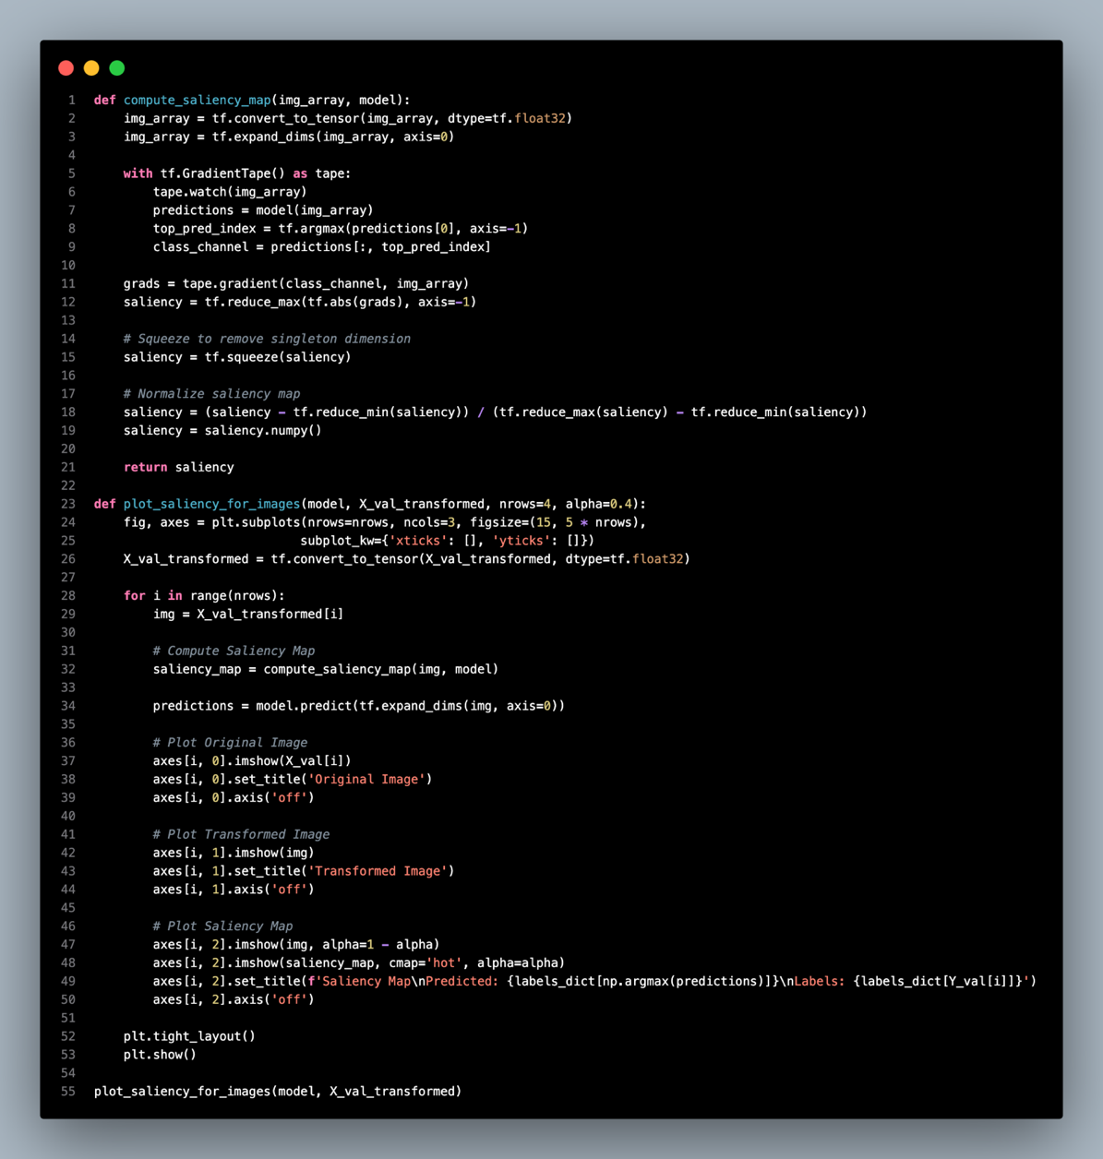

The next visualization is about saliency maps which visualize the most decisive pixels in the images for image classification. The saliency map process started with the `compute_saliency_map()` function, in which we get the gradient of the model’s prediction with respect to the input image. The gradient presented represents how important each pixel is for the model prediction. Subsequently, we obtained the gradient and then reduced it into a single saliency channel, then normalized the map before visualizing it.

For the `view_saliency_for_images()` function, we are plotting the original image along with the transformed input image and then the saliency map. The saliency map is then applied to the transformed image showing the regions that affect the model decision most.

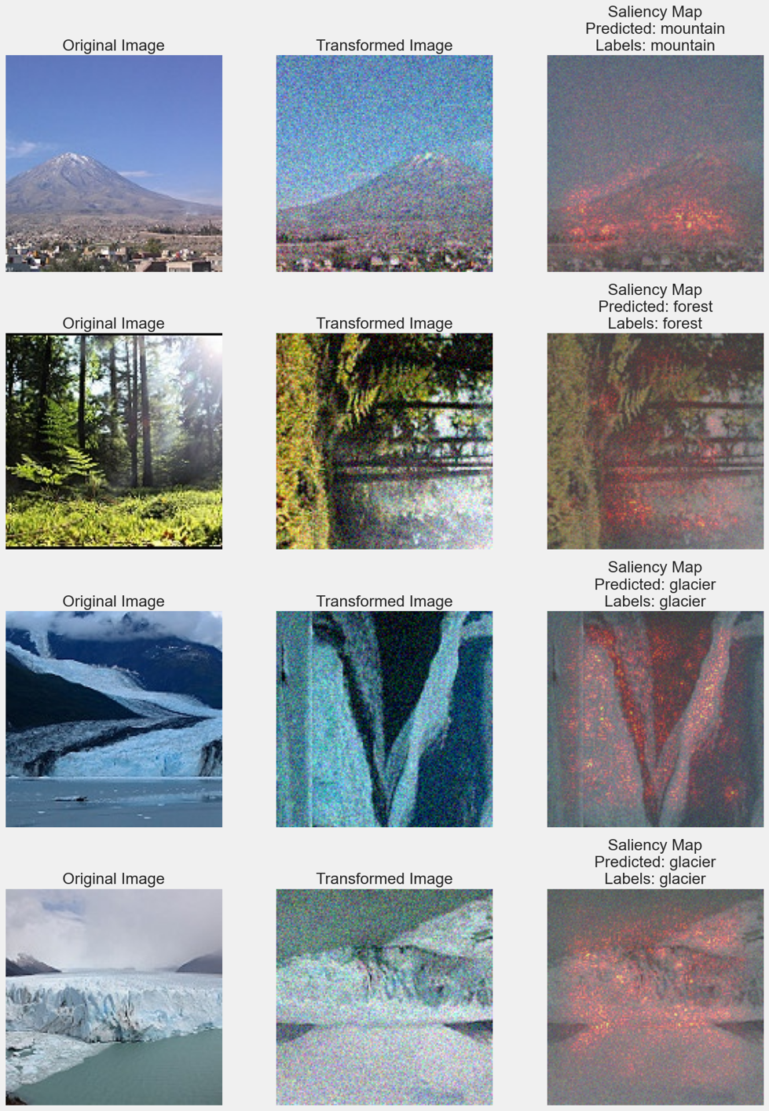

Here, we see which areas of the image the model pays attention to when making its decision. As we can see from the figure, the model has focused on the main structures of the images during classification. For instance, in the **mountains** and **glaciers** images, the light spots do not appear on the elements like the sea in **glacier** images and the sky in **mountain** images, meaning that the model has found the most important part for deciding the class of the image.

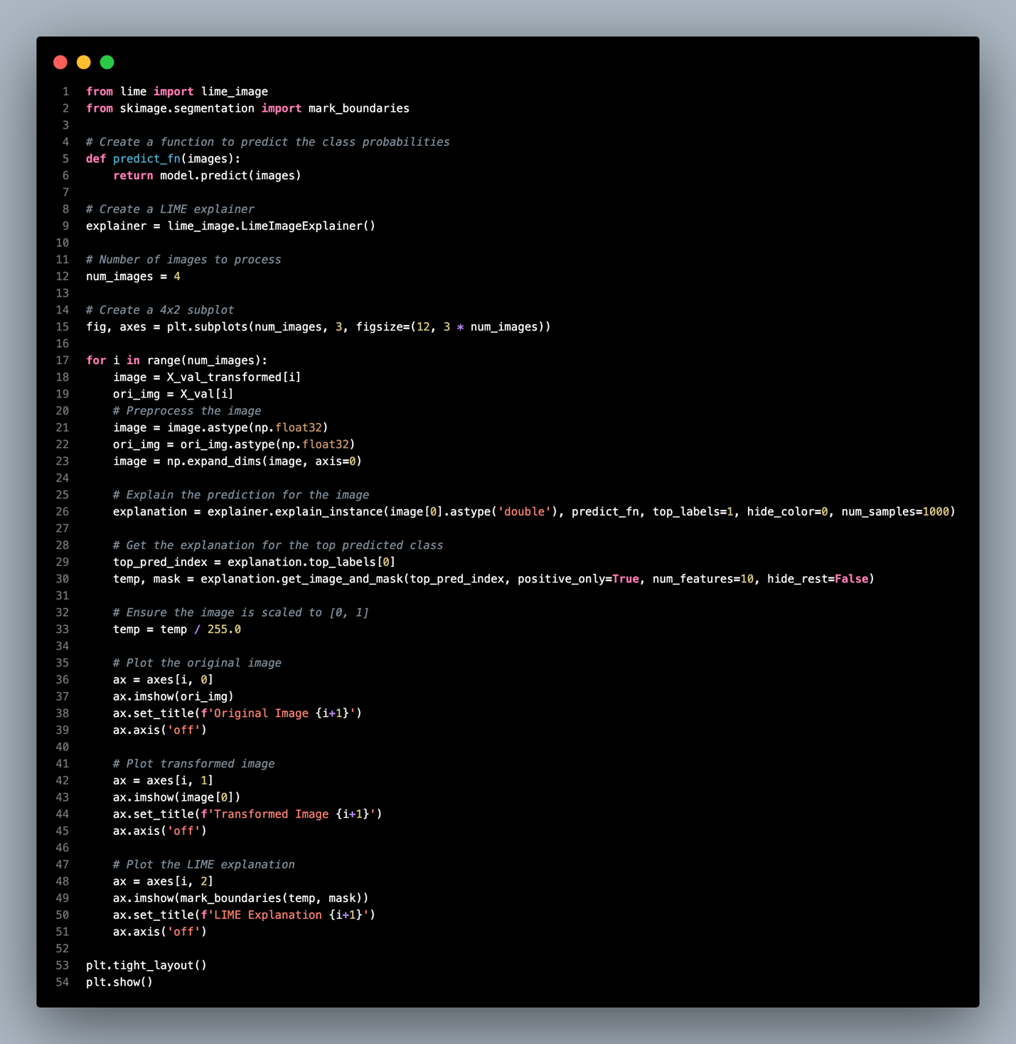

The `predict_fn()` function will use the CNN model to come up with class probabilities of a set of images. This function is then passed to LIME where explanations are generated.

To understand how the model predicts each image, we use the LimeImageExplainer object. We select four images from the validation set and preprocess the image before generating an explanation using `explainer.explain_instance`. LIME explainer generates different versions of the image and identifies which portions of the image influenced the final classification result.

In the explanation for each image, the LIME explainer identifies the most significant area boundaries in the images. We visualize three things for each image: the original image, the transformed image, and the LIME explanation with the boundary around highlighted areas indicating high importance to the model’s prediction. This process assists in making the decision-making criteria of the model more understandable by defining which portion of the image influences its decision.

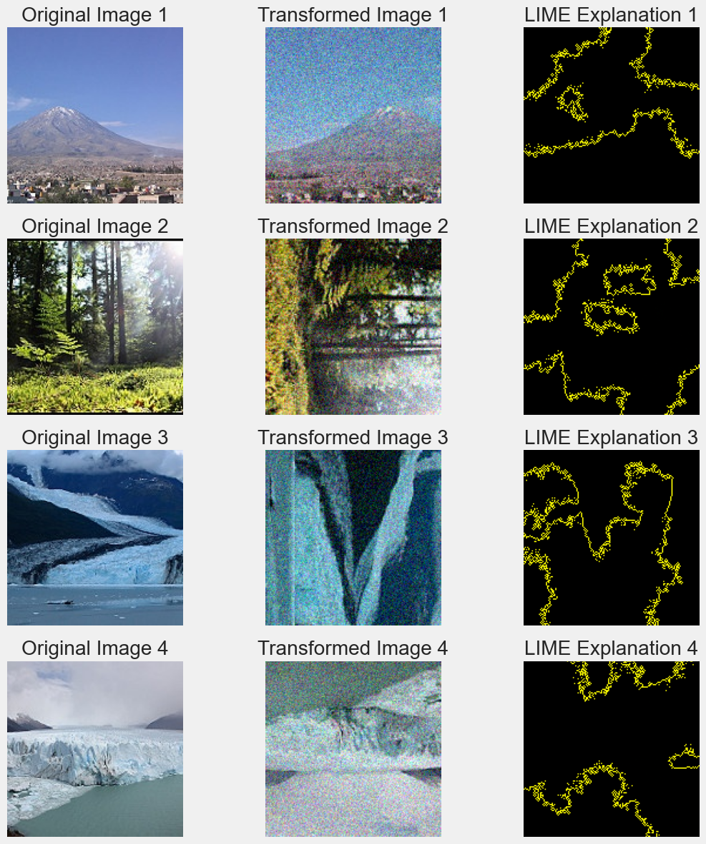

From the explanation figure plotted above, we can see that the highlighted boundaries are most following the shape of the main structure in the transformed image. As for the **mountain** image, the **mountain** boundary in the image has been highlighted. However, for the image like the **forest** and **glacier**, the boundaries are not clear as the image resolution is not enough high for the LIME explainer to draw the exact shape of the tree and glacier.

### Model Testing

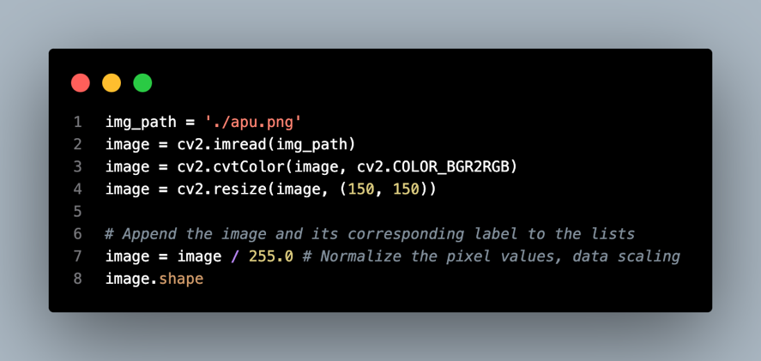

After finishing the model explainability, we are going to streamline the code so that we can use our model to make predictions for images we download from the internet. First, we will resize and normalize the image as the code above.

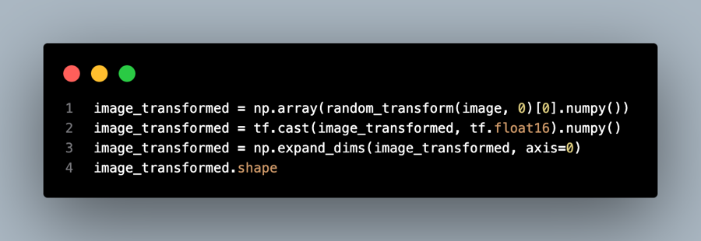

After resizing and normalizing, we will need to make a random augmentation, array format conversion, and dimension expansion for the image.

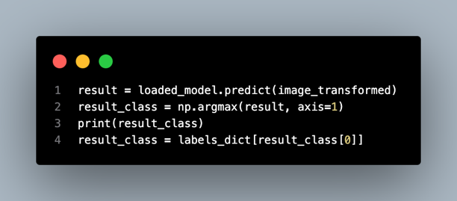

After that, we use the loaded custom CNN model to make the prediction. The predicted class will be identified by using the `argmax()` function to get the class with the highest probabilities. Finally, we convert the predicted class number to the actual class name using the labels dictionary.

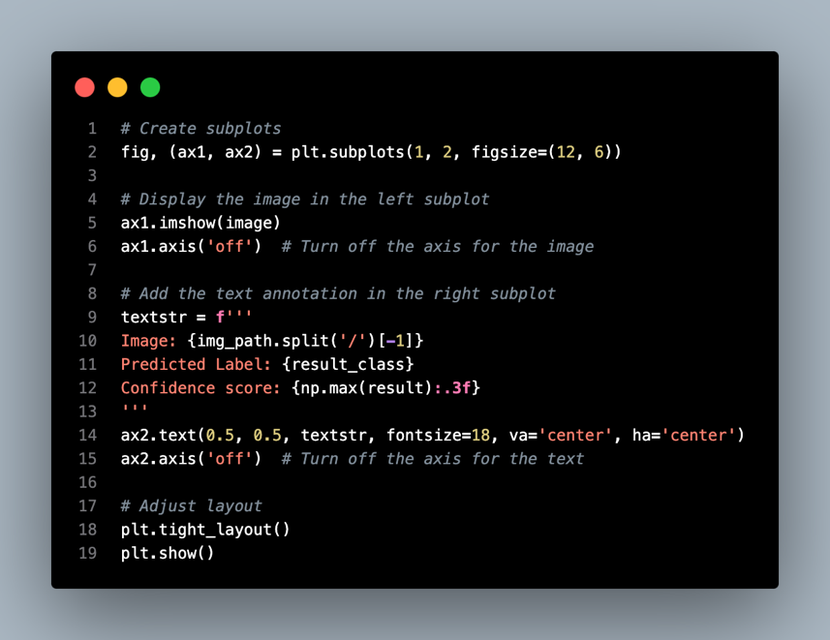

For visualization, we plot out the image used along with the image file name, predicted labels, and confidence score of the prediction.



As plotted above, the resized APU campus image is put on the left, and the result is shown on the right side. The predicted result is **buildings** with a 0.999 confidence score.

## MLP Model (Chen Yong Jing TP066841)

### Model Building

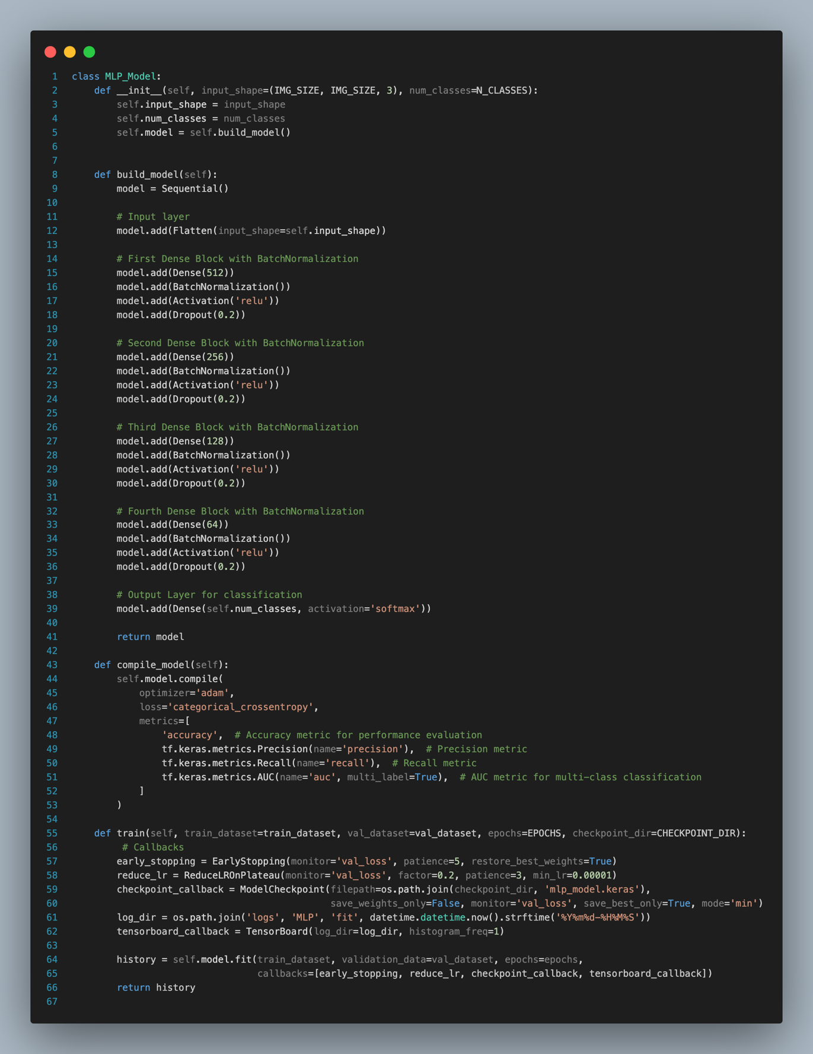

The architecture of the MLP model for image classification is built from scratch within a class of ‘MLP_Model’ where the input shape and the number of output classes are defined as usual. We construct the structure of the MLP model in the ‘build_model’ function as a sequential model with one input layer, four hidden layers, and one output layer. The input layer first employs the flatten function to convert the input images into a 1D array.

The first hidden layers represent a dense block that comprises a fully connected layer with 512 neurons. This is followed by batch normalization and ReLU activation. We apply a dropout rate of 0.2 at the end of the block to minimize the potential for overfitting.

This process is repeated over another three blocks with 256, 128, and 64 neurons. Lastly, the model is included with an output layer with neuron numbers of classes, which is 6 in this case, and the Softmax activation that is useful in predicting multiclass.

Similarly, we compile the model with the same function that utilizes the Adam optimizer, categorical cross-entropy loss, and some metrics that are used for evaluation purposes. The train model function comprises some common approaches, that are early stopping, learning rate reduction, and checkpoint. The other functions such as getting validation information and prediction methods are mentioned in the model building of the CNN model.

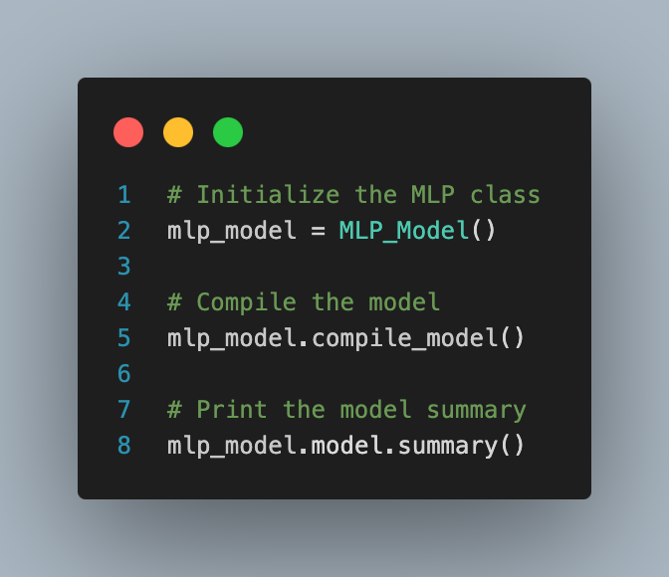

The MLP class is initialized and then proceeds to compile it. The figure below shows the summary of our custom MLP model from scratch.

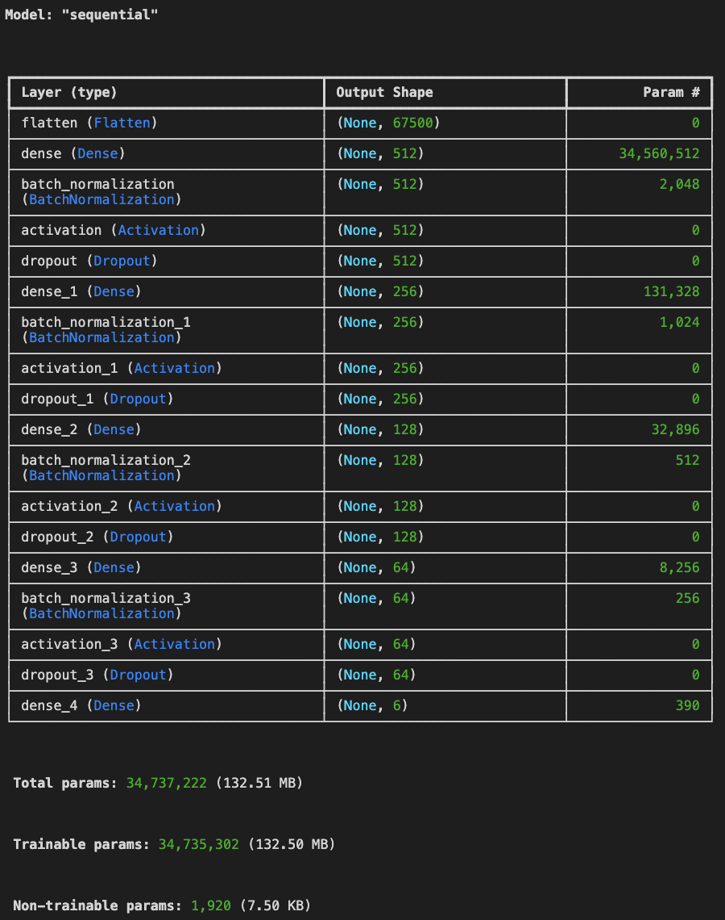

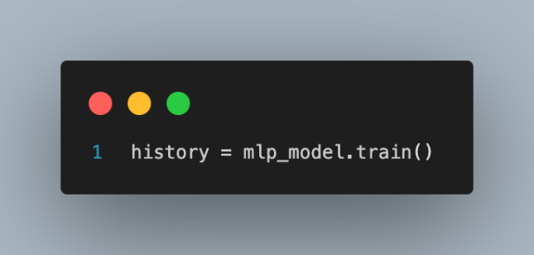

After the model is initialized, we start to train the MLP model. We train the model with a maximum of 50 epochs, five early stopping rounds, and a minimum learning rate of 1x10-6.

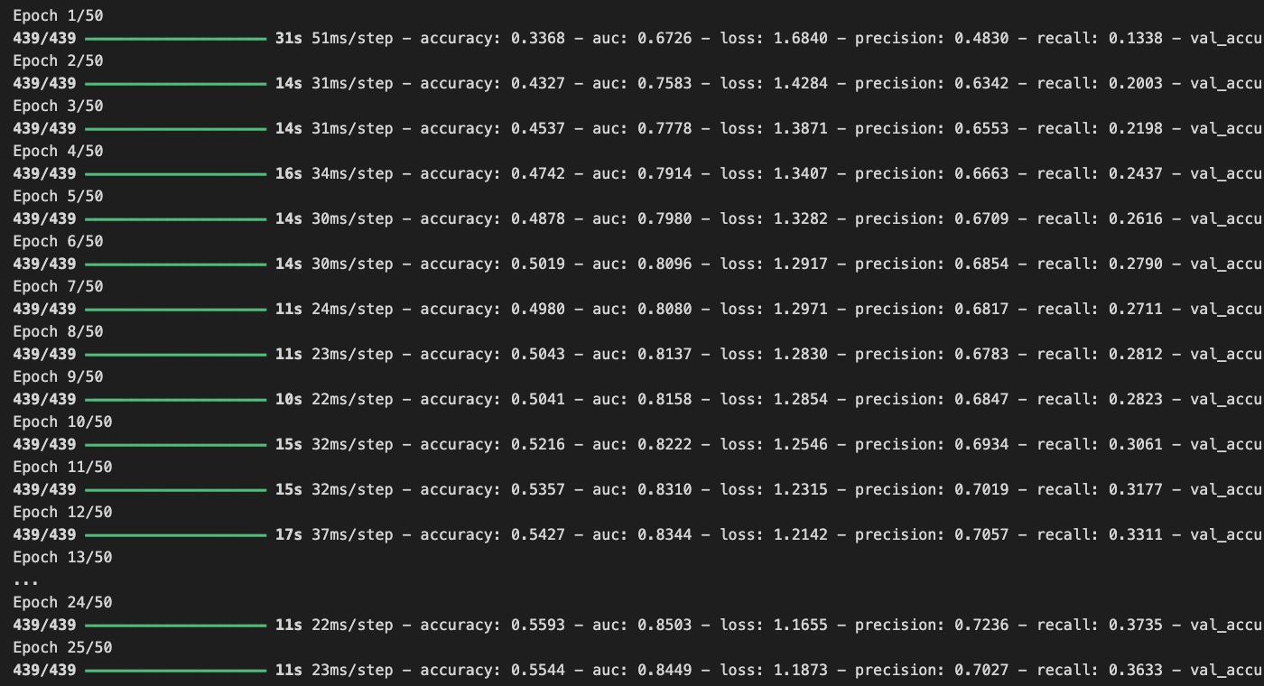

The training stops at the 25th epoch, which gives the result:

**Training:** accuracy: 0.5544 - auc: 0.8449 - loss: 1.1873 - precision: 0.7027 - recall: 0.3633

**Validation:** accuracy: 0.5763 - auc: 0.8612 - loss: 1.1258 - precision: 0.7051 - recall: 0.3993 learning_rate: 1.0000e-05

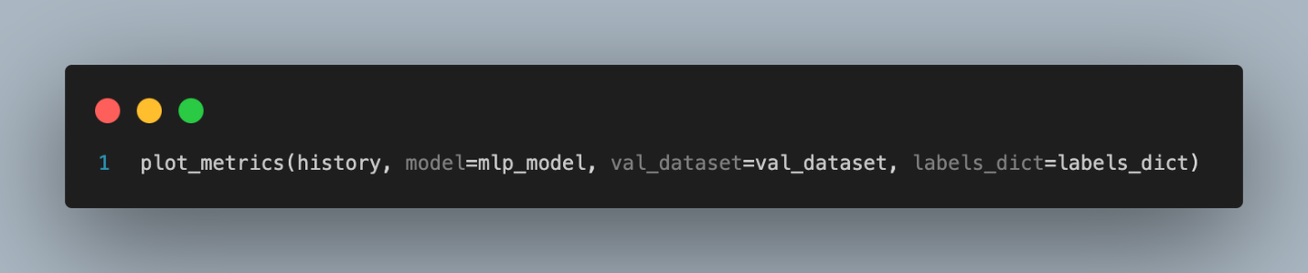

To better understand the model’s performance, the next step is to plot the metrics across the training and validation metrics.

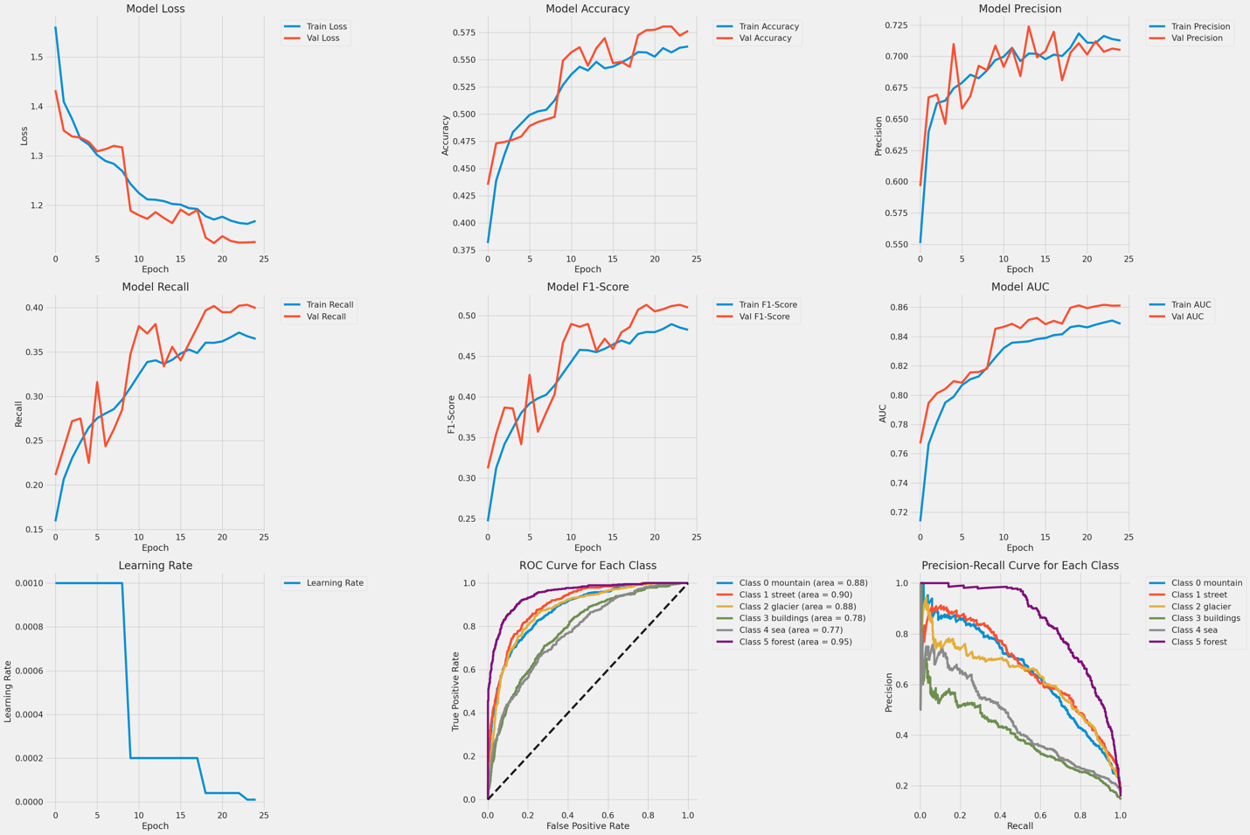

The designed MLP model seems to face some issues when comes to image classification, especially in the context of natural scenes. During the training, the loss for both training and validation decreases consistently, which shows a good sign of learning effectively. However, the validation loss is not stable like training loss; it decreases initially, but begins to plateau, indicating the model generalization is somehow weak to unseen data. It also shows a small gap of divergence between the training and validation loss, hence showing a potential overfitting.

We observed there is improvement in both training and validation accuracy over the epochs. The validation accuracy increases over time but with slight fluctuations around the 14th epoch. However, both accuracies start to plateau as the epochs increase, therefore this shows that the model does not yield a significant improvement. There is a noticeable gap between the two, which shows potential overfitting that the model is less effective to unseen data.

Our MLP model has obtained an acceptable precision result, where both training and validation approach a precision of approximately 0.70 at the end of the 25th epoch. The model not only increases the precision over the epochs but also generalizes well to new data.

However, in the recall and F1-score graphs, we observed an improvement in the training set but both of them display some fluctuation when the epochs increase. This shows the model is trying to minimize loss on the training data and generalize to the unseen data. The low results in both recall and F1-score suggest that the model is not robust enough in this natural scene classification.

The AUC values around 0.85 in both training and validation data have proven that the model can define distinct features for various classes. This is particularly important in multiclass classification problems. The AUC values being consistently high over the epochs also indicate that the classification ability of the model does not deteriorate in consecutive epochs of training.

The learning rate graph progressively decreased the learning rate during the training process within the MLP model. The learning rate scheduler decreases significantly before the 10th epoch to mitigate the risk of overfitting and lastly maintain the learning rate at above zero from just before the 20th epoch. This is crucial for fine-tuning the model to achieve optimal performance.

The actual ROC curves for each class of the dataset indicated that the model had an acceptable ability to classify between the classes. On the other hand, the precision-recall curves of the MLP model again demonstrated reasonable distinguishing classes like mountain and forest. The lower performance in the building class suggests that the MLP model lacks of distinctive features which cause confusion in classifying this category.

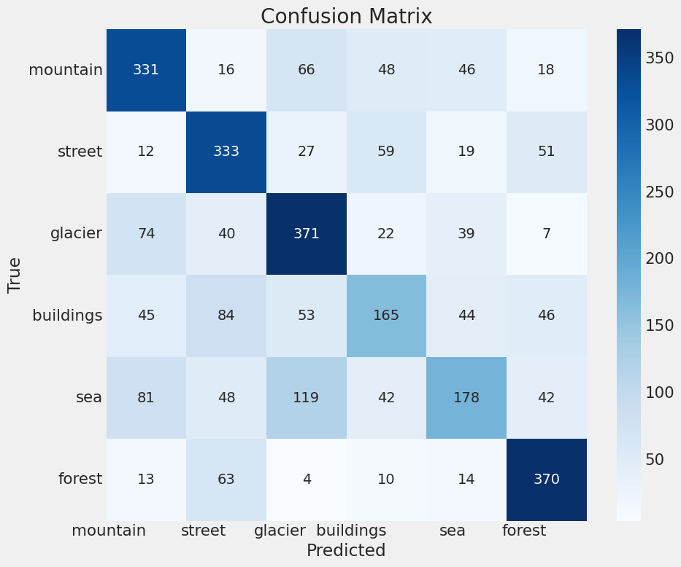

The confusion matrix result of the MLP model shows the performance of a model designed to classify images like mountains, streets, glaciers, buildings, seas, and forests. Within the matrix, it performed comparatively well with glaciers and forests, which give out high true positive rates of 371 and 370, respectively. Similarly, the model also showed strong performance in recognizing mountains and streets, with over 330 correct classifications in each category. However, the model's performance was not uniformly excellent across all categories. It demonstrated relative difficulty in accurately identifying buildings and seas, with significantly fewer correct predictions of 165 and 178, respectively.

The confusion matrix also highlighted where the model struggled with misclassifications. For instance, the mountain class has been confused with glaciers and sea, the street class was often mistaken for forest and sea classes, and the glacier class is simply confused with the sea class.

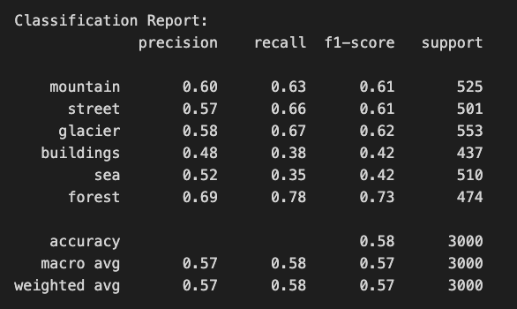

The classification report shows the value of precision, recall, and f1-score for each class. The MLP model gets 57 % to 58% values within the accuracy, macro average, and weighted average of precision, recall, and f1-score.

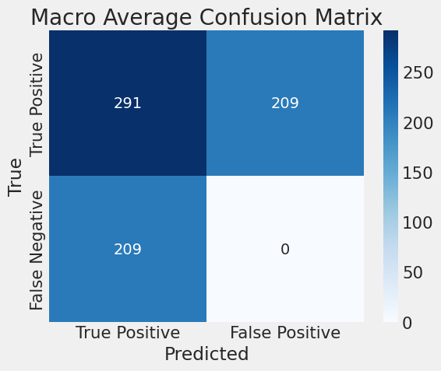

According to the macro confusion matrix, the 291 samples are classified in the true positive class. However, both false positives and false negatives have 209 samples which shows the model predicts the classes incorrectly. This shows the MLP model is not robust in image classification before fine-tuning.

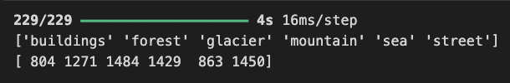

Lastly, we proceed to test our MLP model on the testing dataset using the `predict_batch()` function. The result shows an average predicted outcome across the classes but is less effective in building and sea classes.

### Model Tuning

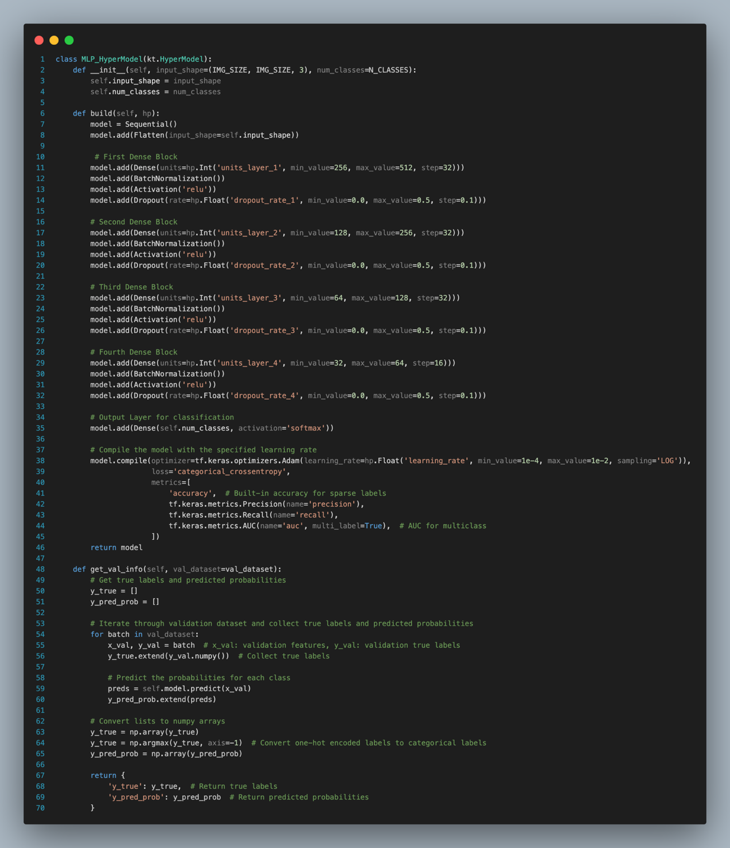

In the hyperparameter tuning of the MLP model, we apply the same structure as the MLP model above with four hidden dense blocks. We set the flexibility in the architecture for optimal tuning to find the best hyperparameters. The number of neurons in each dense block is varied; the first block can be between 256 and 512, the second block can be between 128 and 256, the third block can be between 64 and 128, and lastly, the fourth block can be between 32 and 64. Moreover, the dropout rates within each block are also adjustable, which range between 0 and 0.5 rates. These tuning settings allow us to find the optimal model. The output layer is still the same, where the neuron number is 6 (number of classes) and using the softmax activation function. Furthermore, we set a learning rate within a range of 1e-4 to 1e-2, which makes it possible for the optimizer to adapt to the current model complexity.

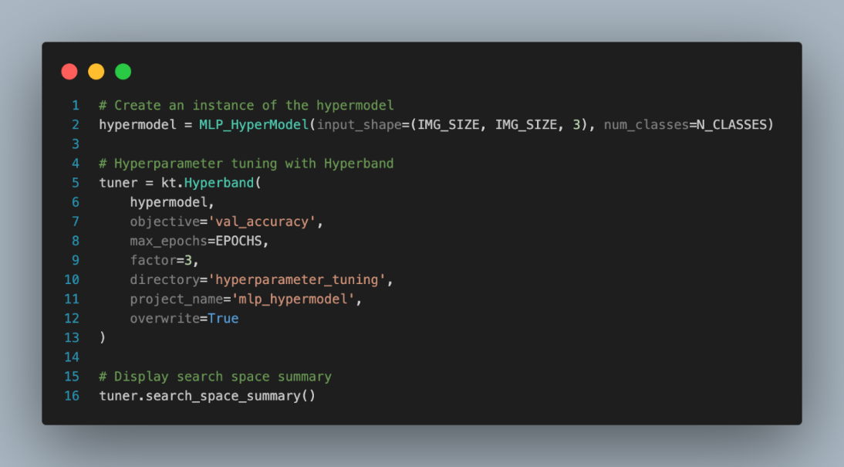

After defining the class for the MLP hypermodel, we still use the Hyperband optimization to search for the best hyperparameters within the search space. The search space summary that we set for the tuner is shown in the figure below.

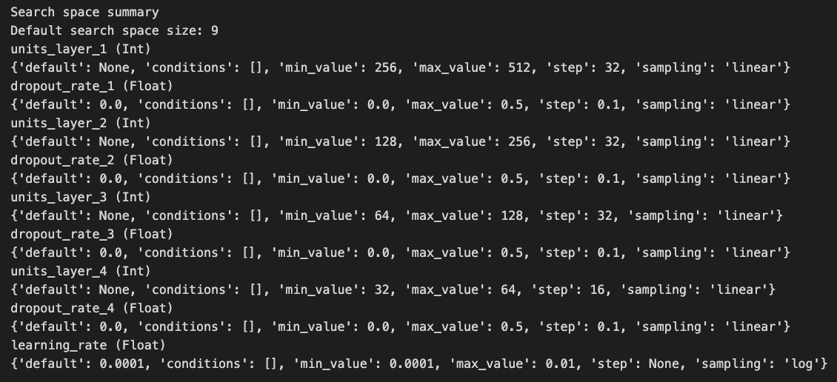

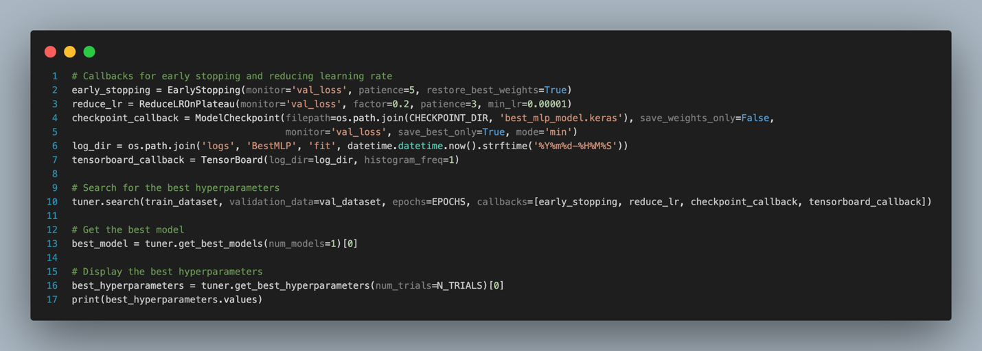

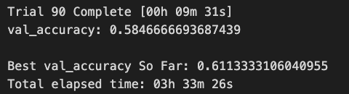

We start the hyperparameter tuning for the MLP model using the Keras tuner. After 3.5 hours of tuning, we obtained the best model with a validation accuracy of 61.1%. The best hyperparameter calculated are:

|  |  |
| --- | --- |
| Hyperparameters | Value |
| units_layer_1 | 480 |
| dropout_rate_1 | 0.0 |
| units_layer_2 | 128 |
| dropout_rate_2 | 0.1 |
| units_layer_3 | 128 |
| dropout_rate_3 | 0.0 |
| units_layer_4 | 32 |
| dropout_rate_4 | 0.1 |
| learning_rate | 0.0009388837297496945 |
| tuner/epochs | 50 |
| tuner/initial_epoch | 17 |
| tuner/bracket | 1 |
| tuner/round | 1 |
| tuner/trial_id | '0074' |

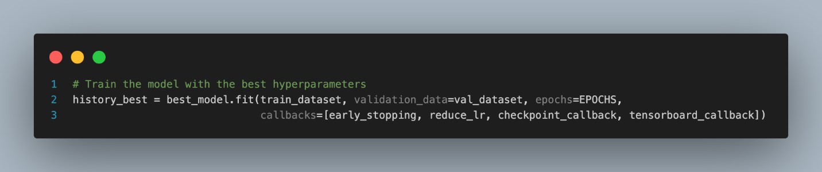

Then we will retrain the MLP model with the best hyperparameter values and store in the variable named ‘history_best’.

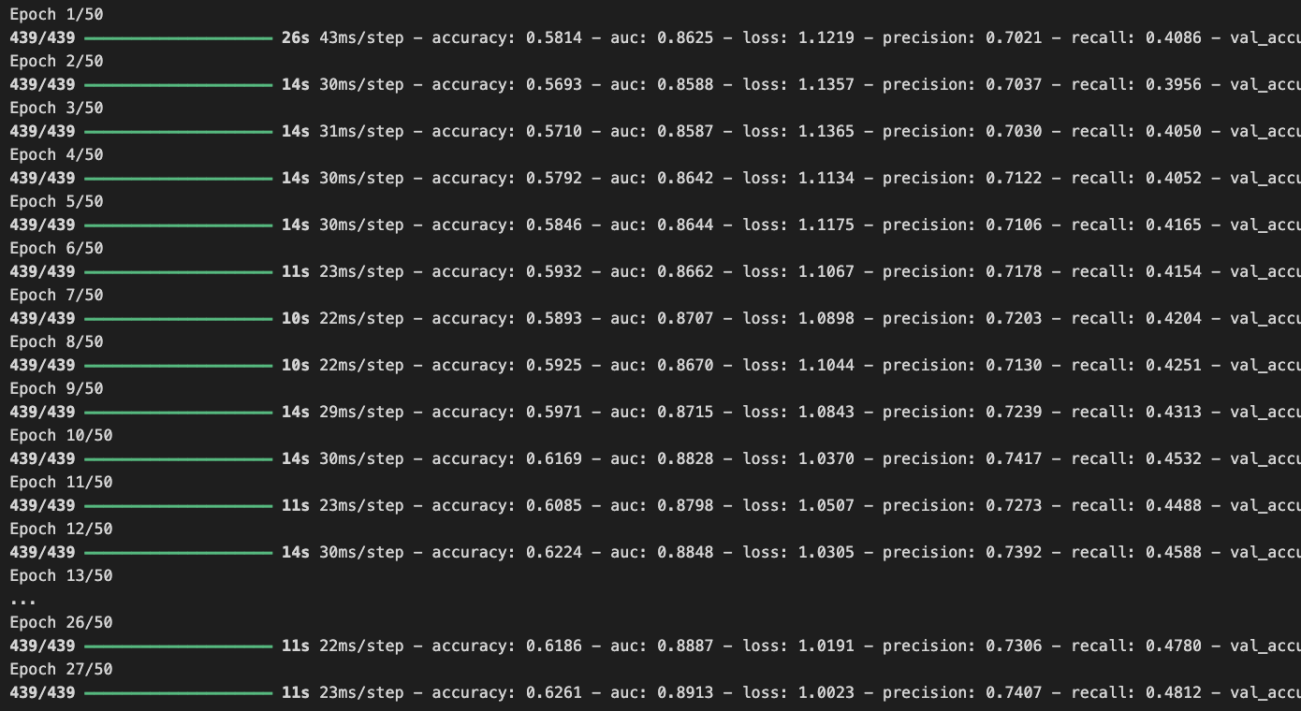

The training stops at the 27th epoch, which gives the best result:

**Training:** accuracy: 0.6261 - auc: 0.8913 - loss: 1.0023 - precision: 0.7407 - recall: 0.4812

**Validation:** accuracy: 0.6110 - auc: 0.8832 - loss: 1.0425 - precision: 0.7099 - recall: 0.4837 learning_rate: 1.0000e-05

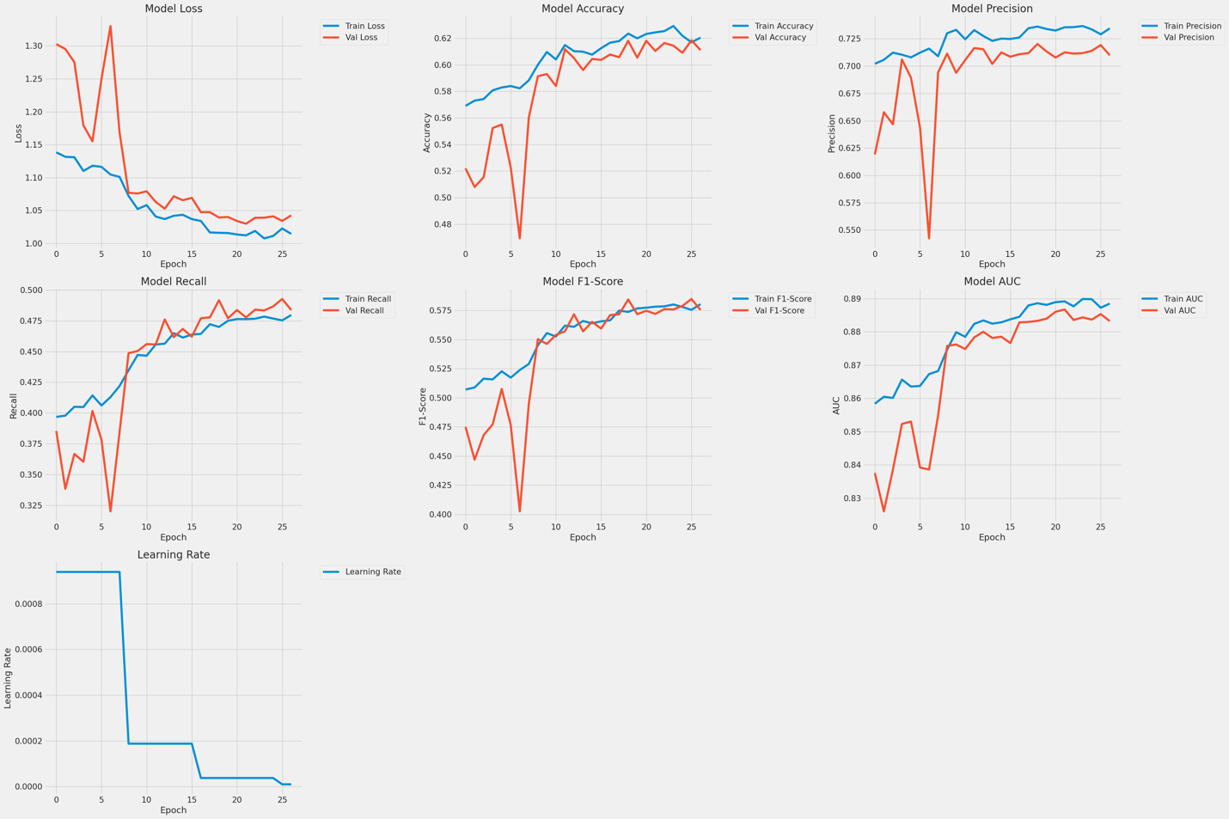

After that, we evaluate the model using the ‘plot_metrics’ function to plot the training and validation metrics. Based on the above figure, both the training and validation loss start high and decrease over epochs. Although the validation loss shows some volatility, it generally decreases. This pattern shows that the model is not overfitting.

The accuracy increases progressively for both training and validation. Over the epochs, the difference between the two is very small, which means that the model is learning effectively. On the other hand, the precision graph shows initial volatility, especially a sharp dip around the 6th epoch, which is also shown in other graphs. After that, the model stabilizes and improves as the epochs progress. This is also shown in the learning rate curve, where the model is learning adaptively. Moreover, the recall and f1-score graphs improve over time and show a balance between the training and validation datasets, which does not show a sign of overfitting.

The AUC is high initially, around 0.86 and 0.84 for both training and validation datasets, respectively. Last but not least, the learning rate is reduced effectively, especially during the 6th epoch. It can be seen that the model has a good generalization ability.



After the training of the best model, we evaluate it on the validation dataset again to get the value of loss, accuracy, precision, recall, and AUC.  The figure above is the result of the MLP model in the validation dataset.

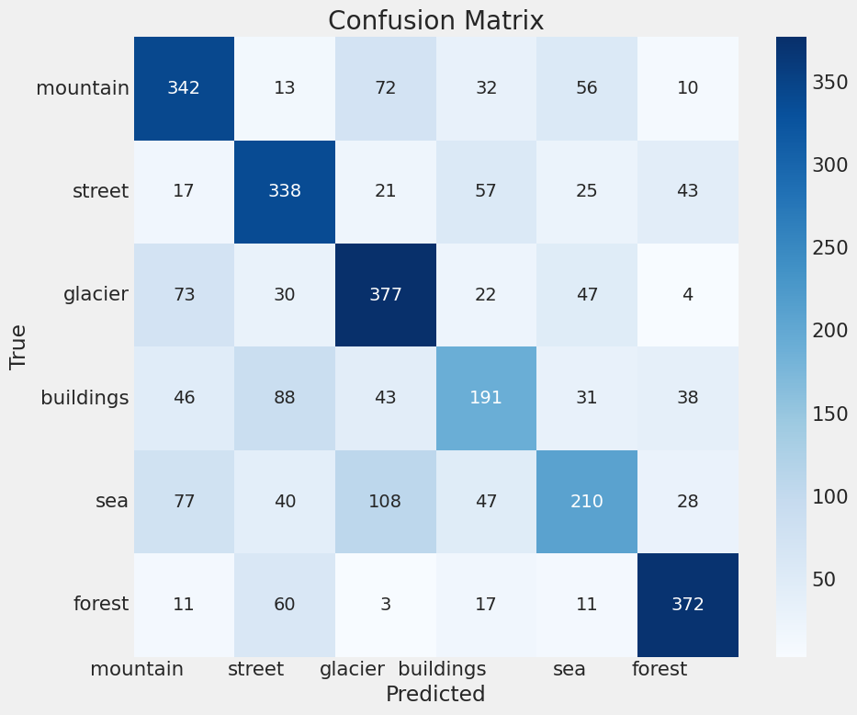

The confusion matrix of the tuned MLP model shows the result with an improvement compared to the initial MLP model. The improvements can be shown in the building and sea classes, which can predict correctly with more values. The number of correct predictions for building class is now 191, whereas previously correct samples are 165. The sea class now predicts correctly with 210 samples, whereas the previous is 178 only. On the other hand, the misclassification between glacier and sea classes also remained high at 108, but it has reduced compared to the initial model. In general, most classes are predicted well, except building and sea classes exhibit higher confusion with other classes.

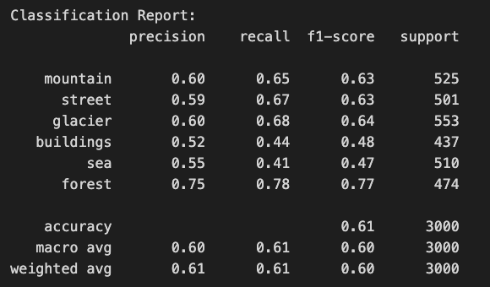

The figure above shows the classification report of the tuned MLP model. Overall, the model has been improved, although not as effective as the CNN model. The accuracy of the prediction is 61%, which is 3% higher than the initial model.

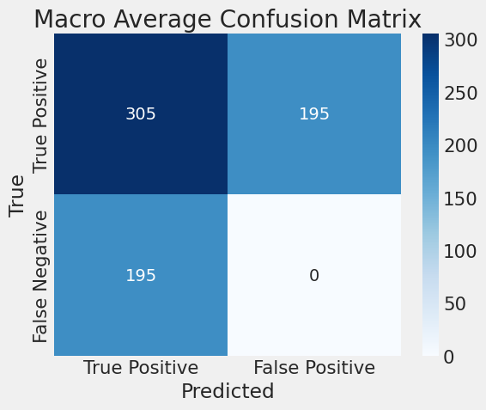

We also plot out the macro average confusion matrix. The true positive class has been increased from 291 to 305 here. On the other hand, the false positives and false negatives decreased from 209 to 195 for both classes.

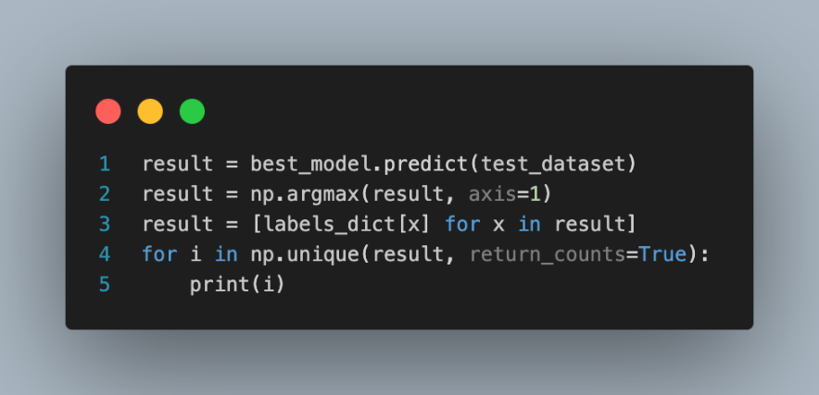

Following that, we still test the model using the testing dataset and print out the prediction result of the model.

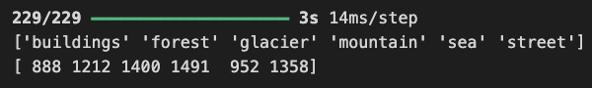

The figure above shows the prediction result distribution of the tuned MLP model on the testing dataset.

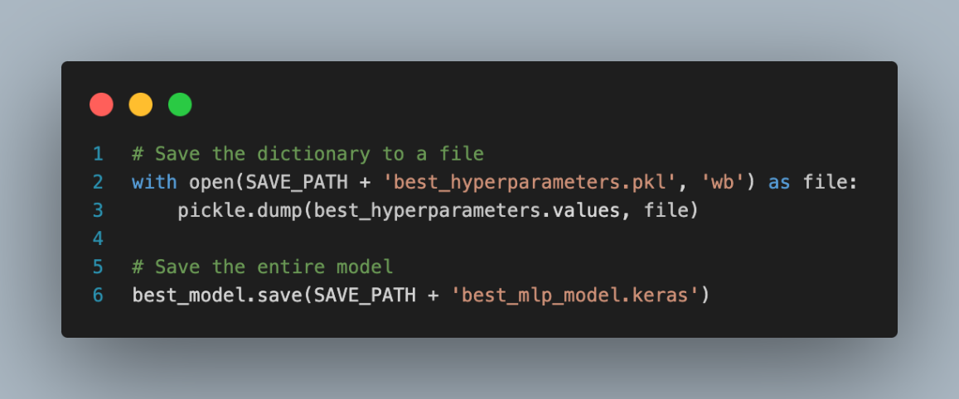

Lastly, we save the best hyperparameter values of the model using pickle and also the best MLP model in the Keras format.

#### Model Error Analysis

In this section, we also do an error analysis using the same code by getting the sample images from the validation dataset and performing preprocessing on the data. As usual, we feed the validation data into the model to get the prediction result. Then, we use the `print_mislabeled_images` function to plot out the misclassified images in the validation dataset

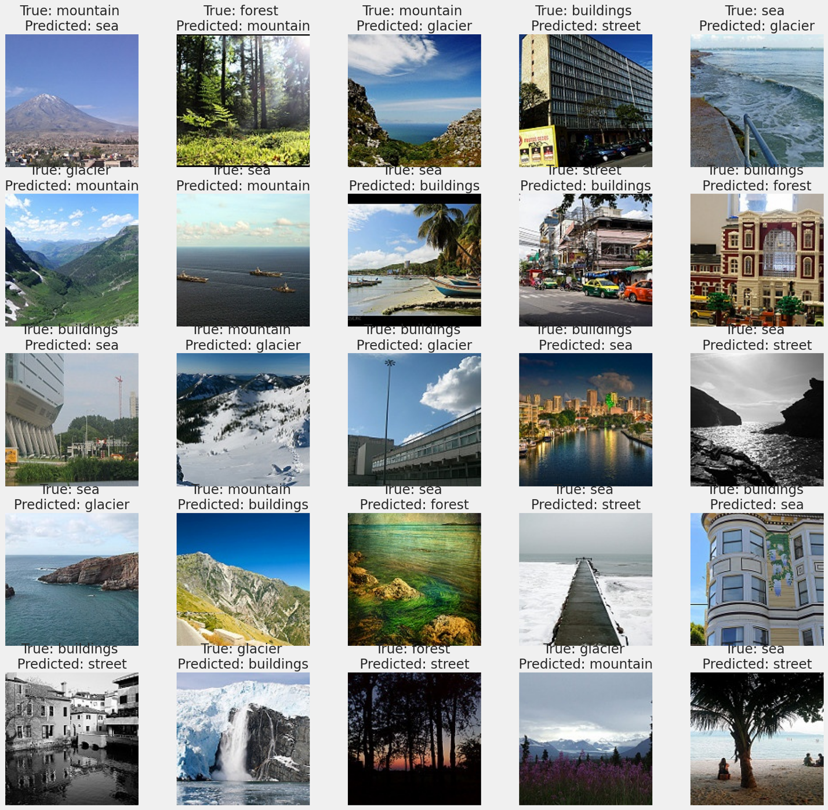

The error analysis above showcases several misclassifications in our MLP model due to some classes sharing similar context features. For example, some of the **buildings** can be confused with **streets** which is probably because most of them are located in urban areas. Likewise, **mountains** and **glaciers** are often mistaken for each other because both have similar characteristics and are rough and rocky landforms. This points towards the idea that the model could be associated more with textures and color features that are quite similar between these classes without differentiating the contextual differences.

The confusion between the classes such as **sea** **and** **glacier** or **buildings** **and** **sea** indicate that this model is not very effective at discriminating scenes where there are common environmental features. For example, water is an ingredient in both **sea** and **glacier** scenes, it might be appearing here as ice or snow. Similarly, those urban waterfronts where **buildings** touch water can lead to misclassifications between **buildings** and the **sea**.

Some of the mispredictions include forests being misclassified as streets or buildings which may show that the model is not capturing all details of the distinct classes. This could be due to the model lacking features for identifying tree patterns of forests by any linear structures within an image.

More so, sometimes the images have complex backgrounds, or they have features of both a particular category and another category, which have been proven to create a challenge to the model. For instance, if a picture is a **mountain** with a **building** in front of it, the picture might be classified as a **building** or a **mountain** depending on which of the two is more dominant. Consequently, the misclassifications mainly result from confusion between some natural landscapes, urban scenes, and surrounding contextual features that our MLP model does not perceive as accurately as possible.

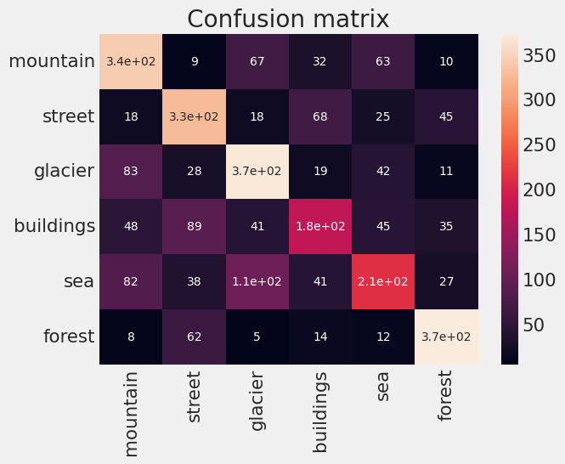

The confusion matrix provided shows the classification performance of the MLP model across six categories. Notably, the model achieved considerably high true positives when classifying **mountain**, **glacier**, and **forest** with 340, 370, and 370 respectively, showing the model’s ability to identify these scenes. For some categories, for example, **buildings** or **sea**, is much less effective with the true positive rates of 180 and 210, and often mistakes misclassification from other similar visual-like categories. On the other hand, the **sea** is often mistakenly recognized as a **glacier** (110 misclassification) or a **mountain** (82 misclassification). The **building** is also often misclassified as a **street** (89 misclassification) due to their similar context features.

.

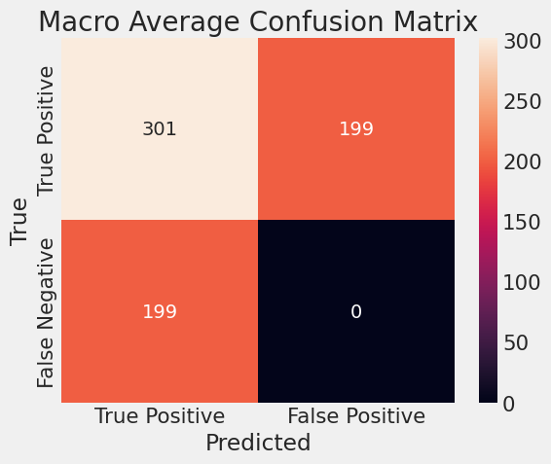

The macro confusion matrix in out MLP model has 301 correct classifications with 199 for misclassifications in false positive and false negative.

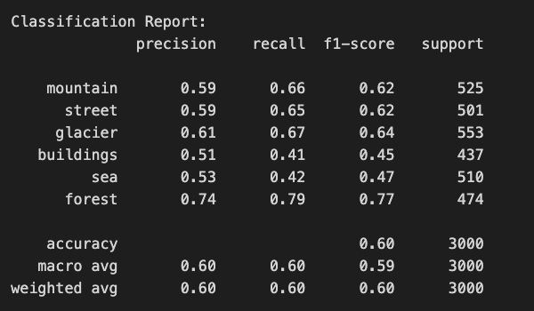

The precision, recall, and f1-score in the prediction range from 41% to 77% across all the classes with an overall accuracy of 60%, a macro average of approximately 60%, and a weighted average of 60%.

### Model Explainability

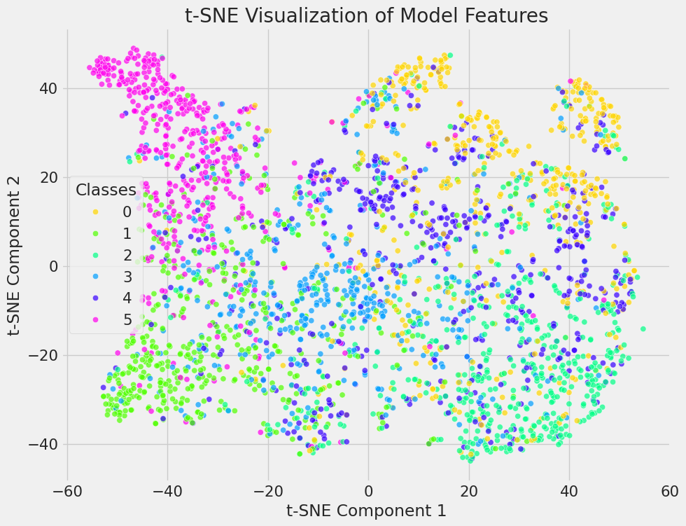

The labels corresponding to each class are as follows:

* Class 0 – Mountain (yellow)
* Class 1 – Street (green)
* Class 2 – Glacier (cyan)
* Class 3 – Buildings (blue)
* Class 4 – Sea (purple)
* Class 5 – Forest (pink)

The t-SNE visualization presented here is a two-dimensional representation of the high-dimensional feature space used by a machine learning model to classify images into six classes: **mountain, street, glacier, buildings, sea,** and **forest**. Every single-colored point refers to part of the image and is accordingly plotted by its real class label. In this plot, we can notice the color clusters mostly overlap with each other, which does not show a good sign in this case. This suggests that the model is confused with most of the classes in the natural scene classification, except for the **forest** class. The forest class is mostly separate clusters in the feature space, followed by the street class, which is considered an acceptable result. It can be concluded that the MLP model is not working well when comes to the natural scene, especially since most images have similar context features.

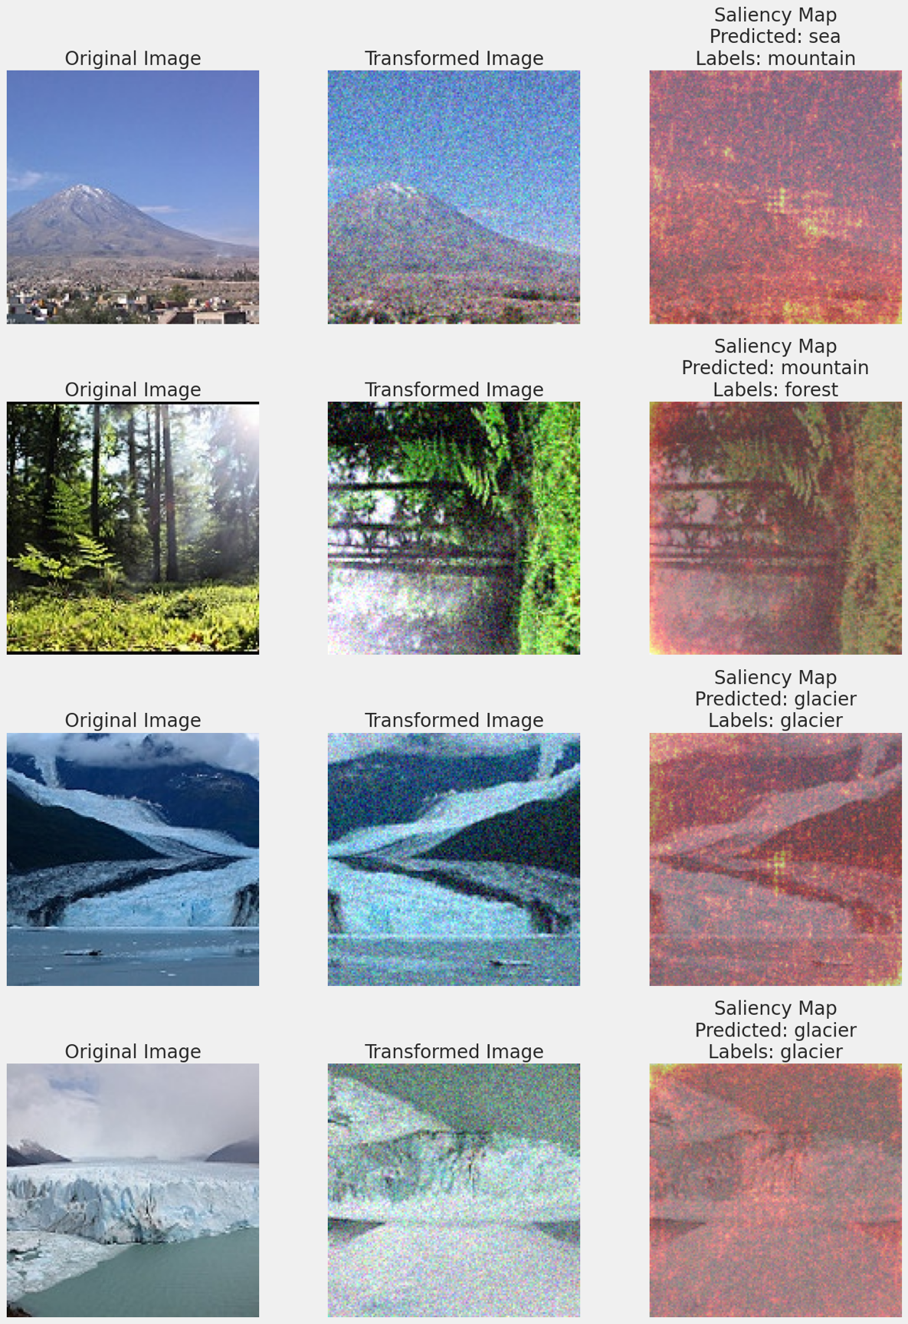

We use saliency maps to identify the region highlighted by the MLP model. As we can see, the result is not as good as the CNN model which identified the most important part of the images. In the MLP model, the light spots highlighted are around all the regions of the images which is probably because the model used the flatten method in the input layer. This has caused a problem when comes to image classification using the MLP model.

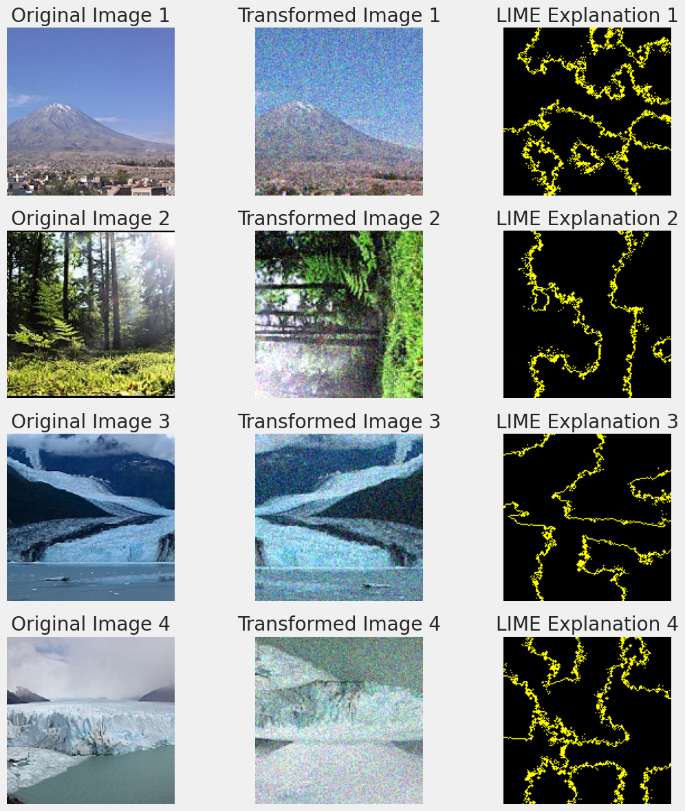

From the figure plotted with the LIME explainer, we can see that the highlighted boundaries are partially following the shape of the main structure in the transformed image but not as clear as the CNN model. The MLP model lacks some ability to draw the shape of the boundaries of the natural scene.

### Model Testing

In this model testing section, we will also input some images other than the images from the Intel Image Classification dataset. We again take the same preprocessing steps to handle the images, like resizing, normalizing, and transforming them using augmentation, array format conversion, and dimension expansion.



As plotted above, the predicted result of the image is **buildings** with a 0.411 confidence score, which is proven by the earlier evaluation that our MLP model is weak in classifying building class.



On the other hand, the result of the resized forest image is predicted as **forest** correctly with a 0.808 confidence score.

## RNN Model (Ng Qi Wern TP066981)

### Model Building

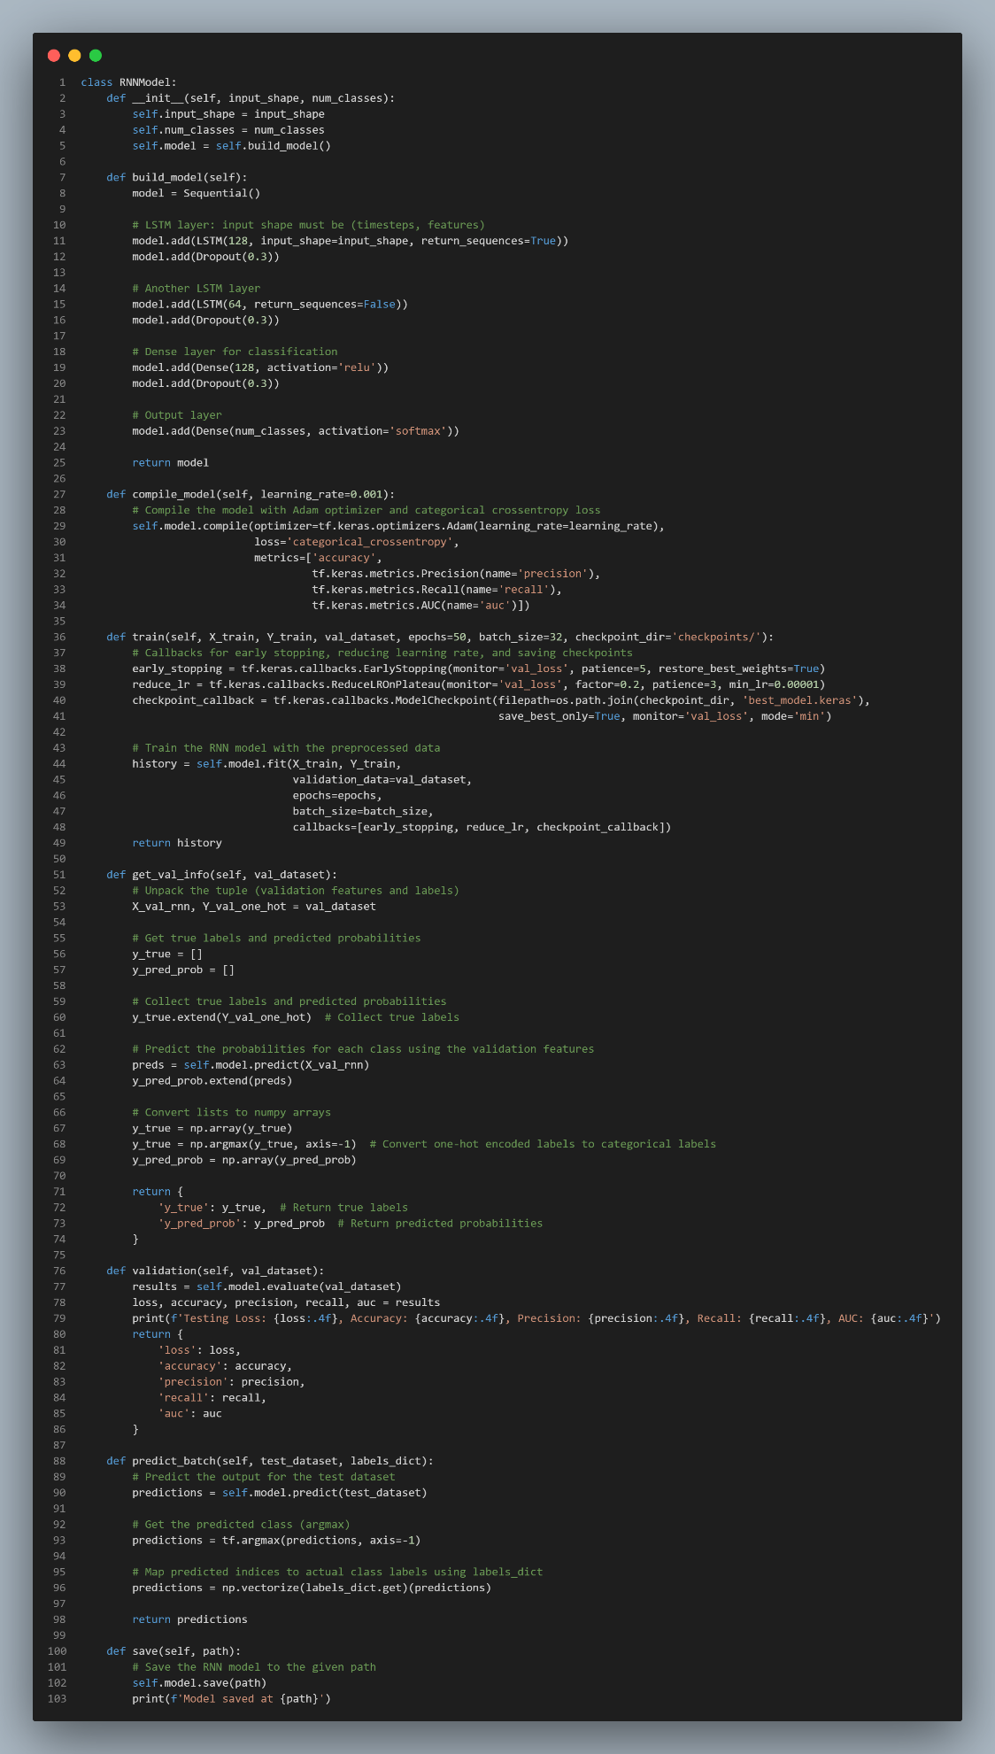

The model building implementation of the RNN begins with defining a class named RNNModel. This approach is similar to the previous implementations of CNN and MLP by other group members, with necessary modifications for the sequential nature of the data. The RNNModel class accepts the input shape and the number of output classes as parameters, allowing for customization based on the dataset.

The architecture is constructed within the build_model method and consists of the following components:

1. **LSTM Layers**: These layers are designed to handle sequential data by learning temporal dependencies. The first LSTM layer processes input data with a specified input shape and ensures compatibility by returning sequences to the next LSTM layer. A second LSTM layer follows with fewer units.
2. **Dropout Layers**: To prevent overfitting, dropout layers are placed after each LSTM layer, with a dropout rate of 0.3.
3. **Dense Layers**: The dense layers are fully connected layers used for classification. A dense layer with 128 neurons and ReLU activation is added, followed by a final dense layer with softmax activation to produce probabilities for each class.

The model is compiled using the Adam optimizer and the categorical cross-entropy loss function, which is suitable for multi-class classification tasks. The metrics used for evaluating model performance include accuracy, precision, recall, and AUC (Area Under Curve), similar to the previously defined CNN and MLP implementations.

To train the RNN, early stopping, learning rate reduction, and model checkpoint saving are implemented, mirroring the training strategies employed in the earlier models.

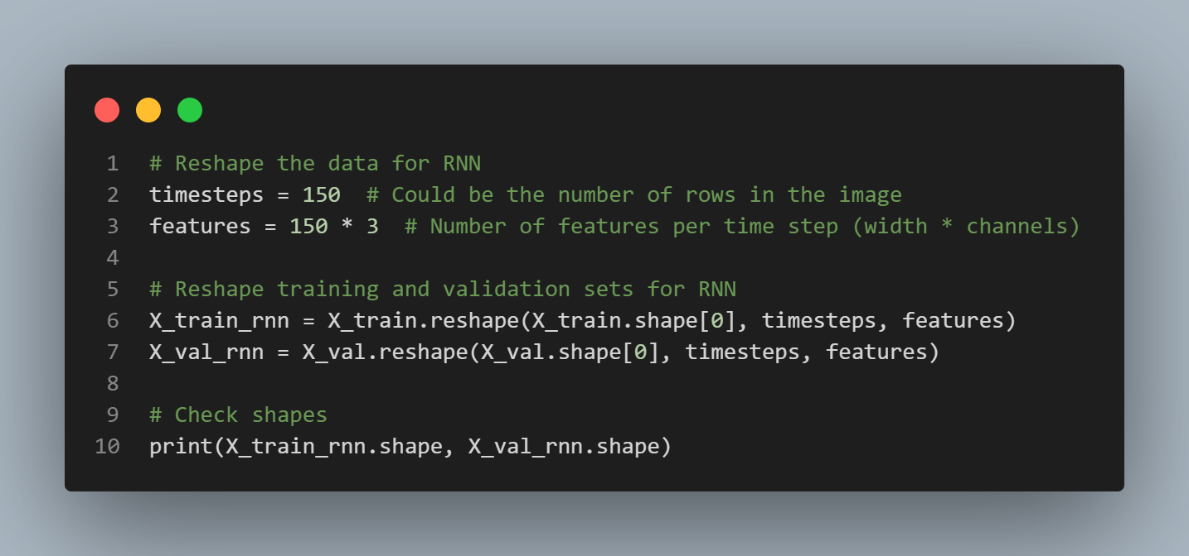

Recurrent Neural Networks (RNNs) require the input data to be flattened before being processed. However, in this implementation, the input data is reshaped prior to training the model, which differs from the previous Multi-Layer Perceptron (MLP) implementation that utilized a Flatten layer. The purpose of this reshaping is to experiment with a different approach, ensuring the data is transformed into a format that the Long Short-Term Memory (LSTM) layers can process. On the other hand, CNN models, as implemented by another group member, do not require such flattening since convolutional layers work directly with the spatial dimensions of the data.

For this RNN, the number of timesteps is set to 150, which could represent the number of rows in the image, and each timestep has 450 features, calculated as 150 for the image width and 3 for the number of channels. The training and validation datasets are reshaped into three-dimensional arrays, with the first dimension representing the number of samples, the second dimension referring to the timesteps, and the third dimension indicating the features for each timestep.



After reshaping, the training set has the shape (14034, 150, 450), and the validation set has the shape (3000, 150, 450).

This reshaping ensures that the data can be processed by the LSTM layers, maintaining the sequential nature of the input without the need for flattening, as required in the MLP. This design choice introduces a variation in how the data is prepared compared to previous models and serves as an experimental comparison between different architectures.

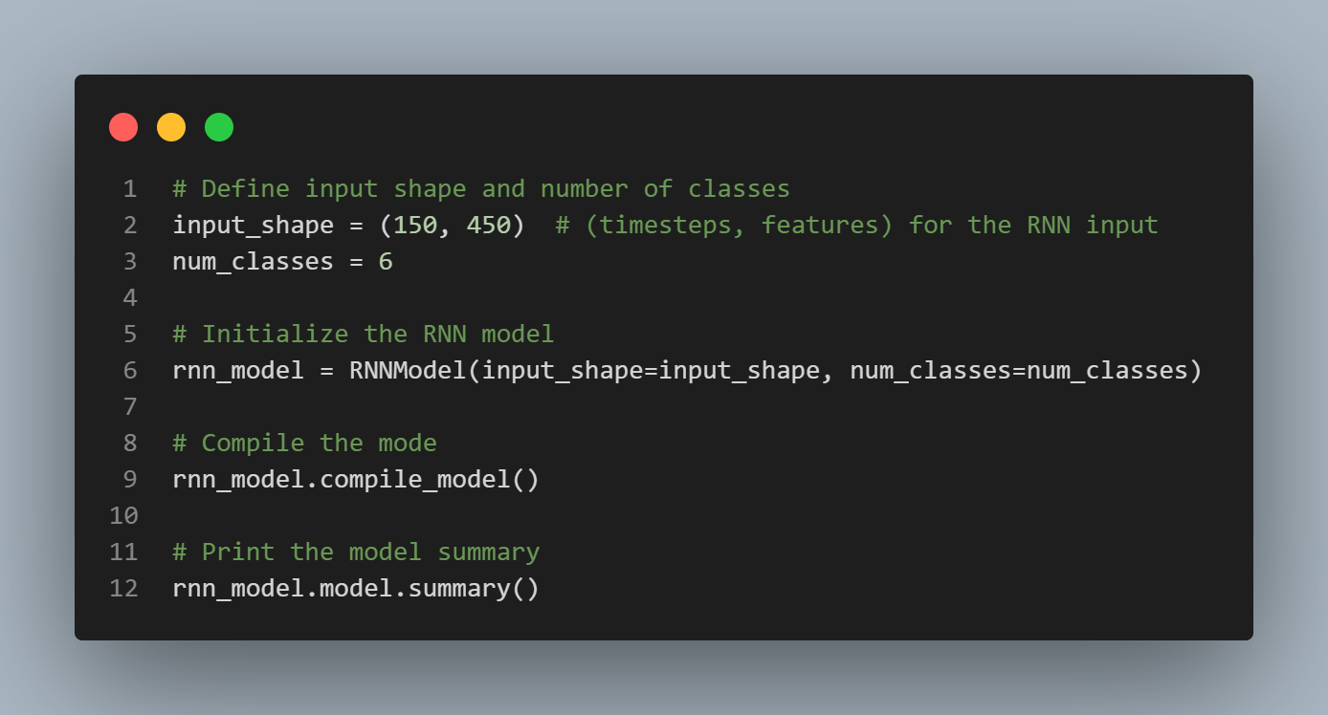

After reshaping the data, the next step involves defining the input shape and the number of output classes. For this implementation, the input shape is set to (150, 450), where 150 represents the timesteps and 450 represents the features, while the number of output classes is set to 6. Once these parameters are defined, the RNN model is initialized using the RNNModel class previously defined.

The model is then compiled, leveraging the same functions as in earlier implementations, and the summary of the model architecture is printed to provide an overview of the layers and parameters involved.

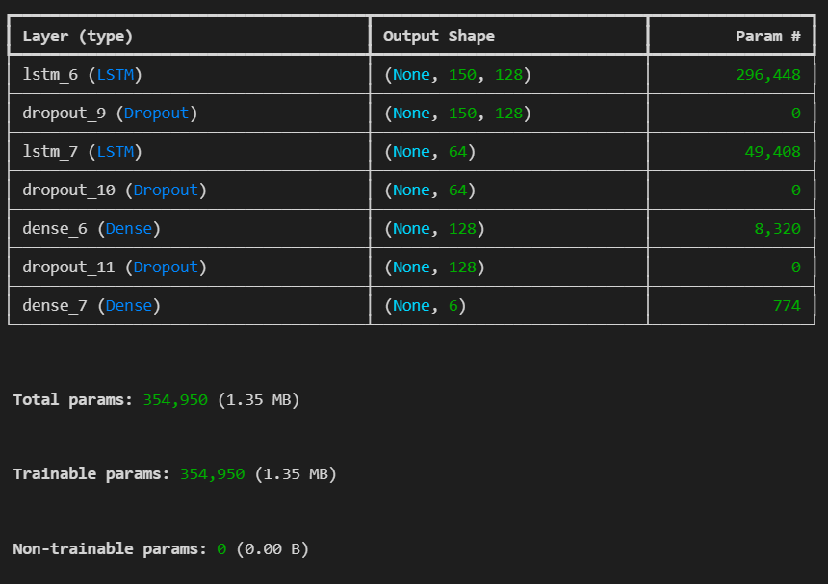

The model consists of two LSTM layers, with dropout layers inserted after each to reduce the risk of overfitting. Following the LSTM layers, a fully connected dense layer with 128 neurons is added, along with another dropout layer. Finally, the output layer contains 6 neurons, corresponding to the number of classes in the dataset, with a softmax activation function to predict class probabilities.

As shown in the model summary, the architecture comprises 354,950 parameters, all of which are trainable. This provides insight into the complexity of the RNN model and the resources required for training. The output shapes of each layer are also displayed, reflecting the transformations that occur as the data passes through the network.

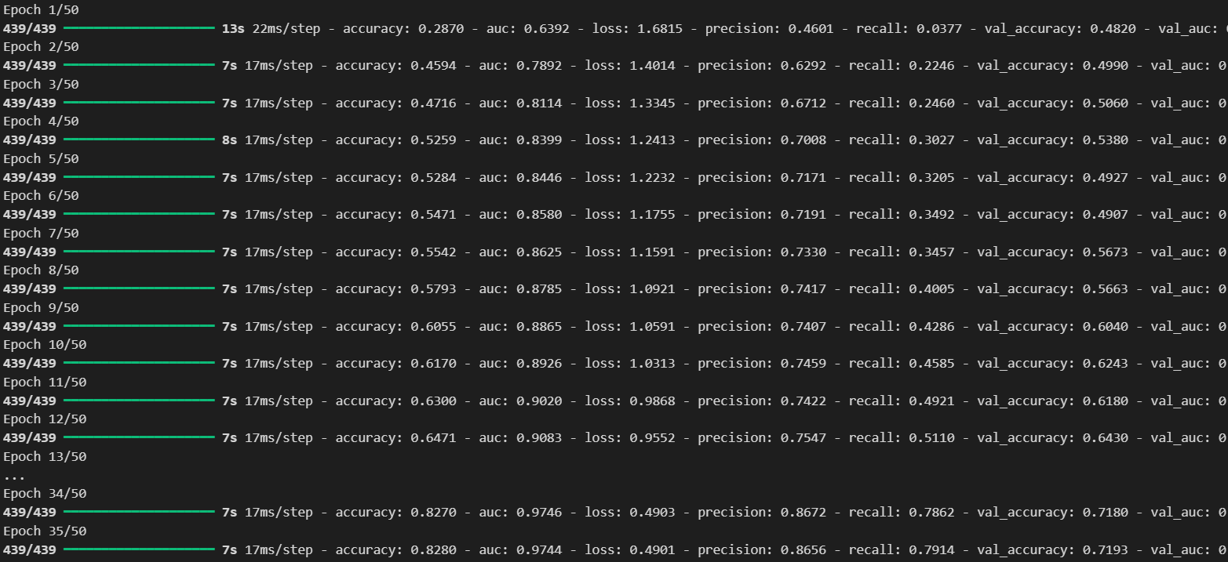

The training process is initiated with 50 epochs, utilizing early stopping, learning rate reduction, and model checkpointing mechanisms. Throughout the training, various metrics are monitored, including accuracy, precision, recall, and AUC. The early stopping criteria were set to monitor the validation loss, which allows the model to halt training early if no significant improvements are observed.

The training began with a lower accuracy and progressively improved over the epochs. However, the process was interrupted at the 35th epoch when the early stopping condition was triggered. This occurred because the validation loss did not show further improvement after the 35th epoch, indicating that the model had reached a point where additional training might lead to overfitting rather than improving the generalization ability.

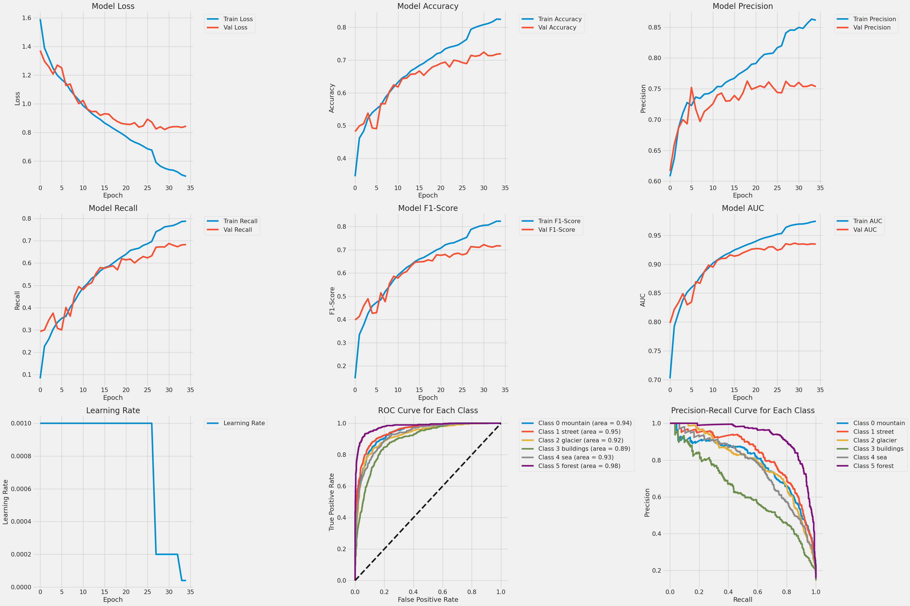

The graphs above provide a detailed look into the training and validation metrics across the epochs. The function used for plotting these metrics follows the same implementation as in the previous CNN and MLP models, as the plotting approach remains consistent across the different architectures.

The model loss graph indicates that both training and validation losses decreased consistently during the training process, with validation loss reaching a stable point around the 25th epoch. This stability in validation loss is the primary reason for the early stopping that occurred at the 35th epoch, preventing the model from overfitting. While the training loss continued to decrease, the validation loss suggested that the model had sufficiently learned from the data by this point.

The accuracy plot shows a steady rise in both training and validation accuracy, with training accuracy achieving a final value of approximately 82.8% and validation accuracy stabilizing at around 71.9%. This suggests that the model generalizes reasonably well to unseen data, although the difference between training and validation accuracy highlights some room for further improvement.

In terms of precision, the model reached approximately 87% for the training set and around 80% for the validation set by the end of the training process. The upward trend in precision suggests that the model becomes increasingly capable of correctly identifying positive samples over time.

The recall graph shows similar progress, with training recall peaking at around 79% and validation recall stabilizing around 74%. The close alignment between precision and recall, as evidenced by the F1-score graph, demonstrates that the model maintains a good balance between identifying positive cases and minimizing false negatives.

The AUC values, which reached around 97.5% for training and 80.3% for validation, further underscore the model’s strong classification performance. These high AUC scores reflect the model’s ability to discriminate effectively between the various classes.

The learning rate graph illustrates the scheduled reductions in the learning rate, with a notable drop occurring after the 15th epoch. This gradual reduction aids in fine-tuning the model, helping it converge more effectively while avoiding large updates to weights during the later stages of training.

Further analysis is provided by the ROC and precision-recall curves for each class, which confirm the model’s robust classification ability. Classes like buildings and streets show high performance with strong AUC and precision-recall values, while classes such as glaciers and seas exhibit slightly more variability. These observations suggest that while the model performs well overall, additional refinement could improve its ability to distinguish between more visually similar categories.

Basically, the training performance demonstrates that the RNN model has effectively learned to classify the dataset, with well-balanced improvements across various metrics. However, further optimization, especially for certain classes, could help enhance the model's performance even more.

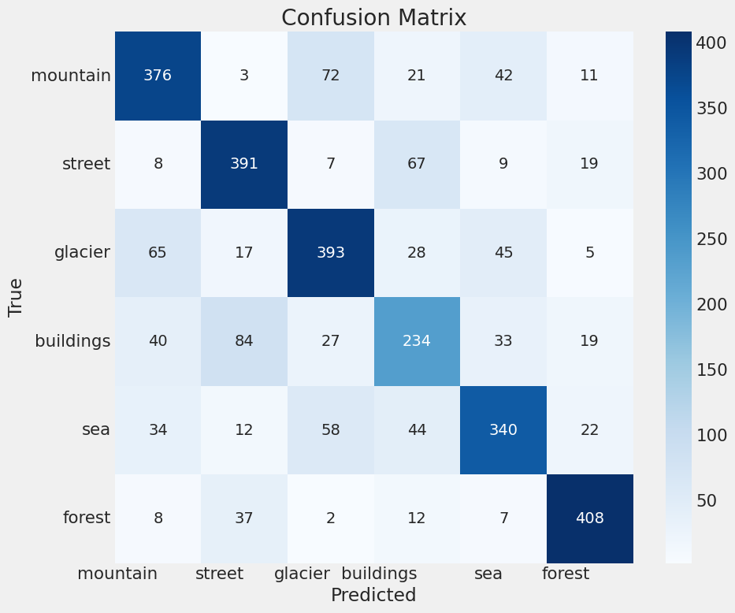

The confusion matrix above provides a detailed view of the model’s performance in classifying each category. The function used to generate this matrix follows the same implementation as the one used in previous sections by the other groupmates, ensuring consistency in the analysis.

From the matrix, it is clear that the model performs well on categories such as **forest** and **street**, with the highest correct classifications being observed in these classes. The forest class, in particular, shows 408 correct predictions, indicating strong model performance for this category. Similarly, the street class exhibits 391 correct predictions, reflecting the model’s ability to distinguish urban environments effectively.

However, the confusion matrix also highlights areas where the model struggles. For instance, there is noticeable confusion between **mountain** and **glacier** classes. The model misclassifies 72 mountain samples as glaciers, which may be due to the visual similarities between these landscapes. Likewise, the model often misclassifies **buildings** as streets, which can be attributed to the fact that buildings are frequently situated within street environments, making it difficult for the model to differentiate between the two.

Other noteworthy misclassifications include **sea** and **mountain** samples. For example, 42 sea samples are incorrectly labelled as mountains, likely due to the similarities in the background features, such as horizon lines or water bodies in mountain settings.

Overall, while the model performs well across most classes, it encounters challenges in distinguishing between visually similar categories. These insights provide a deeper understanding of the model’s behaviour and can inform potential improvements in future iterations.

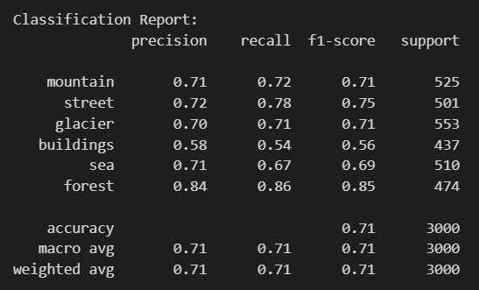

The classification report displayed above provides a detailed breakdown of the model's performance across various metrics, including precision, recall, and F1-score, for each class. The same function used by the groupmates to generate their classification report has been utilized here, ensuring consistency in the evaluation methodology.

The **forest** class demonstrates the highest performance, with a precision of 0.84, recall of 0.86, and an F1-score of 0.85. This indicates that the model has a strong ability to correctly identify instances belonging to this class while minimizing both false positives and false negatives. The **street** class also performs relatively well, with a precision of 0.72, recall of 0.78, and an F1-score of 0.75, suggesting effective classification in urban settings.

In contrast, the **buildings** class shows lower performance, with a precision of 0.58, recall of 0.54, and an F1-score of 0.56. This is consistent with the confusion observed in the confusion matrix, where buildings are frequently misclassified as streets. This discrepancy highlights the challenge the model faces in distinguishing between classes that share visual similarities.

The overall accuracy of the model is 71%, with macro and weighted averages for precision, recall, and F1-score also standing at 0.71. These averages reflect the model's balanced performance across all classes. While the model performs well in certain categories, such as forests and streets, it still struggles with more ambiguous classes like buildings and seas, where additional refinement could lead to further improvements in accuracy.

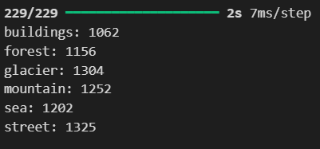

The image above displays the count of samples predicted for each class during the testing phase of the model. This part of the implementation uses the same function as in previous models to count the occurrences of predicted labels across the six classes.

The number of predictions varies slightly across the classes, with **glacier** and **street** receiving the highest number of predicted samples (1304 and 1325, respectively), while **buildings** have the lowest count of predictions at 1062. The imbalance in the predicted sample counts could be indicative of the model's inherent biases toward certain classes, potentially due to differences in the complexity of features or overlap with other categories.

This output helps provide insight into how the model distributes its predictions across various classes, which can be important when assessing performance fairness and potential areas for further refinement.

### Model Tuning

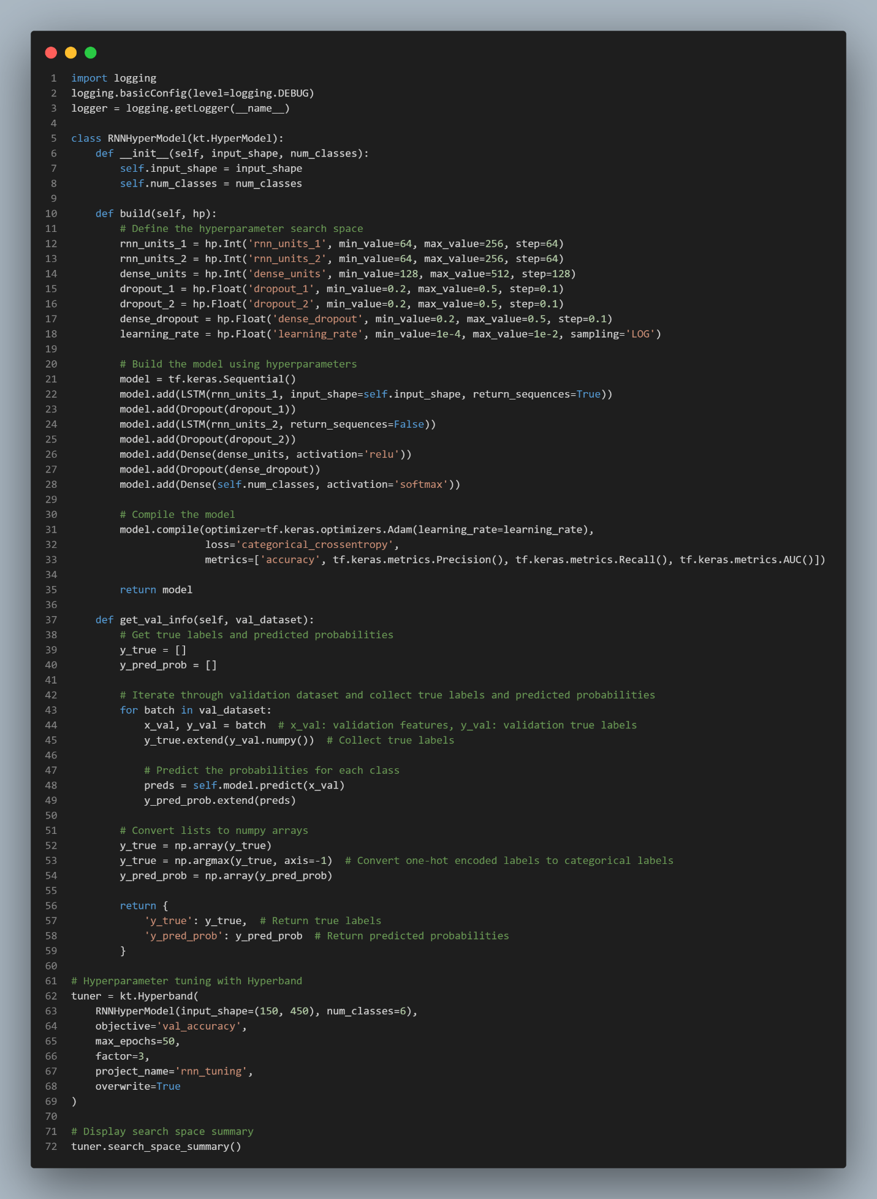

The code above demonstrates the implementation of hyperparameter tuning for the RNN model using **Keras Tuner** with the **Hyperband** strategy. The class RNNHyperModel defines the search space for various hyperparameters, including the number of units for each LSTM layer, dense layer units, dropout rates, and learning rate. Each hyperparameter is assigned a range of values to search through during the tuning process.

The model architecture remains largely similar to the earlier defined RNN, with two LSTM layers followed by dense layers and dropout to prevent overfitting. The key difference here is that the architecture is built dynamically based on the selected hyperparameters. The model is compiled using the Adam optimizer with categorical cross-entropy as the loss function and accuracy, precision, recall, and AUC as evaluation metrics.

The function get_val_info is also defined here to gather validation data predictions, which is useful for model evaluation during the hyperparameter tuning process.

Hyperband is set to explore different configurations across 50 epochs, aiming to maximize validation accuracy. The search space summary, which is displayed in the output, gives a clear view of the parameter ranges that will be explored.

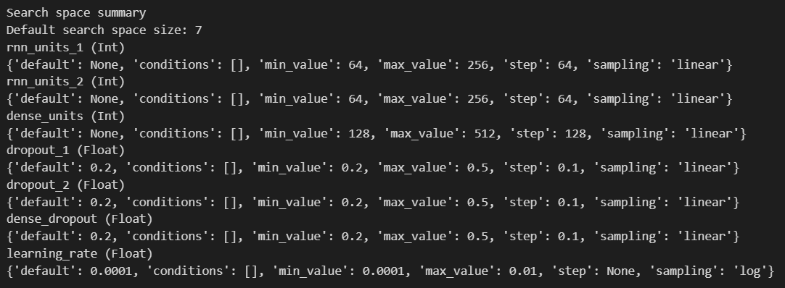

The search space summary displayed above shows the different hyperparameters that will be tuned during the Hyperband process. For instance, the **number of units** for each LSTM layer can range from 64 to 256, while the **dense units** can vary from 128 to 512. Dropout rates are also included in the search space, with values ranging between 0.2 and 0.5. The learning rate follows a logarithmic sampling strategy, ranging from 0.0001 to 0.01.

This setup ensures that the model will explore a wide range of configurations, allowing the tuner to find an optimal combination of hyperparameters that maximizes validation accuracy. The flexibility provided by the defined search space is critical in identifying a model configuration that best fits the data.

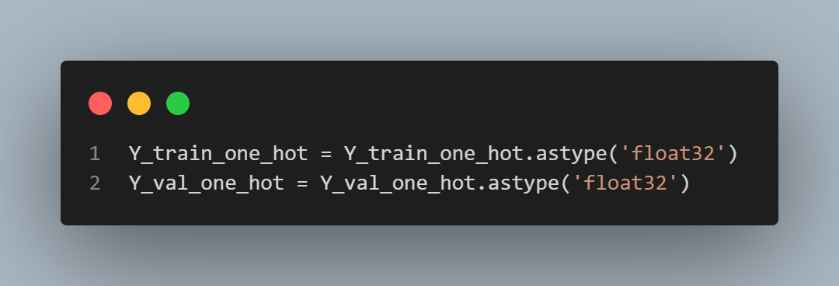

Before initiating the hyperparameter tuning process with the hypermodel, the training and validation labels need to be prepared in the appropriate format. The code snippet above converts the one-hot encoded labels for both the training and validation datasets to the float32 data type. This ensures that the labels are in the correct format required for the training process, particularly when using certain TensorFlow/Keras functions that expect labels to be in float32 precision.

This preprocessing step is crucial to avoid any compatibility issues when fitting the model during the hyperparameter tuning phase, ensuring that the data is properly aligned with the model's input expectations.

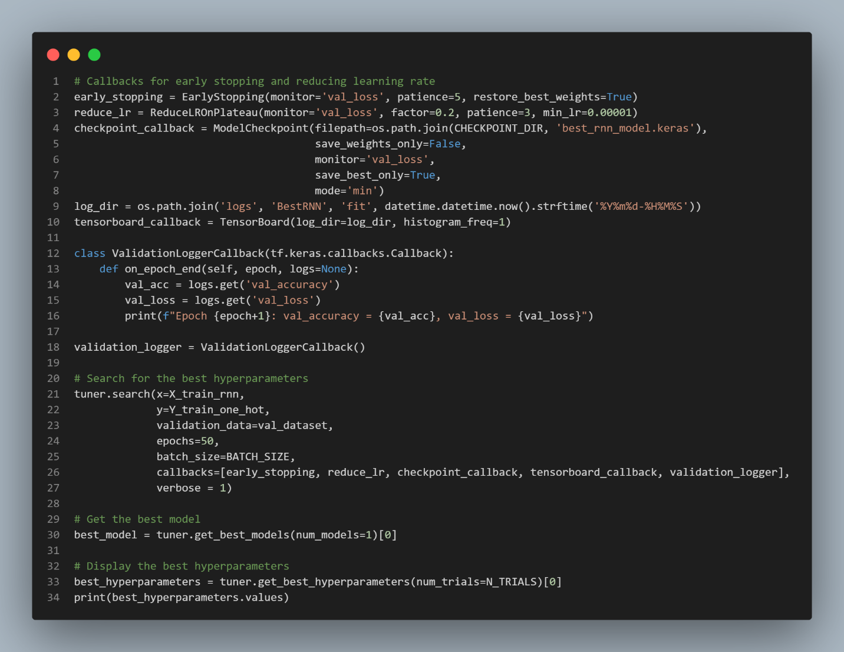

The code above initiates the hyperparameter tuning process using the defined callbacks for early stopping, learning rate reduction, and checkpoint saving. These callbacks play a crucial role in controlling the training process during tuning to prevent overfitting and to save the best model based on validation loss.

The early stopping callback monitors the validation loss and stops the training if no improvements are detected after five epochs. The learning rate is reduced on the plateau to help the model converge more effectively, and a checkpoint callback saves the best-performing model based on the validation loss.

Additionally, a custom ValidationLoggerCallback is implemented to log the validation accuracy and loss after each epoch. This provides real-time insights into the model's performance throughout the tuning process.

The actual hyperparameter search is performed using the tuner.search() function, which initiates the tuning process over 50 epochs, using the training data and validation data provided. The callbacks ensure that the best hyperparameters and models are saved during the search. Once the search is complete, the best model and its associated hyperparameters are retrieved for evaluation and further training.

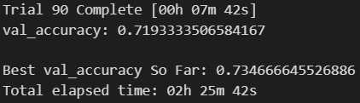

The output above displays the results after 90 trials of hyperparameter tuning using the Hyperband strategy. The tuning process evaluated multiple configurations of hyperparameters to optimize the model's validation accuracy. After approximately 2 hours and 25 minutes of experimentation, the best validation accuracy achieved so far is 0.7347, with the current trial's validation accuracy at 0.7193.

This result demonstrates that the model tuning has been successful in improving the validation accuracy. The tuning process explored various combinations of LSTM units, dense layer units, dropout rates, and learning rates, helping the model generalize better to unseen data. The final chosen hyperparameters will guide the model's performance in subsequent training and evaluation stages, aiming to achieve the best possible accuracy.

The best hyperparameters found are:

|  |  |
| --- | --- |
| Hyperparameters | Value |
| 'rnn_units_1' | 192 |
| 'rnn_units_2' | 256 |
| 'dense_units' | 256 |
| 'dropout_1' | 0.30000000000000004 |
| 'dropout_2' | 0.4 |
| 'dense_dropout' | 0.30000000000000004 |
| 'learning_rate' | 0.002849590134019719 |
| 'tuner/epochs' | 50 |
| 'tuner/initial_epoch' | 17 |
| 'tuner/bracket' | 3 |
| 'tuner/round' | 3 |
| 'tuner/trial_id' | ‘0047' |

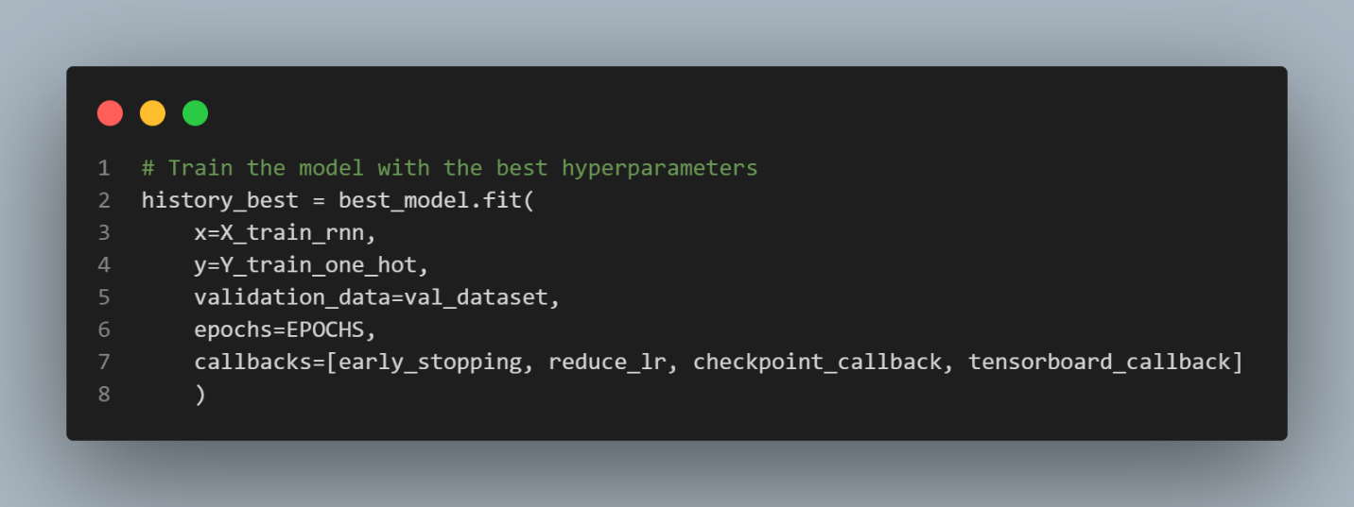

After determining the optimal hyperparameters through the tuning process, the model is retrained using these best hyperparameters. The code snippet above initiates the training process for 50 epochs, utilizing the same callbacks that were used during the tuning phase. These callbacks include early stopping, learning rate reduction, checkpoint saving, and TensorBoard logging, ensuring the model training is monitored and controlled effectively.

By using the best hyperparameters, the model is expected to perform optimally on the training and validation datasets. The performance will be tracked across all epochs to ensure the model reaches the best possible generalization while avoiding overfitting.

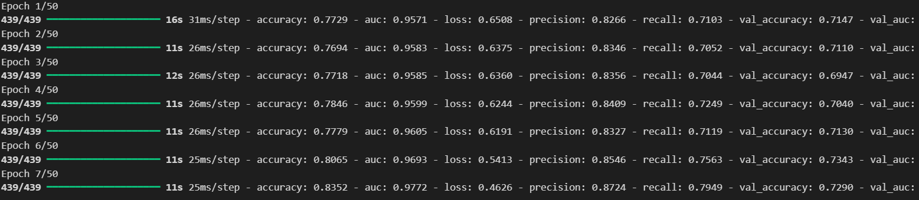

The output shows the model’s progression through the training process. By the 7th epoch, the training accuracy had reached 83.5%, with a validation accuracy of 73.4%. The model also achieved a high AUC score of 97.7%, reflecting its strong ability to distinguish between the different classes. Precision and recall improved significantly as well, with precision reaching 87.2% and recall at 79.5%, indicating that the model effectively minimized false positives and false negatives.

The early stopping mechanism ensured that the model did not overfit, halting training once the validation loss stabilized. As a result, the model reached optimal performance without unnecessary additional training.

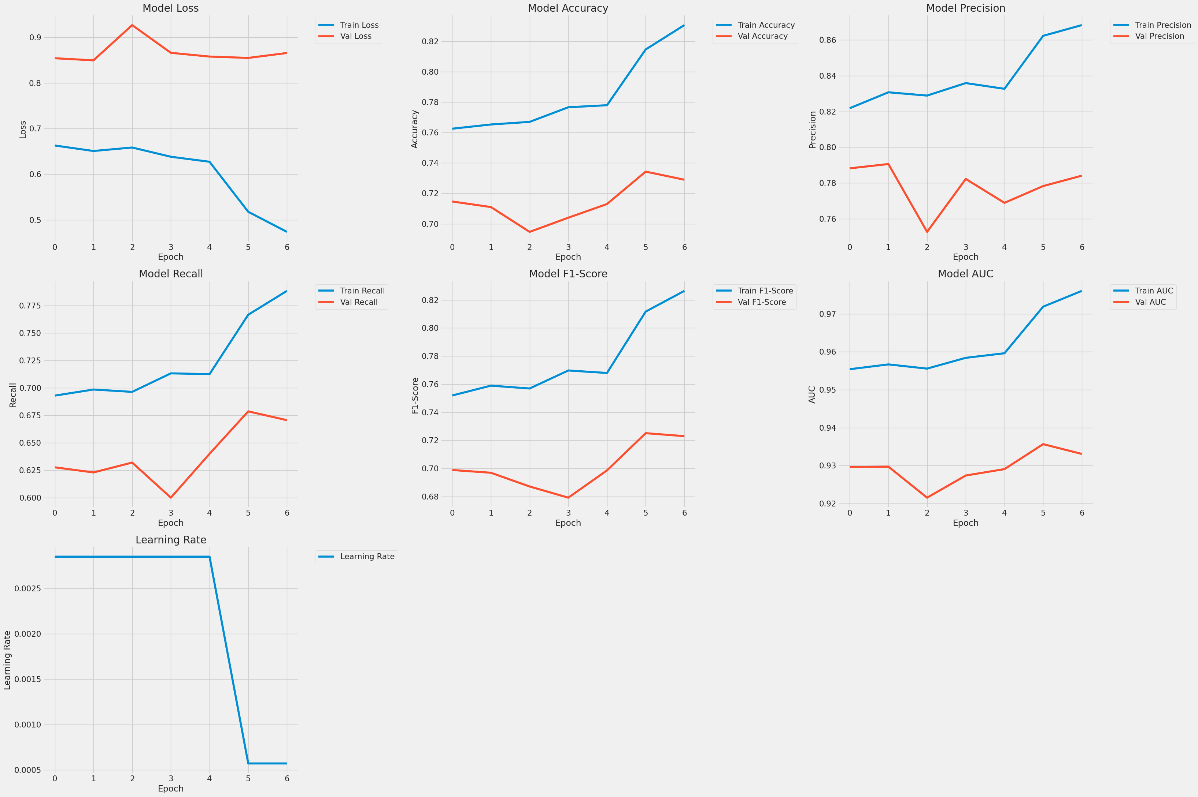

The plots above display the training and validation metrics across the 7 epochs of training with the best hyperparameters. These visualizations were created using the same plotting function utilized in previous sections. The early stopping mechanism was triggered at the 7th epoch due to a lack of significant improvements in the validation loss, which explains the relatively short training duration.

At first glance, the gaps between the training and validation lines might suggest a disparity in model performance. However, it's important to note that the small sample of epochs and the narrow axis ranges exaggerate these differences. The gaps are expected due to the limited number of epochs and are not necessarily an indicator of overfitting. This is further confirmed by the fact that early stopping was triggered, meaning the model halted training before it could overfit to the training data.

The model loss plot shows that the training loss steadily decreased, while the validation loss remained stable with some minor fluctuations, which is typical for models that are nearing optimal performance but not yet overfitting. The accuracy graphs reflect an upward trend, with the model's training accuracy reaching around 83.5% and validation accuracy stabilizing at 73.4% by the 7th epoch. This indicates that the model is generalizing well to the validation data, even if the improvement was gradual.

In terms of precision, recall, and F1-score, the model demonstrated steady improvement throughout training, achieving a precision of 87.2% and a recall of 79.5%. The validation metrics, while slightly lower, show consistent improvement, which supports the conclusion that the model is learning effectively. The area under the curve (AUC) metric further strengthens this observation, with the training AUC reaching 97.7% and the validation AUC stabilizing at around 93%. This suggests that the model has a strong capacity to distinguish between classes, even in the early stages of training.

The learning rate plot shows a controlled reduction, which is part of the learning rate scheduling mechanism that helps the model make smaller, more refined updates in later epochs. This reduction ensures that the model converges effectively while preventing large swings in performance during training.

Overall, the metrics suggest that the model is learning efficiently and effectively, with stable improvements in validation performance. The early stopping mechanism prevented overfitting, ensuring that the model retained its generalization capabilities without the need for extensive additional training. The model's steady performance across key metrics like precision, recall, and AUC indicates that it is well-suited to the task at hand, even in a relatively short training period.

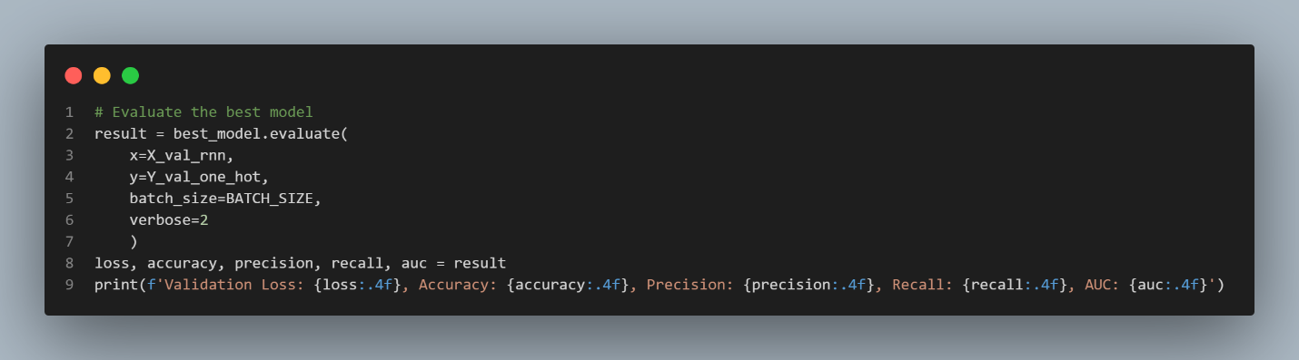



The code snippet above shows the evaluation of the best model, which was previously trained using the optimal hyperparameters. This step involves feeding the validation data into the model and calculating key performance metrics, including validation loss, accuracy, precision, recall, and AUC. These metrics provide a comprehensive understanding of the model's performance on unseen data.

The output from the evaluation process reflects the final performance of the model. The validation accuracy is 71.1%, which is consistent with the values observed during training. The precision stands at 79.1%, indicating that the model is relatively good at correctly identifying positive samples. However, the recall is somewhat lower at 62.3%, suggesting that the model may still struggle to capture all relevant positive instances.

The validation loss is recorded at 0.8495, which shows that the model's predictions are reasonably close to the true labels, but there is room for further refinement. The AUC score of 0.9297 is quite high, indicating that the model is effective in distinguishing between classes across the validation set.

This evaluation highlights that the model is performing well, though there are opportunities to improve recall and reduce the validation loss. The balance between precision and recall also suggests that, while the model is precise, there may still be false negatives that require further tuning or data adjustments.

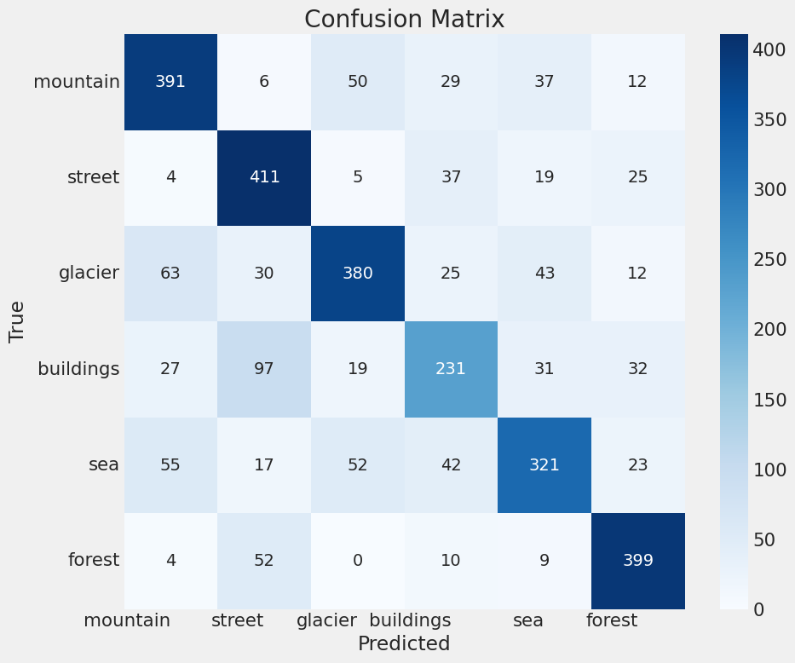

The confusion matrix above was generated using the same function as my groupmates, providing a breakdown of the model's classification performance across different categories. The matrix highlights the number of correct and incorrect predictions made by the model, giving a deeper insight into where the model performs well and where it struggles.

The **forest** and **street** classes continue to show strong classification results, with 399 and 411 correct predictions, respectively. This demonstrates the model's ability to effectively distinguish these categories from others, which is consistent with earlier performance metrics such as precision and recall.

However, the matrix also reveals areas where the model faces challenges. For example, the **buildings** and **glacier** classes exhibit more confusion, with a significant number of misclassifications. Specifically, 97 instances of buildings were misclassified as streets, which is not entirely surprising given the visual similarities between urban settings and street environments. Similarly, glaciers are often confused with mountains, as evidenced by the 63 glacier samples being misclassified as mountains. This pattern reflects the difficulty in distinguishing between certain natural landscapes, likely due to overlapping visual features in the dataset.

The **sea** and **mountain** categories also show some confusion, with 55 sea samples being incorrectly predicted as mountains. This may stem from similarities in the backgrounds, such as horizon lines or water bodies.

Overall, the confusion matrix offers valuable insights into the model's performance. While the model excels in certain categories, there are opportunities for improvement in distinguishing between classes with overlapping features, such as mountains and glaciers or streets and buildings. These findings could guide future efforts in fine-tuning the model or exploring additional data preprocessing techniques to improve classification accuracy.

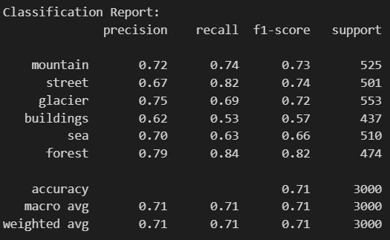

The classification report above provides a detailed breakdown of the model's precision, recall, and F1-score across the six classes, with the same function used as in previous groupmate implementations. These metrics are key indicators of the model’s ability to correctly classify instances for each class, reflecting both its strengths and areas for improvement.

The **forest** and **street** classes show relatively high performance, with **forest** achieving the best overall F1-score at 0.82. This is supported by strong precision (0.79) and recall (0.84), indicating the model’s ability to accurately and consistently classify samples from this category. The **street** class also performs well, with a recall of 0.82, though its precision is slightly lower at 0.67, which means that while the model correctly identifies most of the street instances, it also incorrectly classifies some other categories as streets.

In contrast, the **buildings** class has the lowest performance, with a precision of 0.62 and a recall of 0.53, resulting in an F1-score of 0.57. This suggests that the model struggles to differentiate buildings from other categories, which is consistent with the confusion matrix findings where buildings were frequently misclassified as streets.

The **glacier** and **sea** classes demonstrate moderate performance, with precision and recall values in the 0.70–0.75 range, leading to F1-scores of 0.72 and 0.66, respectively. The confusion between glaciers and mountains observed in the confusion matrix is reflected here, as the model occasionally misclassifies glaciers as mountains.

Overall, the model achieves an accuracy of 71%, with macro and weighted averages for precision, recall, and F1-score all converging at 0.71. While these results indicate that the model performs reasonably well across all classes, there is still room for improvement in specific categories, particularly buildings and sea, where precision and recall scores lag behind.

This analysis highlights the model's ability to handle some classes better than others, with notable success in classifying forest and street images. However, additional tuning or feature extraction might help improve performance in the more challenging categories, such as buildings and sea.

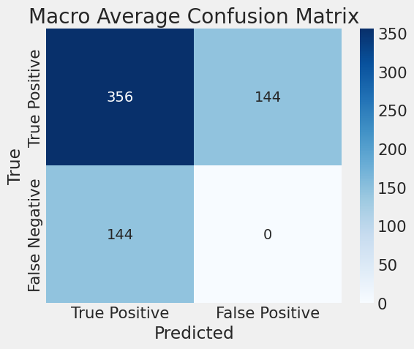

The macro average confusion matrix shown above offers a high-level view of the model's classification performance by averaging over all classes. The macro average approach gives equal weight to each class, ensuring that the model's performance across all categories is considered evenly, regardless of class distribution.

The matrix shows that the model made 356 true positive predictions and 144 false negatives, with no false positives recorded. The absence of false positives indicates that the model is highly precise in its predictions for certain categories, consistently identifying true positives without making incorrect positive predictions.

However, the presence of 144 false negatives suggests that while the model may be precise, it has missed a significant number of true instances, resulting in false negatives. This imbalance is likely contributing to the lower recall observed in some of the individual class metrics. The model's ability to capture all relevant instances (recall) might benefit from further adjustments in training, feature extraction, or the balancing of class representations.

Overall, the macro average confusion matrix reveals that while the model performs well in avoiding false positives, it still struggles to capture all relevant positive instances, as reflected in the higher number of false negatives. Addressing this issue could lead to a more balanced and robust model, particularly in the context of underrepresented or visually ambiguous classes.

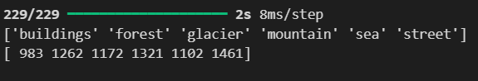

The output shown above represents the number of predicted samples for each class after running the model on the testing dataset. The six classes—buildings, forest, glacier, mountain, sea, and street—have varying numbers of predictions, reflecting the distribution of the model's output across these categories.

The **street** class has the highest number of predictions with 1,461 samples, while **buildings** have the lowest at 983 samples. This discrepancy in predictions may be a result of the class imbalances within the dataset or the model's inherent biases toward certain classes, particularly those with distinct features that the model can more easily recognize, like streets.

Classes like **forest**, **glacier**, and **mountain** have relatively balanced prediction counts (1,262, 1,172, and 1,321, respectively), suggesting that the model performs consistently across these categories. However, **sea** has fewer predictions (1,102), which could indicate that the model struggles to consistently classify samples from this category, potentially due to overlapping features with other natural scenes.

This distribution insight helps in understanding how the model allocates its predictions and provides clues about the model's strengths and weaknesses. Further tuning or dataset balancing might help ensure more even distribution across classes and better overall classification performance.

#### Model Error Analysis

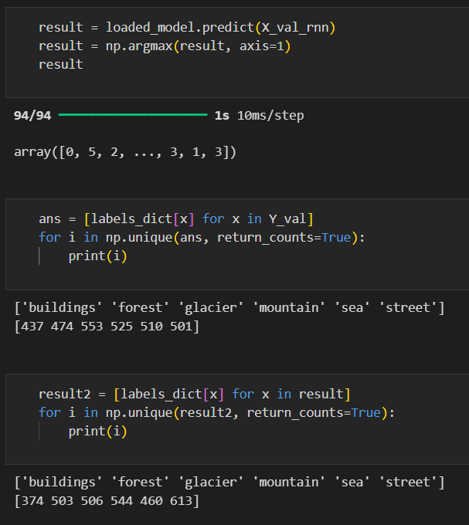

The code and output displayed above provide the groundwork for analyzing the model's prediction errors. The results from the validation dataset are compared against the true labels, and discrepancies between predicted and true values offer insights into the model's performance.

The predictions (result) are obtained by passing the validation data (X_val_rnn) through the trained model. The predicted labels are then converted using argmax to select the class with the highest probability for each sample.

By mapping both the true validation labels (Y_val) and predicted labels back to their respective class names using the labels_dict, the counts of each class in both the ground truth and predictions are compared. For instance, the **forest** class has 474 true instances in the validation set but 503 instances predicted by the model. Similarly, the **buildings** class has 437 true instances but only 374 predicted samples, indicating that some building samples may have been misclassified as other categories, such as streets or sea.

These discrepancies between the true and predicted label counts reveal potential biases in the model. For instance, the over-prediction of certain classes (e.g., **street**) and under-prediction of others (e.g., **buildings**) suggests that the model might be more confident or better at recognizing particular features associated with certain classes, while struggling with others. This could be due to similarities between classes (e.g., **buildings** and **street**) or the imbalance of features learned by the model.

Further analysis of specific instances where the model made incorrect predictions would help to identify the root causes of these errors and provide actionable steps for model improvement, such as augmenting the dataset or tuning hyperparameters further to balance the classification performance across all categories.

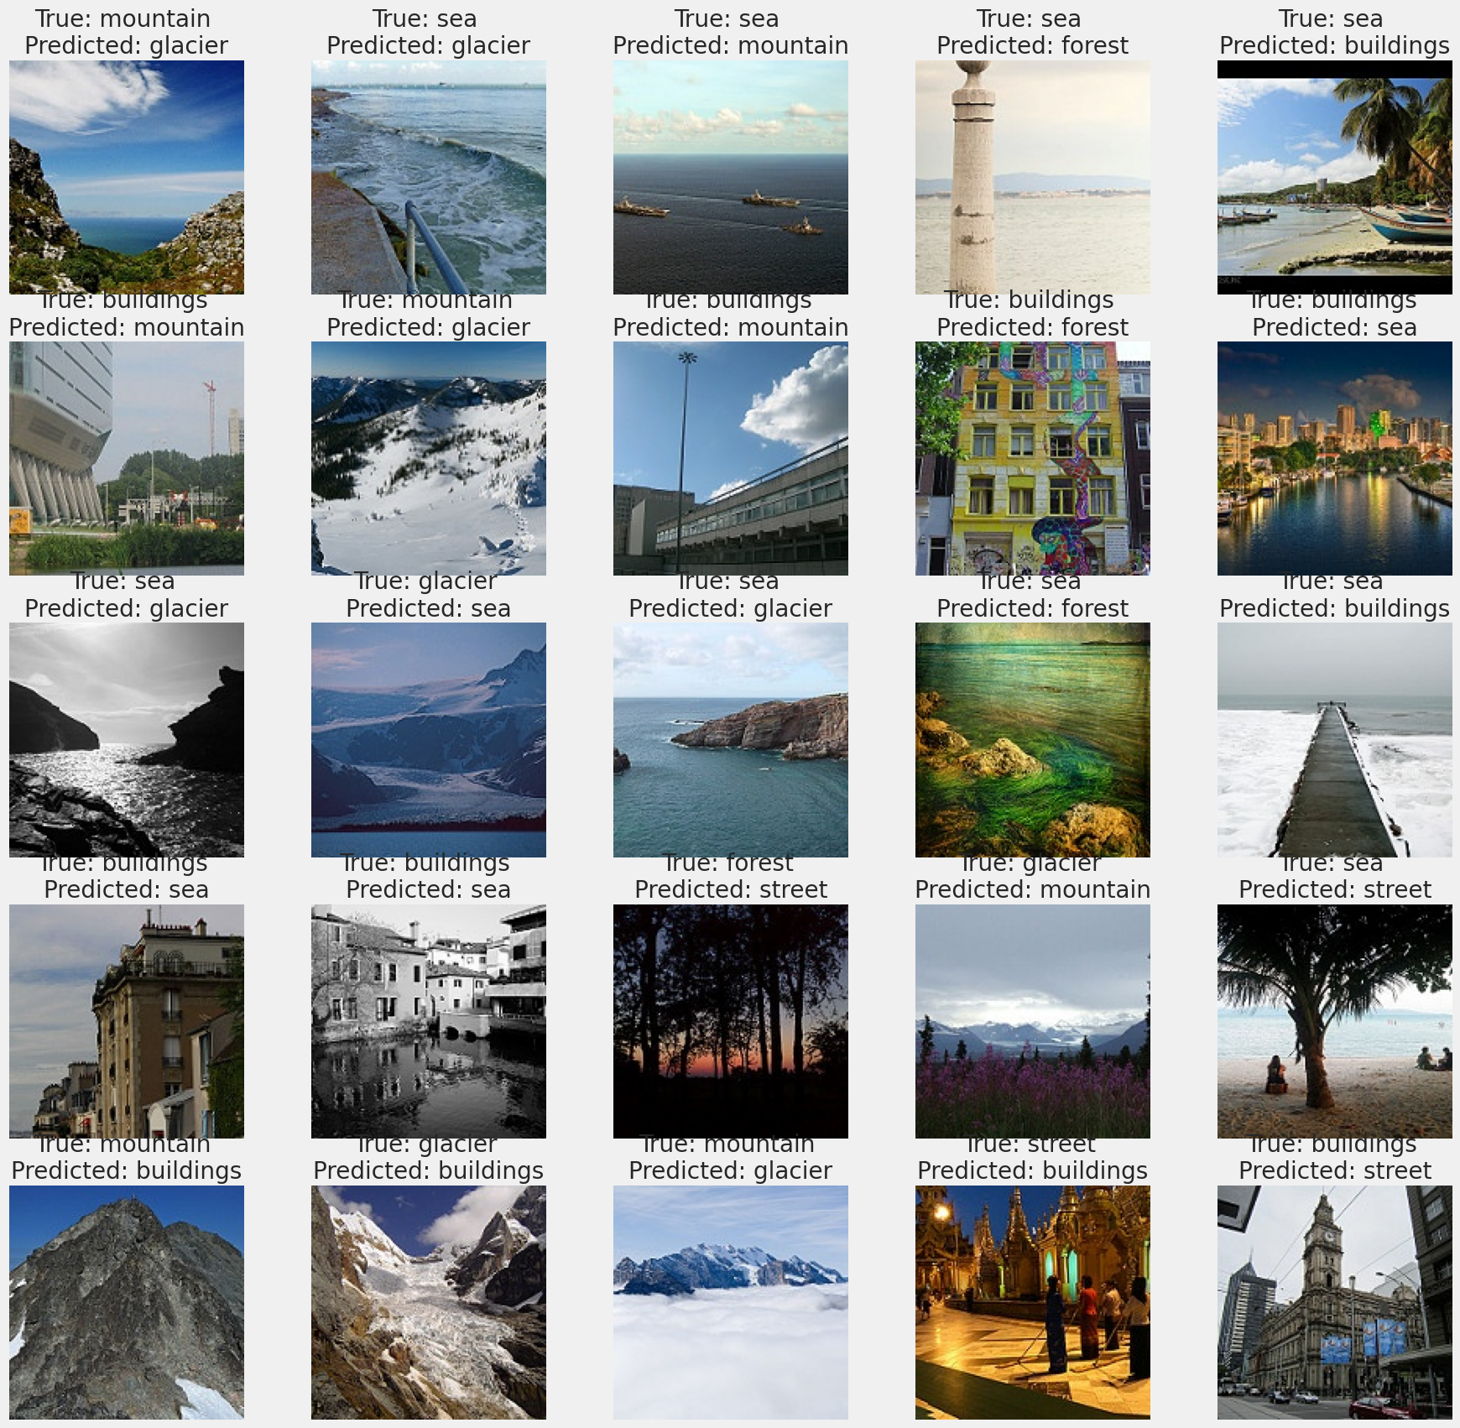

The image grid above displays examples of mislabelled images, showcasing instances where the model made incorrect predictions. This analysis uses the same implementation code as that of the groupmates to visually highlight where the model struggled in distinguishing between certain classes.

Several notable misclassifications can be observed. For example, multiple instances of **mountains** were incorrectly labelled as **glaciers**, and vice versa. This suggests that the model is finding it difficult to differentiate between these two categories, likely due to similar environmental features such as snow-covered landscapes or rocky terrains. Similarly, **buildings** and **streets** also exhibit confusion, with multiple images of **buildings** being misclassified as **streets**, possibly because of overlapping features in urban environments.

Another significant pattern is the frequent confusion between **sea** and **glacier** images. In several cases, **sea** images were predicted as **glacier** or **mountain**, which might be due to similar color tones or horizon lines, causing the model to misinterpret the features.

This visual representation of misclassifications offers valuable insights into the model’s limitations. The patterns of errors observed here provide actionable feedback, such as potentially using more distinctive features or augmenting the dataset with clearer examples of the confused categories to help the model better distinguish between them.

Overall, the misclassifications reveal that while the model performs well in many areas, it struggles with classes that have visually similar or overlapping features.

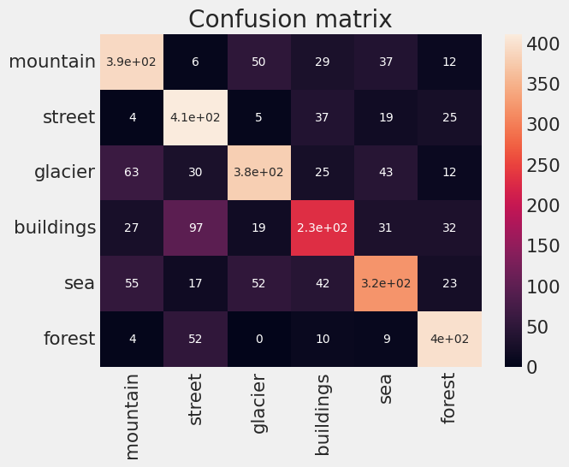

The confusion matrix displayed above provides a visual summary of the model’s classification performance across all six classes after the complete evaluation phase. The matrix uses a color scale to indicate the frequency of correct and incorrect predictions for each class, offering a clearer understanding of where the model performs well and where it struggles.

The **forest** and **street** classes continue to show strong performance, with the highest true positive counts, as seen with **forest** having 400 correct predictions and **street** with 411. These results are consistent with earlier findings, where the model demonstrated a high recall for these categories.

On the other hand, the **buildings** class shows the most significant confusion, with 97 instances misclassified as **street** and 31 misclassified as **sea**. This suggests that the model struggles to distinguish between urban settings and other similar environments, likely due to overlapping visual features in the dataset, such as architectural structures and open spaces.

The **mountain** and **glacier** classes also show notable confusion, with 63 instances of **glacier** misclassified as **mountain** and 50 instances of **mountain** misclassified as **glacier**. This is not surprising given the visual similarities between these two natural landscapes, where features such as snow or rocky terrain can easily be mistaken for one another by the model.

The **sea** class exhibits moderate confusion, with some instances being misclassified as **glacier** or **mountain**, which may be caused by similar horizon lines or color tones that appear in both sea and mountain images.

Overall, the confusion matrix reveals that while the model has strong predictive power for certain classes like **forest** and **street**, it still faces challenges with others, particularly **buildings** and **glacier**, where visual overlap with other categories leads to misclassifications.

### Model Explainability

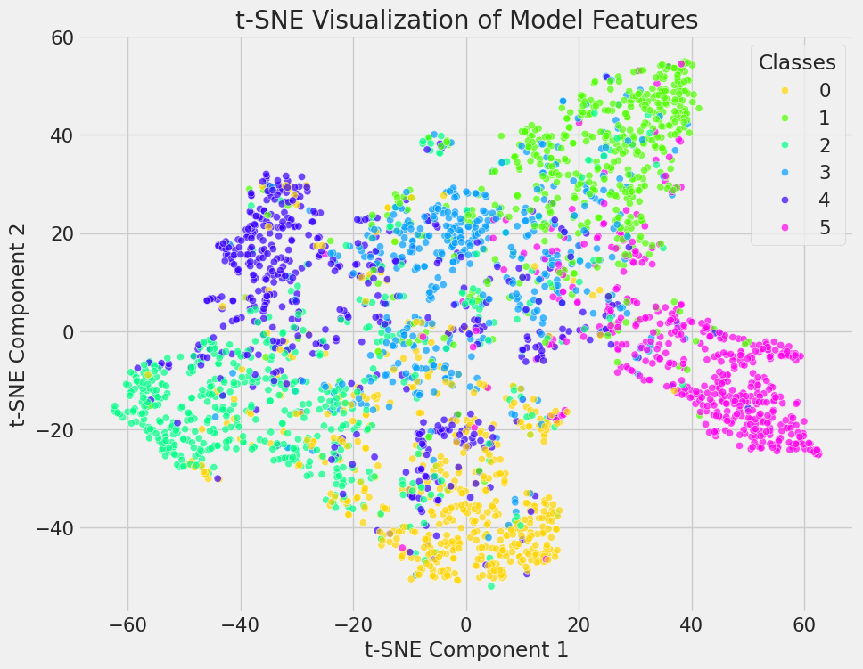

The t-SNE (t-distributed Stochastic Neighbor Embedding) visualization above shows the distribution of the model’s learned features across the six classes. This method is widely used for dimensionality reduction, providing a two-dimensional representation of the high-dimensional feature space that the model learned during training. The code used to generate this visualization is consistent with what other groupmates have implemented.

At a glance, classes like **forest** (in pink) and **street** (in light green) form fairly tight, well-defined clusters, suggesting that the model has learned strong, discriminative features for these categories. This aligns with the high accuracy and recall observed for these classes in the confusion matrix and classification report.

On the other hand, classes like **glacier** and **mountain** (blue and light blue) show more overlapping regions. This reflects the earlier observation from the confusion matrix, where the model had difficulty distinguishing between these two categories, likely due to the visual similarities between snowy mountain ranges and glaciers.

Interestingly, the **sea** class (green) appears somewhat spread out and overlaps slightly with other categories, which might explain why some sea images were misclassified as glacier or mountain. Similarly, **buildings** (yellow) show less cohesion, indicating that the model may struggle to learn distinctive features for urban environments, which could lead to misclassification with streets or other visually similar categories.

This t-SNE visualization provides valuable insights into how the model is interpreting the data and where it struggles to separate classes effectively. It also reinforces the earlier findings from the confusion matrix and classification report, where certain classes performed well while others, particularly those with visual overlap, encountered more challenges.

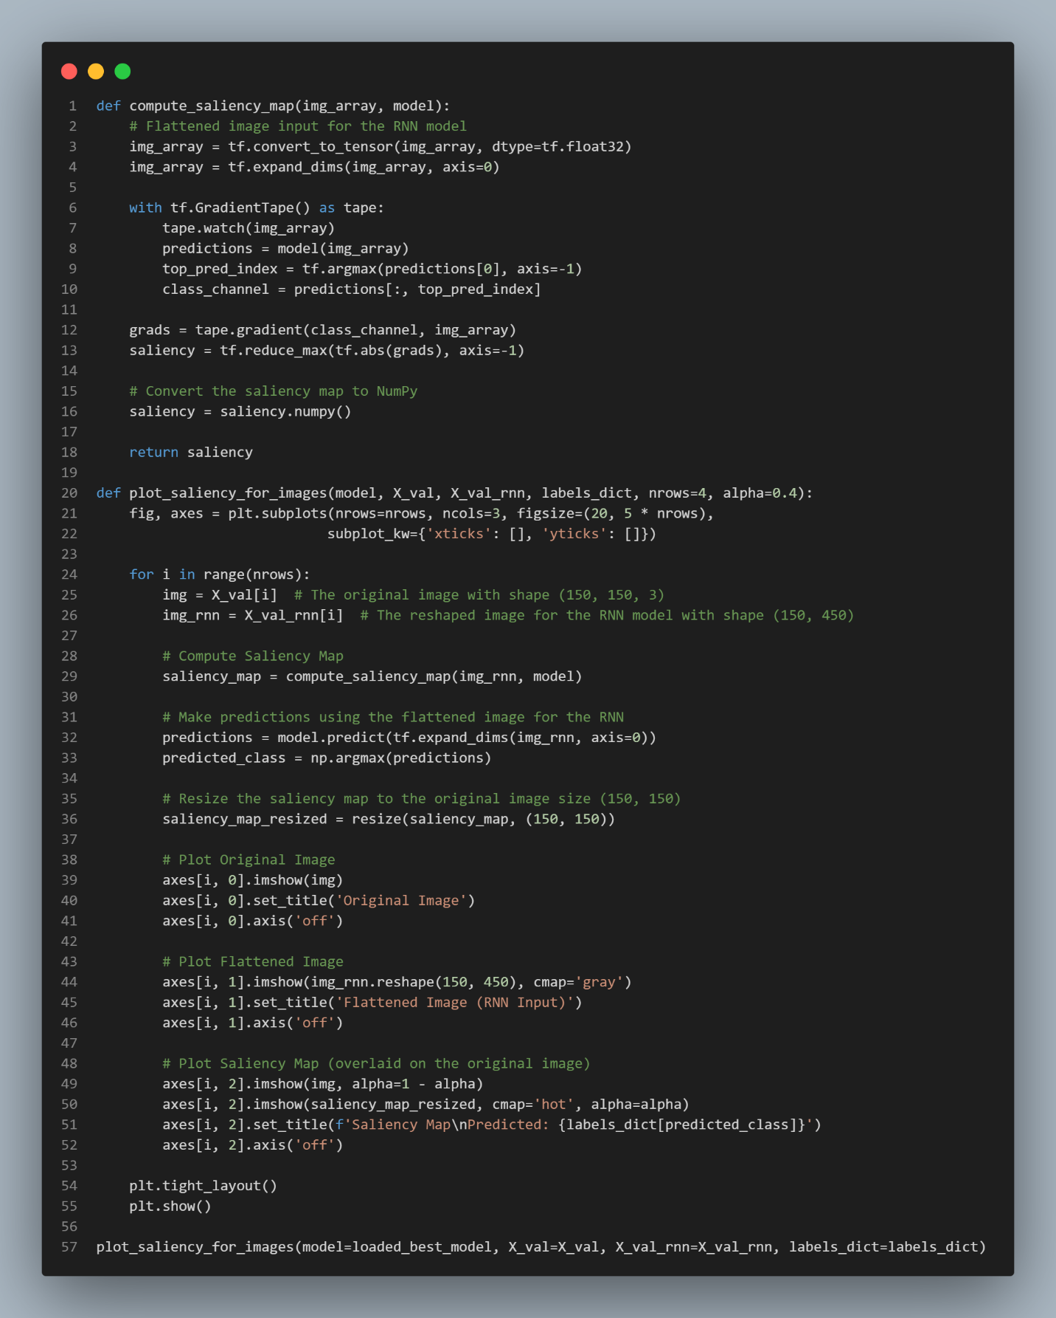

In this implementation, the process of generating saliency maps is tailored to fit the requirements of the RNN model. Unlike CNNs, which process image data in its original 2D/3D shape, RNNs require the input to be flattened into a sequential format. This transformation is similar to what was done in another groupmate’s MLP implementation, where a **flatten layer** was applied to the input data. However, in this case, the image data is flattened explicitly before being passed to the RNN, as the model architecture expects sequential data rather than spatial data.

The process begins by converting the input image into a format that the RNN can process. The image is reshaped to match the sequential input structure required by the model. Once the data is reshaped, a **GradientTape** is used to compute the saliency map by identifying the gradients with respect to the predicted class. These gradients show which parts of the image have the most influence on the model’s decision, highlighting the important features.

The code then generates and displays the saliency maps along with the original and flattened images. Since the input is flattened, the visual representation of the data changes, leading to **vertical lines** in the saliency map instead of the more common heatmap patterns seen in CNNs. This is because the sequential nature of the data in RNNs distorts the original spatial layout of the image.

The output showcases three components:

1. The **original image** from the dataset.
2. The **flattened image**, which the RNN processes as input.
3. The **saliency map**, indicating the regions where the model places the most importance when making predictions.

This implementation provides a unique view of how RNNs handle image data, focusing on sequential patterns rather than spatial features, similar to how MLPs with flatten layers also require input transformations. However, the RNN's approach differs in that it explicitly works with time steps rather than fully connected layers, as seen in the MLP.

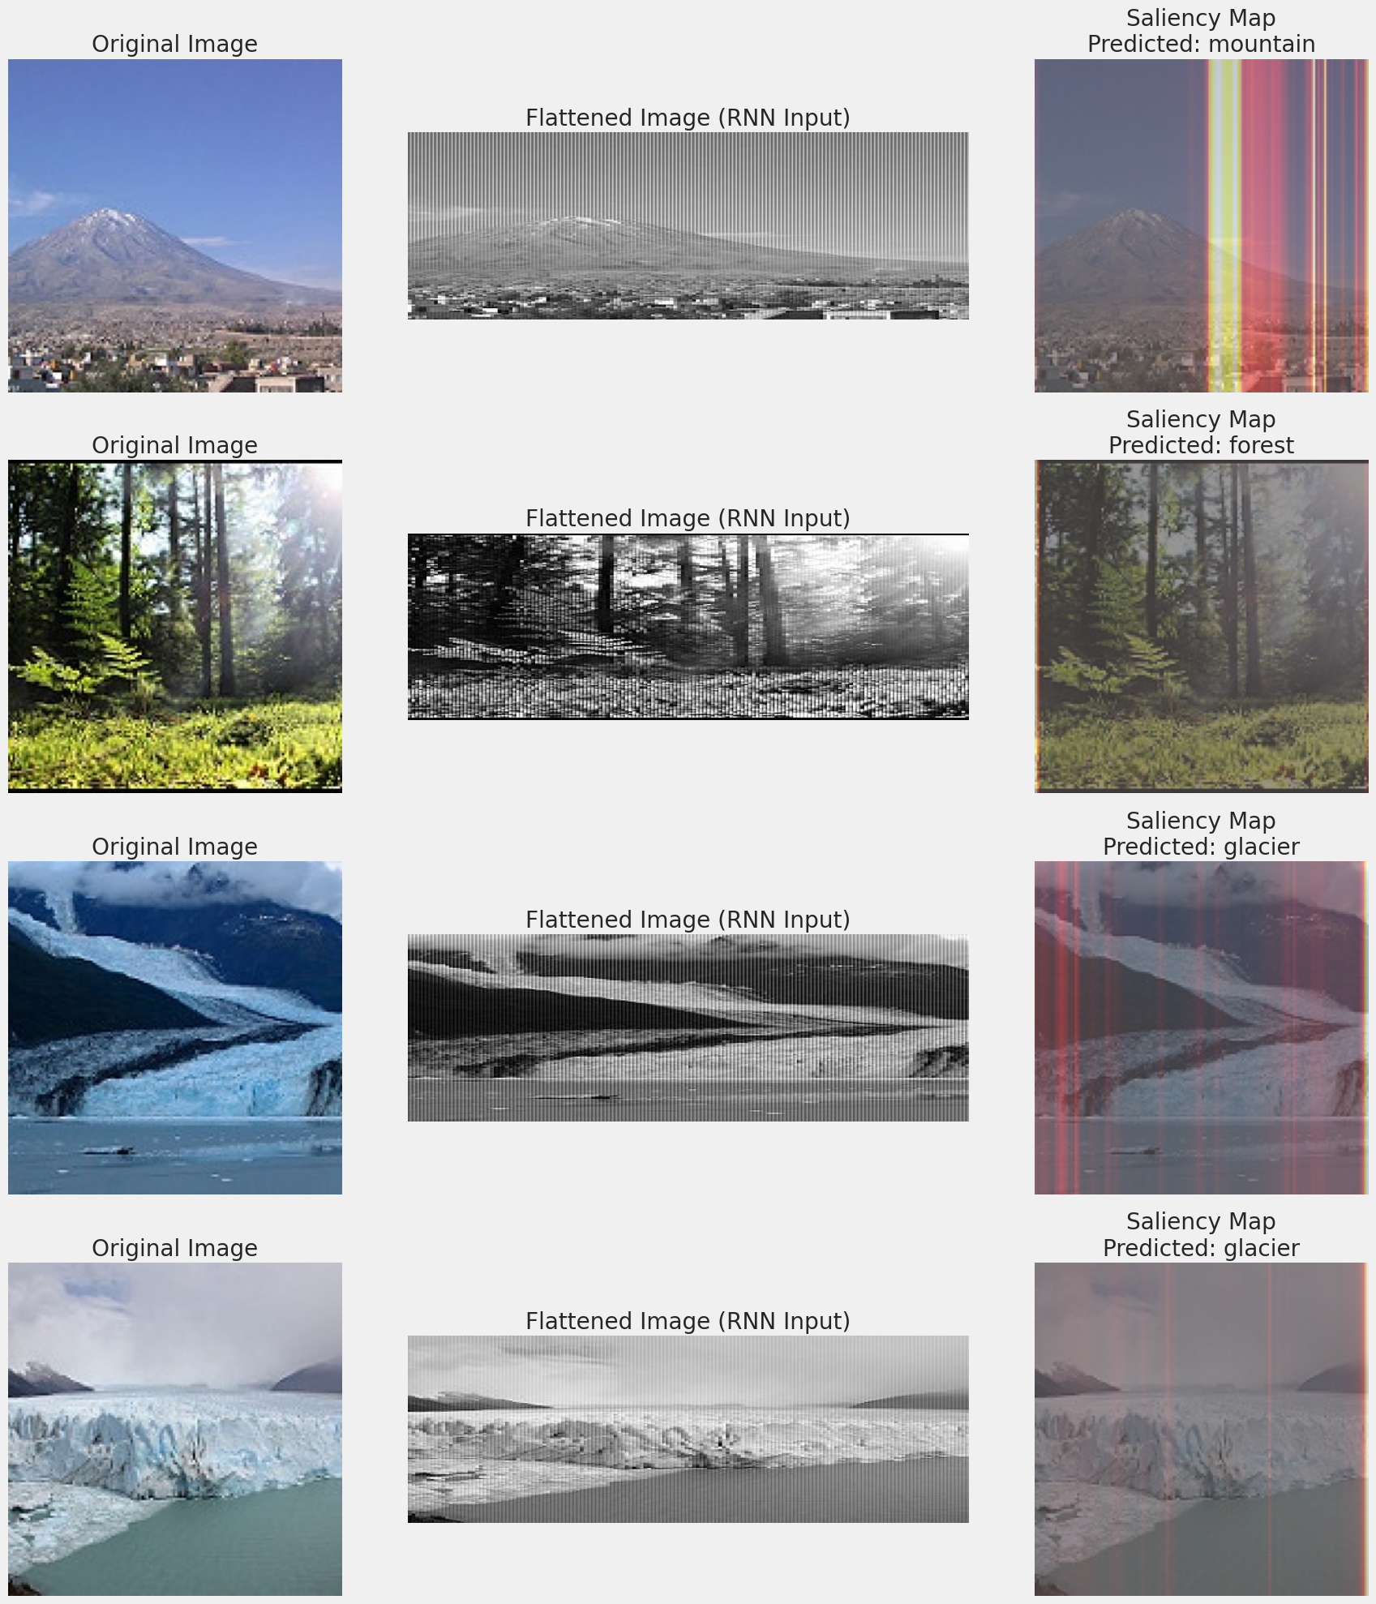

The displayed saliency maps provide valuable insights into how the RNN model interprets and classifies each image, particularly by highlighting which portions of the sequential input contribute most to the predicted class.

In the case of the mountain image, the saliency map for this image shows vertical lines of intense color over the peak of the mountain. The RNN seems to focus primarily on the contours of the mountain and its contrast against the sky. This makes sense as the sharp peak and its distinct separation from the background are key features in identifying a mountainous landscape. The model likely bases its prediction of "mountain" on these strong vertical features, which are unique to mountainous regions compared to flatter terrain.

For the forest image, the saliency map highlights the dense tree trunks and foliage, with emphasis on the vertical structures in the image. The RNN is likely recognizing the repetitive vertical patterns of the trees and the variation in light as key features that distinguish forests from other environments. The focus on these areas suggests that the model is correctly identifying forests based on the characteristic verticality of the trees.

In the first glacier image, the saliency map shows emphasis on the wide, reflective surface of the ice. The model likely uses the smooth, bright patches of the glacier as distinguishing features to correctly classify this environment. The uniformity in the saliency map over the glacier suggests that the RNN is recognizing the expansive, reflective surfaces that are unique to glaciers, differentiating them from forests or mountains, which generally have more textured and uneven surfaces.

Similar to the previous glacier, the second saliency map for glacier highlights the broad expanses of ice. The strong vertical streaks of color in the map are concentrated over areas with fewer features (smooth ice fields), indicating that the model is using these uniform surfaces to reinforce its classification of the image as a glacier. The model likely focuses on the lack of texture and the high reflectivity of the ice to differentiate glaciers from other natural landscapes.

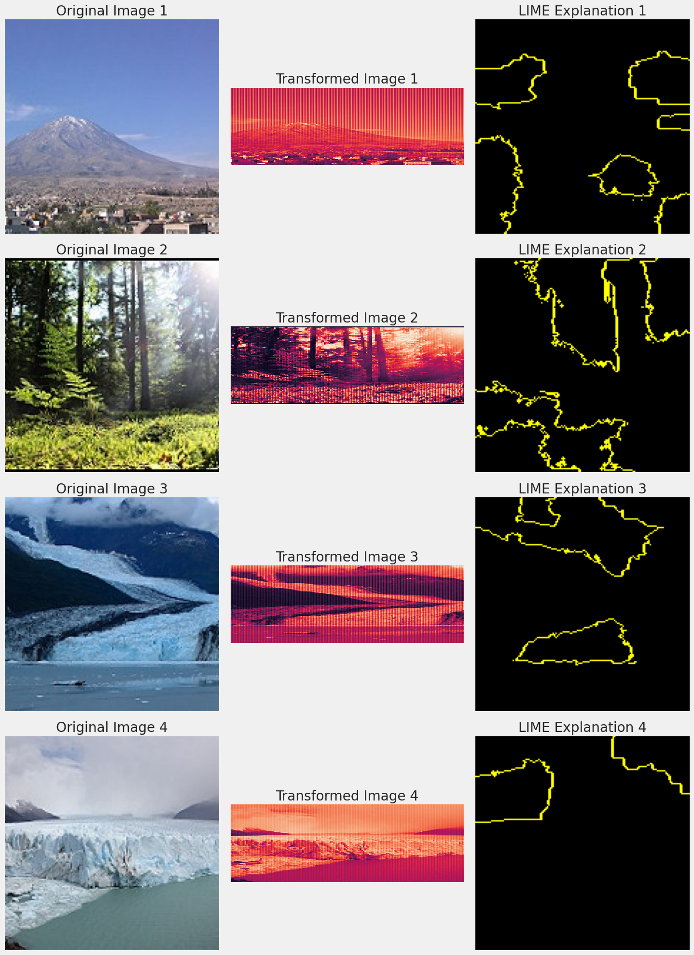

The LIME visualizations provide a detailed insight into how the RNN model interprets images for classification. The implementation utilized to generate these explanations follows a similar approach to what was done by the groupmate for his CNN model, though adapted for the RNN architecture. Another groupmate, who implemented the MLP model, also used a flattened layer. The key difference in the RNN implementation is that the input data is reshaped before being fed into the model, rather than flattened, as seen in the MLP model.

The original image is shown alongside the transformed image (which represents how the RNN processes the flattened input) and the LIME explanation. In the LIME visualizations, highlighted regions represent the areas the model deemed most relevant to its decision-making process.

For instance, in the mountain image, LIME highlights the skyline and mountain contours, suggesting that these were the features the RNN relied on to classify the image. In contrast, the forest image shows that the model focused on the vertical structures of the trees and areas with sunlight, which influenced its classification decision. In the third and fourth rows, the glacier images have regions near the glacier's edges and the contrasting textures of ice and water highlighted. This shows that the model focuses on the glacier's unique texture and boundary with the surrounding environment to make its prediction.

Although the LIME code is similar to the other groupmates’ implementation, the way RNN processes the data (by reshaping it) creates a different pattern of interpretation compared to CNN’s spatial handling or the MLP’s flattened input. This comparison underscores how these different models—RNN, CNN, and MLP—approach and process the same visual data differently, even when using the same explanation techniques like LIME to ensure consistency in analysis.

### Model Testing





For the final model testing, two images from the internet were used to assess the RNN model’s performance. The implementation code for this process was identical to what the other groupmates used, ensuring consistency in the methodology. The first image tested was of a building, the same image used to test the CNN model by another groupmate. Interestingly, the RNN model struggled with this image, producing a relatively low confidence score. This correlates with the model's performance on the "building" class during training and evaluation, which showed weaker metrics in comparison to other classes.

From the earlier confusion matrix and classification report, it was evident that the "building" class had one of the lower precision and recall values. This suggests that the model had difficulty recognizing buildings, possibly due to the nature of architectural elements like windows and vertical lines, which may be misinterpreted when the image is flattened and passed into the RNN. Given that an RNN processes data sequentially, this type of detailed, structured information may not be as easy to analyse as more organic forms.

In contrast, the second image tested was a forest, another random image found online. The model classified this forest image with more confidence, which aligns with its stronger performance on this class in earlier evaluations. Forest images contain features such as tree trunks, foliage, and varying lighting, which might offer more consistent, sequential patterns that the RNN can better handle. The natural, less structured environment of forests may present clearer signals for the model, leading to higher prediction accuracy compared to buildings.

Overall, while the model performed reasonably well on natural landscapes like forests, its ability to handle structured objects such as buildings remains a challenge. This discrepancy in performance highlights a potential limitation of using this particular RNN model, especially for tasks requiring detailed recognition of man-made structures.

## Model Selection

Comparing the 3 types of models developed throughout the assignment, the Custom CNN model seemed to be the best-performing model among all. Simply comparing the evaluation metrics obtained, the CNN model outperformed the other 2 with outstanding accuracy, precision, and recall as referred to the following table that displays the evaluation scores of the models in validation dataset.

|  |  |  |  |
| --- | --- | --- | --- |
| Metrics | Custom CNN | MLP | RNN |
| Accuracy | 0.8587 | 0.6080 | 0.7110 |
| Precision | 0.8730 | 0.7068 | 0.7906 |
| Recall | 0.8457 | 0.4853 | 0.6230 |
| AUC | 0.9814 | 0.8816 | 0.9297 |

Other than that, based on the analyses for the 3 models in the model explainability section, CNN’s result also makes much more sense, especially in the LIME explanation. This shows that the CNN model has much more powerful feature extraction ability compared to the other 2 models, which aligns with the literature research results in section 1.1.2. The model explainability part also proposed that the CNN model has a clearer classification ability as shown in the t-SNE visualization, where the MLP model’s and RNN model’s results are much more overlapped for each class.

On the other hand, although all the 3 models successfully predicted a correct label for the random images fed for testing, the CNN model’s testing result also outshines the other 2 with a high confidence score of 0.999. Whereas the MLP and RNN models can only achieve low confidence score of 0.411 and 0.271 respectively, showing weak classification ability in labelling ‘buildings’ image. Even for predicting ‘forest’ which has much clearer feature, the 2 models are yet to achieve a high score as high as 0.999.

Generally, the assignment’s image classification task is rather difficult sometimes, when performing on classifying images with similar environmental features. For instance, ‘mountain’ in winter conditions could be mistaken as ‘glacier’, and the ‘glacier' images normally comes with water besides, which might be confused as ‘sea’. Besides, ‘street’ and ‘building’ images propose ambiguity as well, considering they are both views in a city and there are possibly buildings around a street. Therefore, models without strong feature extracting capabilities such as basic MLP and RNN models struggle to make clear classification between the previously mentioned labels. Hence, most of the studies that deal with image classification integrate a convolutional block for MLP and RNN models for feature extraction, making them hybrid CNN-MLP or CNN-RNN models (Guo et al., 2018; Sharifzadeh et al., 2019; Shawky et al., 2020; Yin et al., 2019).

Overall, the CNN model developed was undeniably the best-performing model within this assignment in the classifying natural scenes task. Its’ balanced classification capability (as shown in the classification report as in 2.2.2) gave it more credibility as the best model with more reliability.

## Conclusion

When it comes to classifying images of natural scenes, **Convolutional Neural Networks (CNNs)** have proven effective more than other models as they involve convolutional filters to form spatial hierarchies. Our model also aligns with other works on this topic, in which CNNs are known to be good at discriminating among important image features such as edges, textures, and shapes. For example, studies such as those by Y. Zhang et al. (2020b) demonstrate the ability of the CNN model to efficiently learn spatial hierarchies for more advanced tasks such as natural scene classification. Moreover, it is quite notable that CNNs perform well with complex datasets such as the Intel Image Classification dataset, which contains images taken from different light and weather conditions. However, it is reported in the literature that the performance of the CNN model can be improved even more if deeper architectures are employed such as ResNet or VGG since they allow better feature extraction by the lower layers (Soudy et al., 2022). Transfer learning from pre-trained models on external large-scale datasets, for instance, ImageNet is also a typical practice in studies aimed at improving model performance on complex image datasets.

The results obtained from our **Multi-Layer Perceptron (MLP)** model reflect the analysis of academic literature indicating that MLPs are poorly suited for image classification tasks. The main reason for this is the MLP’s conversion of image data using the flattened method, which turns the image into one-dimensional vectors, eliminating the spatial relationship that is needed for natural scene classification. This is because it treats the representation of the pixels as features independently. Research pointed out that MLPs appear to be ineffective in applications that involve the recognition of spatial patterns as they perform well with less complex datasets or tasks that have few variables (Zheng & Sun, 2021b). This is consistent with the findings of the study which show that MLP fails due to complex categories, such as whether the image is an urban or natural scene. For instance, the classification accuracy of our MLP model (61% after tuning) shows it is less adequate in scene classification which clearly demonstrates the difficulties with the structure and texture of the images. To achieve higher accuracy and other metrics in the future, others proposed the use of hybrid models consisting of CNN architecture to extract features and MLP for classification which worked quite well with limited data and provided a balance between complexity and generalization (C. Zhang et al., 2018b).

**Recurrent Neural Networks (RNNs)**, and in particular Long Short-Term Memory (LSTM) networks, are capable of understanding the temporal relationships presented in image sequences. However, as other studies support, it is shown that RNNs are more useful in sequential data such as video classification or time-series analysis, rather than static image classification (Ma & Filippi, 2020b). While our implementation demonstrates that RNNs can capture dependencies across image patches, this approach is generally less effective compared to CNNs when applied to static images. The previous studies thus suggest that CNN-RNN hybrids, which take advantage of the spatial feature extraction capabilities of CNNs and sequence processing capabilities of RNNs, have produced better outcomes in complex classification tasks (J. Wang et al., 2016). Hence, even though our RNN model yielded a moderate accuracy (72.9% following tuning), it may work better with a hybrid architecture.

Further improvement could also be done using **more sophisticated data augmentation techniques.** Our models are already performing basic augmentations like rotation, flipping, and zooming. The studies suggest that further improvement by adding Gaussian blur, random erasing, and colour jitter that might give more robustness to variations in lighting, texture, and viewpoints in the dataset. These methods indeed improved model generalization by increasing the diversity of the training dataset, consequently reducing overfitting and improving performance on previously unseen data (Ostrovskiy, 2024).

# References

Akhtar, M., Murtza, I., Adnan, M., & Saadia, A. (2023). Cross-Domain Transfer Learning for Natural Scene Classification of Remote-Sensing Imagery. *Applied Sciences (Switzerland)*, *13*(13). https://doi.org/10.3390/app13137882

Guo, Y., Liu, Y., Bakker, E. M., Guo, Y., & Lew, M. S. (2018). CNN-RNN: a large-scale hierarchical image classification framework. *Multimedia Tools and Applications*, *77*(8). https://doi.org/10.1007/s11042-017-5443-x

Gupta, N., & Khobragade, P. (2023). Muti-class Image Classification using Transfer Learning. *International Journal for Research in Applied Science and Engineering Technology*, *11*(1). https://doi.org/10.22214/ijraset.2023.48665

He, X., & Chen, Y. (2021). Modifications of the multi-layer perceptron for hyperspectral image classification. *Remote Sensing*, *13*(17). https://doi.org/10.3390/rs13173547

Lv, P., Wu, W., Zhong, Y., Du, F., & Zhang, L. (2022). SCViT: A Spatial-Channel Feature Preserving Vision Transformer for Remote Sensing Image Scene Classification. *IEEE Transactions on Geoscience and Remote Sensing*, *60*. https://doi.org/10.1109/TGRS.2022.3157671

Ma, A., & Filippi, A. M. (2020a). Hyperspectral Image Classification via Object-Oriented Segmentation-Based Sequential Feature Extraction and Recurrent Neural Network. *International Geoscience and Remote Sensing Symposium (IGARSS)*. https://doi.org/10.1109/IGARSS39084.2020.9323594

Ma, A., & Filippi, A. M. (2020b). Hyperspectral Image Classification via Object-Oriented Segmentation-Based Sequential Feature Extraction and Recurrent Neural Network. *International Geoscience and Remote Sensing Symposium (IGARSS)*. https://doi.org/10.1109/IGARSS39084.2020.9323594

Meng, Z., Zhao, F., & Liang, M. (2021). Ss-mlp: A novel spectral-spatial mlp architecture for hyperspectral image classification. *Remote Sensing*, *13*(20). https://doi.org/10.3390/rs13204060

Ostrovskiy, N. (2024). *Comparison of Data Augmentation Techniques for efficient Training of Image-Text Classification Algorithms* [Doctoral dissertation, Hochschule für Angewandte Wissenschaften Hamburg]. http://hdl.handle.net/20.500.12738/15878

Sharifzadeh, F., Akbarizadeh, G., & Seifi Kavian, Y. (2019). Ship Classification in SAR Images Using a New Hybrid CNN–MLP Classifier. *Journal of the Indian Society of Remote Sensing*, *47*(4). https://doi.org/10.1007/s12524-018-0891-y

Shawky, O. A., Hagag, A., El-Dahshan, E. S. A., & Ismail, M. A. (2020). Remote sensing image scene classification using CNN-MLP with data augmentation. *Optik*, *221*. https://doi.org/10.1016/j.ijleo.2020.165356

Sorkhi, A. G., Hassanpour, H., & Fateh, M. (2020). A comprehensive system for image scene classification. *Multimedia Tools and Applications*, *79*(25–26). https://doi.org/10.1007/s11042-019-08264-y

Soudy, M., Afify, Y., & Badr, N. (2022). RepConv: A novel architecture for image scene classification on Intel scenes dataset. *International Journal of Intelligent Computing and Information Sciences*, *0*(0). https://doi.org/10.21608/ijicis.2022.118834.1163

Wang, J., Li, W., Zhang, M., Tao, R., & Chanussot, J. (2023). Remote-Sensing Scene Classification via Multistage Self-Guided Separation Network. *IEEE Transactions on Geoscience and Remote Sensing*, *61*. https://doi.org/10.1109/TGRS.2023.3295797

Wang, J., Yang, Y., Mao, J., Huang, Z., Huang, C., & Xu, W. (2016). CNN-RNN: A Unified Framework for Multi-label Image Classification. *Proceedings of the IEEE Computer Society Conference on Computer Vision and Pattern Recognition*, *2016-December*. https://doi.org/10.1109/CVPR.2016.251

Wang, S., Wang, R., Yao, Z., Shan, S., & Chen, X. (2020). Cross-modal scene graph matching for relationship-aware image-text retrieval. *Proceedings - 2020 IEEE Winter Conference on Applications of Computer Vision, WACV 2020*. https://doi.org/10.1109/WACV45572.2020.9093614

Yin, Q., Zhang, R., & Shao, X. (2019). CNN and RNN mixed model for image classification. *MATEC Web of Conferences*, *277*. https://doi.org/10.1051/matecconf/201927702001

Zhang, C., Pan, X., Li, H., Gardiner, A., Sargent, I., Hare, J., & Atkinson, P. M. (2018a). A hybrid MLP-CNN classifier for very fine resolution remotely sensed image classification. *ISPRS Journal of Photogrammetry and Remote Sensing*, *140*. https://doi.org/10.1016/j.isprsjprs.2017.07.014

Zhang, C., Pan, X., Li, H., Gardiner, A., Sargent, I., Hare, J., & Atkinson, P. M. (2018b). A hybrid MLP-CNN classifier for very fine resolution remotely sensed image classification. *ISPRS Journal of Photogrammetry and Remote Sensing*, *140*. https://doi.org/10.1016/j.isprsjprs.2017.07.014

Zhang, Y., Wang, Y., Liu, X. Y., Mi, S., & Zhang, M. L. (2020a). Large-scale multi-label classification using unknown streaming images: Large-scale multi-label classification using unknown streaming images. *Pattern Recognition*, *99*. https://doi.org/10.1016/j.patcog.2019.107100

Zhang, Y., Wang, Y., Liu, X. Y., Mi, S., & Zhang, M. L. (2020b). Large-scale multi-label classification using unknown streaming images: Large-scale multi-label classification using unknown streaming images. *Pattern Recognition*, *99*. https://doi.org/10.1016/j.patcog.2019.107100

Zheng, Q., & Sun, J. (2021a). Effective point cloud analysis using multi-scale features. *Sensors*, *21*(16). https://doi.org/10.3390/s21165574

Zheng, Q., & Sun, J. (2021b). Effective point cloud analysis using multi-scale features. *Sensors*, *21*(16). https://doi.org/10.3390/s21165574